Writing
You are going to write a fictional story about a fun day in the sun. This is not a recount so you are not telling me what you have done. It can, however, be based on some things you have done. You do not use ‘I’ instead you would make up a name, for example, Poppy.
Paragraph 1: Intro, characters, setting (where)
Paragraph 2: what they are doing, when it is, why they are there
Paragraph 3: something happens – what is it?
Paragraph 4: how is it resolved? What happens? Conclusion
Learning Intention:
We are learning to write a fictional story.
Success Criteria:
- Finger spaces
- .
- C
- abc
- sp
- Bonus point for feelings (remember that it is the characters feelings, not your own!)

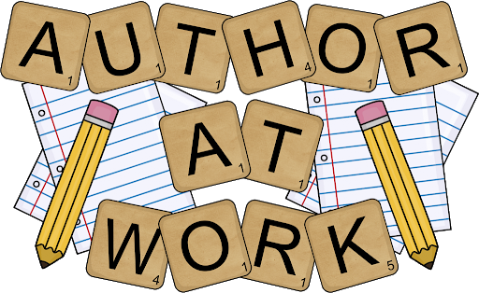

Spelling
Learning Intention: We are learning to spell our common words and phoneme words correctly.
Success Criteria: I can:
- Sound out and spell each word correctly
- Use my words in sentences
- Self-assess my work to check if I have spelled my words correctly
Brain Boxes
Common Words  said  big  could | Phoneme  ai | Phoneme Words  fair  stair  hair  air  chair  rain  pain  grain  brain

Clever Cookies
Common Words  under  were  thing  know | Phoneme  kn | Phoneme Words  knock  know  knee  knight  kneel  knew

Genius Gems
Common Words  does  changes  show  think  same | Phoneme  dge | Phoneme Words  fudge  bridge  edge  hedge  ledge  judge  badger  fridge

Superstars
Words ending in ‘–ing’ ‘–ed’
One Syllable Words e.g. hop, need the final consonant to be doubled before adding endings that start with a vowel.
hop + ing = hopping
hop + ed = hopped
- Find at least 10 more words that fit this Spelling Rule

Activities
Practice your common words and phoneme words in any way you wish. Some suggested ideas include:

- Rainbow writing
- Writing words 3 times
- Look, say, cover, write and check
- Writing your phoneme in a different colour e.g. phone

I have attached a copy of the spelling menu that is in your homework diary for some extra ideas.

Try to use as many of your words in sentences. This could be separate sentences, a phoneme story or a paragraph.

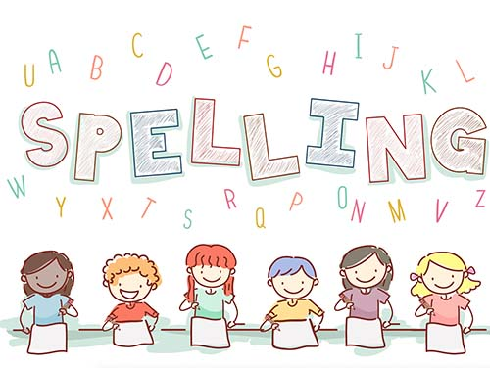
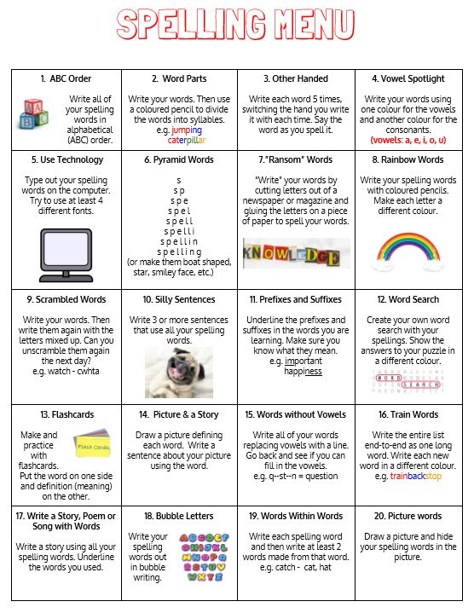

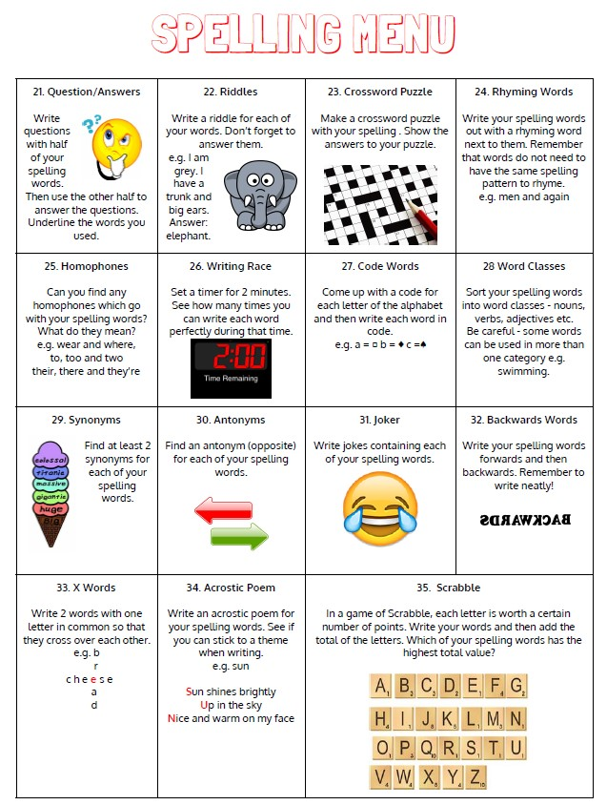

Maths
Circles | Squares | Triangles
Mental Maths: Continue the following patterns.  1, 2, 3, __, 5, 6, __.  9, __, 11, 12, __, __, 15  2, 4, 6, __, 10, __, 14.  12, 14, __, 18, 20.  10, 20, 30, 40, __, 60, __, 80. | Mental Maths: Continue the following patterns.  6, 8, __, __, 14, 16, __, 20.  40, 50, __, 70, __, 90, __.  3, 6, 9, __, 15, __, __, 24, 27.  100, 90, 80, 70, __, 50, __.  12, 10, __, 6, 4, __, __. | Mental Maths: Continue the following patterns.  12, 14, __, 18, 20, __, __.  3, 6, 9 ,12, __, __, __, 24, 27.  4, 8, 12, __, 20, __, 28, 32.  80, 70, 60, __, 40, __, __, 10.  50, 45, 40, __, __, __, 20, 15.
Practise counting forwards and backwards starting from any number in the sequence.  Practise 2, 5 and 10 times tables. | Practise counting forwards and backwards starting from any number in the sequence.  Practise 2, 3, 5 and 10 times tables. | Practise counting forwards and backwards starting from any number in the sequence.  Practise 2, 3, 4, 5 and 10 times tables.
Sumdog Multiplication Challenge.
If you are feeling confident with the times tables set for your group, challenge yourself by learning another times table. Remember that there are lots of videos on YouTube that we watched in class that will help you to practise your times tables. Good luck!

If it is sunny, why not use some chalk and practise your times tables outside on the ground? Or, collect lots of stones to make your calculations on the ground out of stones. You could use leaves (if it’s not too windy) and lay them out on the ground to show your answers. Can you think of any other fun ways to do your Maths work outdoors?

Here are some games from top marks that you might want to play:
https://www.topmarks.co.uk/maths-games/5-7-years/times-tables
*Self-assess your learning. Put a red, amber or green at the top of your worksheet to let me know how you found it.
- I found this work too difficult and I didn’t really understand it.
- I managed this work but found some of it tricky.
- I managed to complete my work independently.

Primary 2/3 Challenge: Fitness Fun in the Sun

Each week in June Primary 2 and 3 children will be given a new challenge which will be announced on a Monday.
You must post a picture or video of yourself doing your challenge on your Class Microsoft Teams page by Friday evening.
The prize: A digital certificate for you to keep and display in your home.
We will also be awarding certificates to the class who has the most participants.
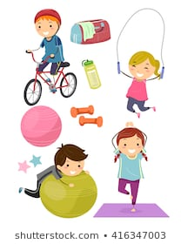

Week 1: Miss Harper’s Challenge
Week 2: Miss Williamson’s Challenge
Week 3: Mrs Hasselstrom’s Challenge
Week 4: The ULTIMATE Challenge
Who is up for the CHALLENGE?

First up Miss Harper’s Challenge:
This week, your challenge is a keepie uppy and shot put challenge!

- Keepie uppy challenge: How many keepie uppys can you do using a toilet roll?
- Shot put challenge: Using a toilet roll, see how far you can throw it. Measure the distance using your feet.

Remember to upload a photo/video to Microsoft Teams for your teacher to see!

