Lines of Symmetry

REMINDER: *Lines of symmetry are when the exact reflection of a line, shape or object is created. This can be done by folding a piece of paper equally.*

[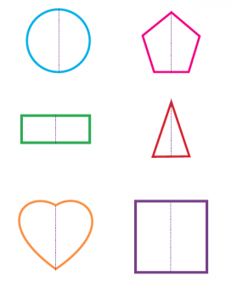](https://www.google.co.uk/url?sa=i&url=https%3A%2F%2Fwww.theschoolrun.com%2Fwhat-is-symmetry&psig=AOvVaw3Qo77hHLzUC_DOD2wzDTkL&ust=1590666455027000&source=images&cd=vfe&ved=0CAIQjRxqFwoTCLjh6b_80-kCFQAAAAAdAAAAABAD)

Are the following shapes symmetrical? Think… Would you be able to fold this equally in half?

1. [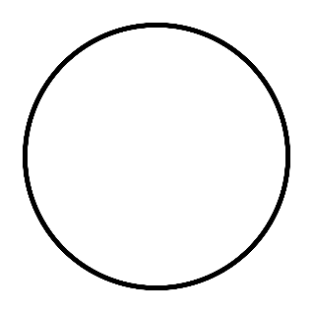](https://www.google.co.uk/url?sa=i&url=https%3A%2F%2Fen.wikipedia.org%2Fwiki%2FMegagon&psig=AOvVaw2EU9nSI-ptI90cvtBlVKN_&ust=1590666664673000&source=images&cd=vfe&ved=0CAIQjRxqFwoTCJC_vZ390-kCFQAAAAAdAAAAABAD) 3. [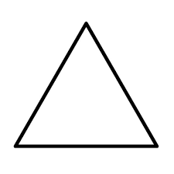](https://www.google.co.uk/url?sa=i&url=https%3A%2F%2Fwww.pelennapatchworks.co.uk%2Ffreezer-paper-templates-for-patchwork%2Fequilateral-triangle-freezer-paper-templates.html&psig=AOvVaw3DwaPE4UX0UU1rnjokk3vs&ust=1590666686717000&source=images&cd=vfe&ved=0CAIQjRxqFwoTCPjwjqj90-kCFQAAAAAdAAAAABAD)
2. [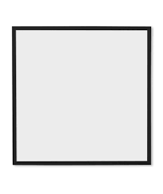](https://www.google.co.uk/url?sa=i&url=https%3A%2F%2F1stamender.com%2Farticle.php%3Farticlenumber%3D1361&psig=AOvVaw0gbIu6ZcLYx3jT3NGQ9AnA&ust=1590666713750000&source=images&cd=vfe&ved=0CAIQjRxqFwoTCNjriLX90-kCFQAAAAAdAAAAABAD) 4. [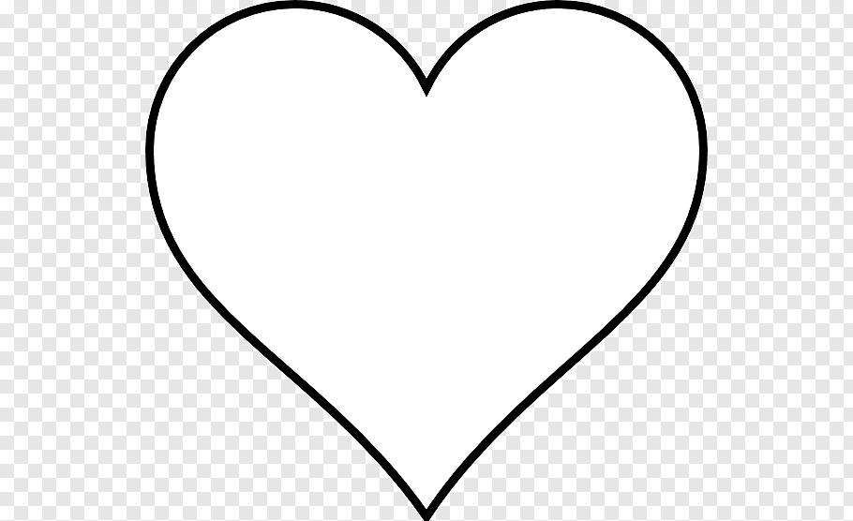](https://www.google.co.uk/url?sa=i&url=https%3A%2F%2Fwww.pngfuel.com%2Ffree-png%2Favrnb&psig=AOvVaw3ZtfvaNsRBQBsYj_zq62Lk&ust=1590666761399000&source=images&cd=vfe&ved=0CAIQjRxqFwoTCOCj6Mv90-kCFQAAAAAdAAAAABAD)

Challenge: Use some scrap paper to create lines of symmetry by folding the paper equally.