Primary 6/Miss O’Toole – Home Learning 2nd of June

Every Tuesday and Thursday (before 10am) I will be posting home learning tasks for you to work through. New spelling words will be posted every Tuesday.
Spelling Tasks
Red Group | Blue Group | Green Group
LI: To identify the correct homophone word.  Homophone Set 4  tears  tiers  their  there  they’re  threw  through  time  thyme  to  too  two  TASK  Complete the homophone worksheet. Select the correct homophone word for each sentence.  NOTE: Use a dictionary to find out the meaning of any of the homophone words that you are unsure of.  Success Criteria:  Identify the correct homophone word in the given context. | LI: To create sentences using my phoneme words.  ‘oi’ Phoneme Set 1  coin  poison  spoil  choice  point  noise  enjoy  annoy  loyal  royal  TASK  Create 4 sentences using your phoneme words.  Success Criteria:  Create 4 sentences which include given spelling words.  Use adjectives and verbs to provide description.  Use appropriate punctuation. | LI: To sort the given homophone words.  Phoneme set 1 ‘ow’  bow  cow  how  house  mouse  cloud  TASK  Complete the ‘ow’ phoneme worksheet.  Success Criteria:  Match the images to their correct phoneme sounds.

Spelling Strategies Grid
The grid below will help ALL groups recap their spelling strategies. It is important that you refer to these strategies when looking at your new words. It may be a good idea to print this out and have it handy for when you are completing spelling tasks!
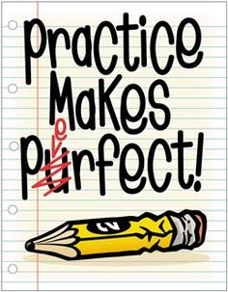
Spelling Strategy | Example
Phoneme Knowledge (PK) | Money – the ‘ey’ phoneme in this word can help you to spell it.
Spelling Rule (SR) | Make – the ‘silent e’ (or as we say ‘magic e’) makes the vowel ‘a’ say its name.
Word Within a Word (WWW) | Space – the word ‘ace’ helps us to spell the word ‘space’.
Mnemonic (M) | Rhythm – Rhythm Helps Your Two Hips Move. Creating a rhyme or poem can help you spell tricky words!
Syllabification (S) | Yesterday – yes/ter/day. This is when we clap out the syllables in the word.  Tip: Use our classroom strategy where we put our hand under our chin. Every time your chin moves, it’s a new syllable!
Compound Word (CW) | Football – foot/ball. Compound words are two or more words combined to make a new word like ‘football’. Try not to get this mixed up with ‘Word Within a Word’.

Reading Tasks
Red Group | Blue Group | Green Group | Orange Group
LI: To create summary of given chapters.  TASK  Read chapters 5 and 6 of ‘Storm Chasers’ (Oxford Owl – link below). Create summary of both chapters.  Oxford Owl Login  Username:sthelensp6  Password: school  Success Criteria:  Identify the main ideas of the chapters.  Summarise key points. | LI: To create a visualisation of a given character.  TASK  Read chapters 5 and 6 of ‘Black Beauty’  (Oxford Owl – link below). Create a visualisation of a character of your choice (Eg: Black Beauty/James).  Oxford Owl Login  Username:sthelensp6  Password: school  Success Criteria:  Use descriptive language to describe a given character.  Use evidence from the text. | LI: To make informed predictions.  TASK  Listen to chapters 20 and 21 of ‘Kid Normal’ story (audio version – link below). Share with an adult what you think will happen next.  NOTE: You do not have to write anything for this task.  Success Criteria:  Understand plot of given chapters.  Share what you think will happen next. | LI: To research a range of equipment.  TASK  Again, access ‘Sport: Then and Now’. (Oxford Owl – link below). Use the internet to research the equipment used ‘then’ and ‘now’. Do you notice any differences?  Oxford Owl Login  Username:sthelensp6  Password: school  Success Criteria:  Use the internet to research given sports equipment.  Make clear comparisons.

Link to Clips:
Red Group https://www.oxfordowl.co.uk/api/digital_books/1386.html
Blue Group https://www.oxfordowl.co.uk/api/digital_books/1336.html
Green Group https://stories.audible.com/pdp/B07533YSBN?ref=adbl_ent_anon_ds_pdp_pc_cntr-1-1
Orange Group https://www.oxfordowl.co.uk/api/interactives/12942.html

Numeracy Tasks
1) Mental Starter: Play 1 round of ‘Hit the Button’ and select the times tables option (this should only take around 5 minutes). https://www.topmarks.co.uk/maths-games/hit-the-button
2) Number Talks: Try to aim to solve your chosen question within 5 minutes (use a timer). If you manage to solve the problem with time to spare, try to use a different Number Talks strategy like we do in class. See the grid below to recap your strategies.
Hot | 1188 ÷ 12 =
Spicy | 98 ÷ 14 =
Mild | 72 ÷ 8 =
Number Talks Strategy Examples – Division
You may recognise some of these sums from our Maths wall. I have created this grid to recap your memory of the different division strategies we have learned in class.
Repeated Subtraction  25 ÷ 5 = 5  25  -5  20  When you reach 0, count up how many 5’s you have used to complete the sum.  -5  15  -5  10  -5  5  -5  0 | Sharing/Dealing Out  25 ÷ 5 = 5 | Multiplying Up  308 ÷ 14 = 22  10 x 14 = 140  10 x 14 = 140  2 x 14 = 28  140 + 140 + 28 = 308. When you reach the starting point in the sum, the last step is to add your circles (ie 10 + 10 + 2).
Partial Quotients  308 ÷ 14 = 22  14 308  -140 10  168  -140 10  28  -28 2  0 | Proportional Reasoning  308 ÷ 14  ÷ 7  ÷ 7  44 ÷ 2 = 22  Find a common multiple in each of the numbers. Remember, if it is an even number, try dividing by 2 if you are struggling. This is a good first step. | Final Number Talks Hints  - Choose the strategy you feel most confident in to begin with.  - Afterwards, you can begin to think about the strategy that is most efficient for your given sum. (This is a top goal of ours in class).  - Show your working.
Red Group | Blue Group | Green Group | Orange Group
LI: To identify given angles.  TASK  Watch the ‘angles’ video clip to recap your knowledge of basic angles. Complete the ‘Identifying Angles’ task.  Success Criteria:  Name the angles (‘acute’, ‘obtuse’ or ‘right’). | LI: To identify right angles in the environment.  TASK  Watch the ‘angles’ video clip below to recap your knowledge of angles. Next, complete the ‘Angles in the Environment’ task  Success Criteria:  Find right angles in the environment.  Note the names of the objects which feature right angles. | LI: To identify lines of symmetry.  TASK  Watch the symmetry video clip. Complete the ‘green’ symmetry task.  Success Criteria:  Note shapes that are symmetrical and asymmetrical (not symmetrical). | LI: To identify lines of symmetry.  TASK  Watch the symmetry video clip. Complete the ‘orange’ symmetry task.  Success Criteria:  Identify symmetrical shapes.  Use paper to create a symmetrical shape.
3) Main Tasks:

Red and Blue Clips: https://www.bbc.co.uk/teach/skillswise/angles/zbxqrj6
Green and Orange Clips: https://www.youtube.com/watch?v=_Xs56r9o3Tw

R.E Task
LI: To explore the life of a given Saint.
Read the fact file below and answer the questions.
Saint Enoch

Enoch was a princess, daughter of a British prince called Lothus (from whom the province of Lothian was named). She lived in the 6th Cenury. Her father discovered that she had conceived out of wedlock and sentenced her to death. She was thrown from a cliff but miraculously was found unharmed at the bottom. Not satisfied he then set her adrift in a boat on the Firth of Forth. It was expected that she would die at sea, but God had other plans for the young woman…She landed at Culross, where she was sheltered by Saint Serf. She gave birth to Saint Mungo who became the patron Saint of Glasgow. The original church which was built and later demolished in St Enoch’s Square is thought to the site of her grave. Her feast day is celebrated on the 18th July.

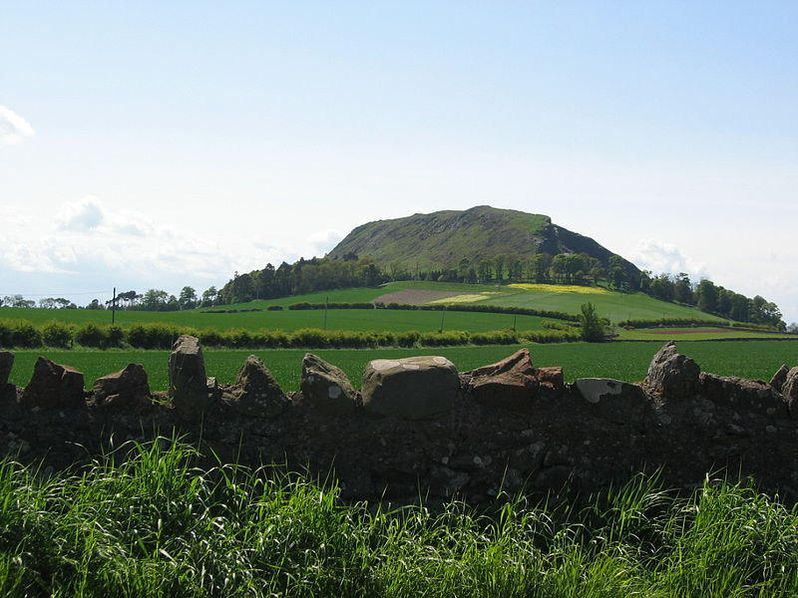
In legend, Traprain Law in East Lothian was the cliff from which St Enoch, the mother of St Mungo, was thrown.

You can listen to a traditional folk song about the life of St Enoch at the following link:
http://stmungomusic.org.uk/music/st-enoch/

Complete the following in full sentences.
- Saint Enoch was born in the _________ century.
- She was a ___________ which meant that she was raised to worship a variety of gods and goddesses.
- Her father became angry with her because she became ____________ out of wedlock.
- Briefly explain the two ways in which he tried to have her killed.
- Saint Enoch miraculously survived and was rescued by ___________________.
- She gave birth to a boy who later became ___________________ the patron saint of _______________.
- She is though to be buried in ___________________. The site was marked by a church but this was __________________ in __________.
- Her feast day is on ________________________.

Challenge: Where else have you heard the name ‘St Enoch’?
Hint… think about the centre of Glasgow.

Expressive Arts – Dance Task
LI: To evaluate a given dance routine.
You can access the ‘River Dance’ clip at https://www.youtube.com/watch?v=x80AmEyHrVY or by scanning the QR code below.

Answer each of the following questions:
Definitions:
Tempo – the speed of which music is played.
Choreography – the sequence of steps/movement within dance.

Red Spelling Task
Homophones Task
LI: To identify the correct homophone words.
Remember… Miss O’Toole’s ‘Homophone Hint’
ultiple
Homophones = M&M
eaning

Task 1: Select the correct homophone words in each of the sentences.
- The young baby cried many tiers/tears when she dropped her favourite teddy.

- A highlight of the Molly and Owen’s wedding day was the scrumptious wedding cake which had three tiers/tears. The bride and groom both shed many tears/tiers throughout this day.

- The two golden retriever puppies, Harley and Marlow, love there/their/they’re squeaky toy bone.

- Mr Russel walked through/threw the forest with his son. They through/threw small pebbles into the pond to make large splashes.

- Mary had to check what time/thyme the lemon time/thyme chicken had to be taken out of the oven.

- There were to/too/two many cars parked in the street. The parking attendant distributed tickets to/too/two each driver.

Task 2: Create 3 sentences using 3 homophone words from your spelling list.

