Writing

L.I- I can practise the second join.

S.C- * the second join. (diagonal join to a tall letter)

*tall lellers touch the top of the line

*middle letters stay in the middle of the line

*Self assess your work

Pracise your handwriting. Get warmed up by practising the, that and not. Take a look at this weeks spelling words and try to write them on lined paper.

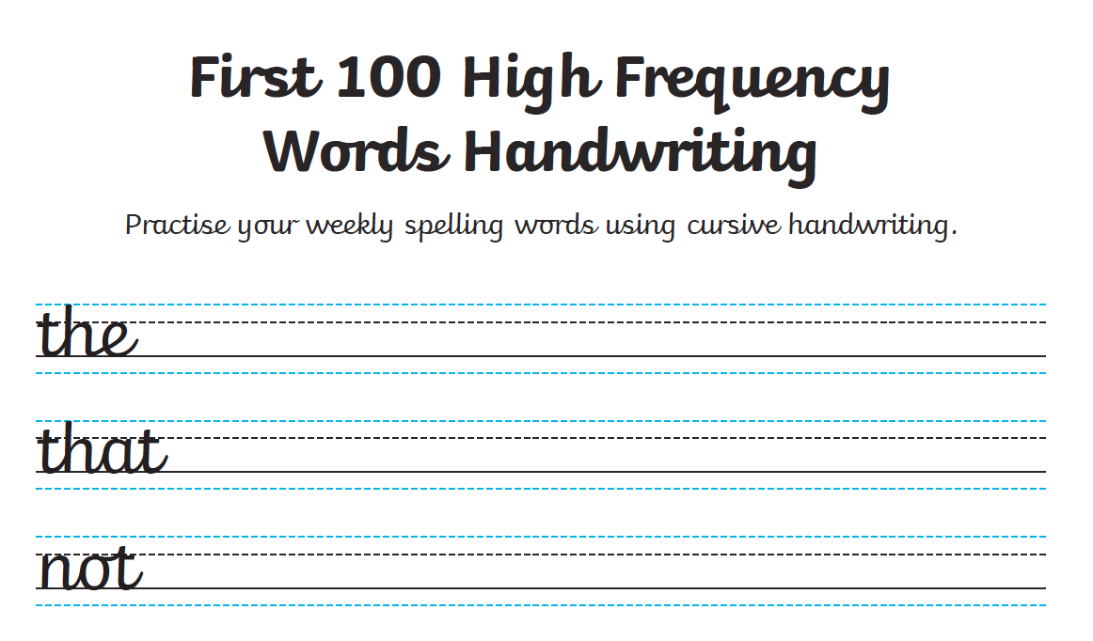

Spelling

Green/ yellow group

.I- I can choose a fun spelling task to help me spell my common words.

S.C-* correct spelling

*a suitable fun spelling task

Take a look at the spelling grid below and choose a fun spelling task.

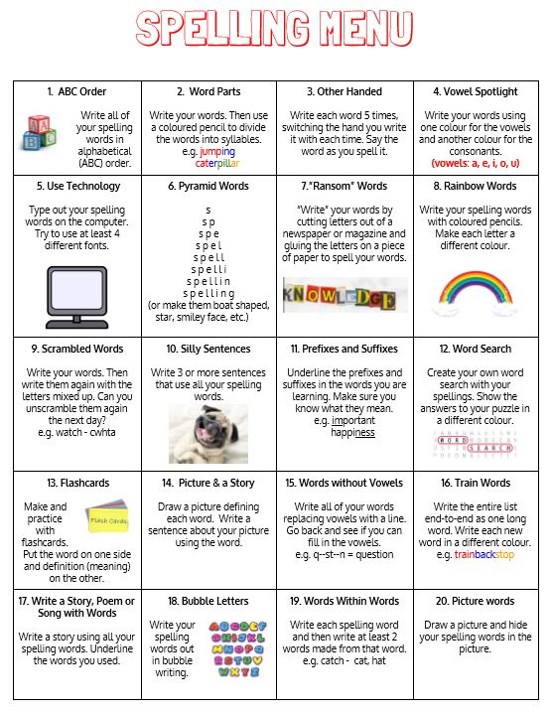

|  |  |  |  |
| --- | --- | --- | --- |
| Green | Yellow | Red | Orange |
| being  coming  jumped  started  used  walked  woke  only | young  across  both  following  near  brother  sister  cousin  friends | Common words  list  most  must  high  late  Phoneme words gn  sign  gnaw  gnome  design  gnarl  gnash | Common words  Consolidation  take  gave  cold  don’t  every  find  want  girl  Phoneme consolidation  a-e  u-e |

Reading

Green/Yellow

Please login into oxford reading owl.

Class user name: st helens p5

Password: School123

Green/Yellow – Mythical Beast and Fabulous Monsters

<https://www.oxfordowl.co.uk/api/digital_books/1336.html>

Listen to chapter 4 of the book. Now try to read it by yourself or to an adult. Answer the questions about the chapter.

L.I- I can use metalinguistic strategies to help me find the meaning of unfamiliar words.

S.C-*to listen to the audio version of the book.

* to read it by yourself.

* to complete the metalinguistic table.

.

Red and Orange- East of the Sun, West of the Moon.

<https://www.oxfordowl.co.uk/api/digital_books/1251.html>

Listen to the audio version of Chapter 3 . Now try to read it by yourself. You could ask an adult or older sibling to read with you. Now make a prediction about the text.

L.I- I can make a prediction about the text.

Success Criteria: *to read your book to an adult.

*to continue the story in the authors style.

Numeracy

Each day try to practise your mental maths skills on the Topmarks -daily 10

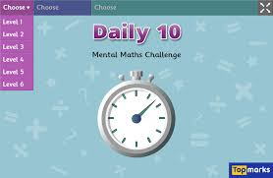

Success criteria:

* Use N.T. strategies to work out sums when required
* Answer each question
* Use the most efficient N.T. strategy

Circles/Triangles

We are calculating durations of time this week. Complete the day out worksheet. You may want to have a clock or a watch in front of you to help you complete the worksheet.

L.I- I can calculate time durations.

S.C *to complete the worksheet.

* to add hours then minutes.

Squares

We were learning about 5 min intervals. Last week we worked on minutes past the hour. This week we are learning about minutes to the hour. Take a look at the time power point to help you.

.L.I- I can tell the time in five minute increments.

S.C * to look at the time powerpoint

* to complete the worksheet.

R.E

The month of May is dedicated to Mary. Mary is known as the Queen of Heaven. Can you find out why Mary is the Queen of Heaven? Your task is to make a crown for Mary. You could use a range of materials such as cardboard, tissue paper, crepe paper. Think about what you could use for jewels. You could perhaps use pasta and paint it? **Don’t worry if you don’t have any of these materials lying around in the house. You could draw a crown for Mary on paper.**

**See attached sheet**

L.I- I know that during the month of May we honour Mary.

S.C. * discuss why Mary is the Queen of heaven.

*design or make a crown for Mary