Spelling Test
Learning intention:
I can test my knowledge of my spelling words.
Success criteria:
- Review your weekly spelling words from the list below.
- Get a family member or friend to test your knowledge of your spelling words. They should say one word at a time, whilst you write them down.
- Mark your spelling test.
- Post your results in the ‘assignment’ section of My Teams.

Red Group  (prefix - anti) | Blue Group  (prefix - anti) | Green Group  (sh phoneme)  Representations: sh, ti, ch | Yellow Group  (ie – long /ee/ sound)
antiseptic  anticlockwise  antiaircraft  anti-climax  antisocial  antifreeze  antibiotic  antibacterial  antiviral  antidote  antihistamine  antibody | antiseptic  anticlockwise  anti-climax  antisocial  antifreeze  antibiotic  antibacterial  antiviral  antidote  antibody | shoulder  shriek  shuffle  station  option  rational  relation  brochure  chic  chiffon | brief  chief  thief  thieve  grief  grieve  priest  shield  field  shriek

Spelling challenge!

Fill the page

Using a variety of colours, fill an A4 page with as many of your spelling words as you can fit. Try to have as little white space left as possible!

Speech Marks
Learning intention: I can correctly punctuate direct speech.
Success criteria:
- Open the worksheet for your group.
- Create direct speech to match the scene in your worksheet and punctuate the direct speech correctly (red group).
- Change each speech bubble into a direct speech sentences and punctuate correctly (blue group).
- Re-write the direct speech sentence, adding correct punctuation (green group).
- Post evidence of your work in the assignment section of Teams.

Direct speech worksheet
Red group - https://blogs.glowscotland.org.uk/nl/public/sthelens/uploads/sites/29690/2020/05/27095315/Using-Speech-Punctuation-Practise-in-Independent-Writing-red-group.pdf

Blue group - https://blogs.glowscotland.org.uk/nl/public/sthelens/uploads/sites/29690/2020/05/27095320/Comic-Strip-Speech-blue-group.pdf

Green group - https://blogs.glowscotland.org.uk/nl/public/sthelens/uploads/sites/29690/2020/05/27095331/Spot-the-Missing-Speech-Marks-green-group.pdf

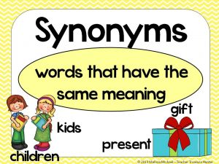
Direct Speech Challenge

1. How many other words can you think of that you could use instead of the word said. Write down at least eight other words for said.
2. For each of the eight words that you came up with, write a sentence with direct speech that uses that word.

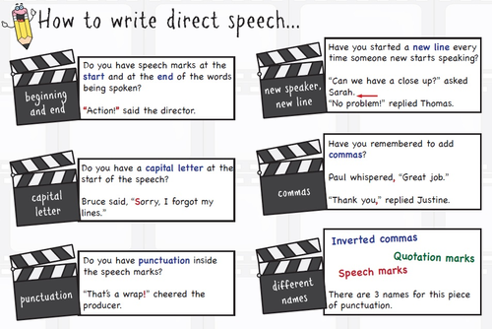

Area and Perimeter
Success criteria
- Design/draw a house floorplan
- Draw each room
- Label each room
- Calculate area and perimeter of each room
- Use correct units of measurements e.g. m or m²

Scale
1cm = 1m so 10cm =10m or 15cm = 15m
Learning Intention
I can calculate the area and perimeter of my floorplan.

Using your knowledge of area and perimeter design a house floor plan. Use a ruler to draw straight lines and measure carefully.
A floorplan is a visual representation of what a house will look like from above.
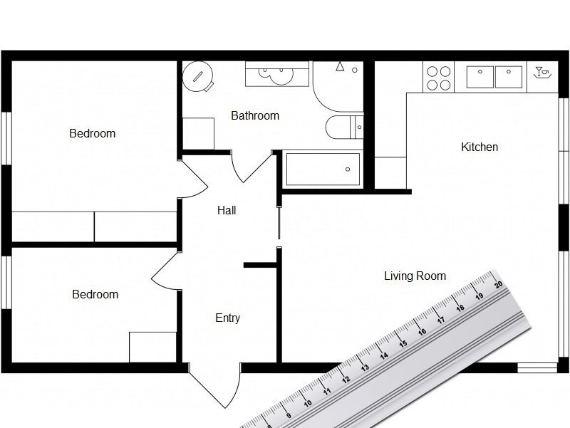

Your floorplan must have at least 7 rooms-
- Living room
- Kitchen
- Master bedroom
- Another bedroom
- Bathroom
- Two other rooms of your choice

Draw your floorplan and then calculate the area and perimeter of each room.
Perimeter = Add all sides
Area = L X B

Here is an example of a completed floorplan that Ewan made. Hope this helps.

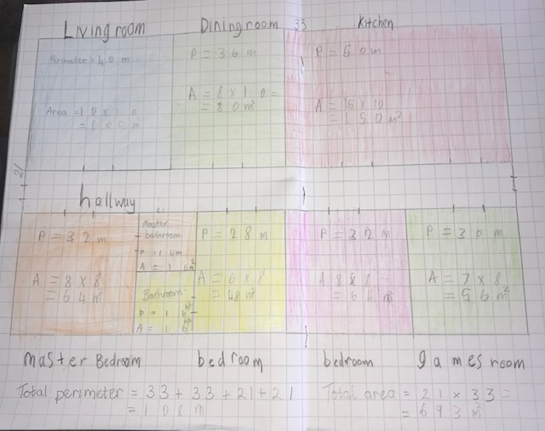

Magimixer

Learning intention:
I can use the four operations to reach a target number, using a set of given numbers.

Success criteria:
- Use the four operations to reach the target number (+ - x ÷).
- Use the six numbers given.
- Only use each of the six numbers once.
- Show your workings.

Can you reach our target number using all operations and all given numbers?

Target number is

The numbers you can use are

The Weather
Learning intention:
I can apply my knowledge of my class weather topic, to complete a range of learning tasks.
Success criteria:
- Select at least 1 task of your choosing from the weather activities grid below.
- Post your work in the ‘assignment’ section of My Teams.

Write an imaginative story about a storm. Think of your setting and include lots of figurative language.  e.g. the rain hammered on the widows; lightening flashed in the dark, grey sky; thunder roared like an angry lion. | You have been collecting weather information each day. Take this information and display it as a graph (line or bar). You could use the daily temperature over the last week and daily rainfall from information you gather from your rain gauge.
Weather forecast -  Write a weather forecast and film yourself presenting it. Make a weather map, weather symbols and have some fun. | Write an information report about extreme weather. Research extreme weather and write a report about it.  e.g. hurricanes, tornadoes etc
Sunshine – design and make a poster about how to stay safe in the sun. | Make a picture that shows how a scene can change throughout our four seasons.

