[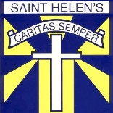](https://www.google.co.uk/url?sa=i&url=http%3A%2F%2Fwww.kitmykid.co.uk%2FSt-Helens-Cumbernauld%2F&psig=AOvVaw3ZkgHlqSaISiO3_QI8FvE4&ust=1585218082517000&source=images&cd=vfe&ved=0CAIQjRxqFwoTCMD219eztegCFQAAAAAdAAAAABAD) **Primary 6/Miss O’Toole – Home Learning 28th of May** [](https://www.google.co.uk/url?sa=i&url=http%3A%2F%2Fwww.kitmykid.co.uk%2FSt-Helens-Cumbernauld%2F&psig=AOvVaw3ZkgHlqSaISiO3_QI8FvE4&ust=1585218082517000&source=images&cd=vfe&ved=0CAIQjRxqFwoTCMD219eztegCFQAAAAAdAAAAABAD)

*Every Tuesday and Thursday (before 10am) I will be posting home learning tasks for you to work through. New spelling words will be posted every* ***Tuesday****.*

**Reading Tasks**

|  |  |  |  |
| --- | --- | --- | --- |
| **Red Group** | **Blue Group** | **Green Group** | **Orange Group** |
| ***LI: To create a visualisation of a given character.***  **TASK**  Read chapters 3 and 4 of ‘**Storm Chasers’** (Oxford Owl – link below). Create a visualisation of Max. Remember to use evidence from the text.  **Oxford Owl Login**  **Username**:sthelensp6  **Password:** school  **Success Criteria:**  [Image result for star emoji](https://www.google.co.uk/url?sa=i&url=https%3A%2F%2Fwww.iemoji.com%2Fview%2Femoji%2F45%2Fanimals-nature%2Fglowing-star&psig=AOvVaw06GYxWwJ3AvNliwBAuGC65&ust=1585218982355000&source=images&cd=vfe&ved=0CAIQjRxqFwoTCLDI0YS3tegCFQAAAAAdAAAAABAD) *Use descriptive language to describe Max.*  [Image result for star emoji](https://www.google.co.uk/url?sa=i&url=https%3A%2F%2Fwww.iemoji.com%2Fview%2Femoji%2F45%2Fanimals-nature%2Fglowing-star&psig=AOvVaw06GYxWwJ3AvNliwBAuGC65&ust=1585218982355000&source=images&cd=vfe&ved=0CAIQjRxqFwoTCLDI0YS3tegCFQAAAAAdAAAAABAD) *Use evidence from the text.* | ***LI: To use evidence from the text to state what the author infers.***  **TASK**  Read chapters 3 and 4 of **‘Black Beauty’**  (Oxford Owl – link below). Complete inference task (see end of home learning grid).  **Oxford Owl Login**  **Username**:sthelensp6  **Password:** school  **Success Criteria:**  [Image result for star emoji](https://www.google.co.uk/url?sa=i&url=https%3A%2F%2Fwww.iemoji.com%2Fview%2Femoji%2F45%2Fanimals-nature%2Fglowing-star&psig=AOvVaw06GYxWwJ3AvNliwBAuGC65&ust=1585218982355000&source=images&cd=vfe&ved=0CAIQjRxqFwoTCLDI0YS3tegCFQAAAAAdAAAAABAD) *Refer closely to the text.*  [Image result for star emoji](https://www.google.co.uk/url?sa=i&url=https%3A%2F%2Fwww.iemoji.com%2Fview%2Femoji%2F45%2Fanimals-nature%2Fglowing-star&psig=AOvVaw06GYxWwJ3AvNliwBAuGC65&ust=1585218982355000&source=images&cd=vfe&ved=0CAIQjRxqFwoTCLDI0YS3tegCFQAAAAAdAAAAABAD)*Write in full sentences.* | ***LI: To identify the main events within a given chapter.***  **TASK**  Listen to chapter 20 of ‘**Kid Normal’** story (audio version – link below). Complete the comic strip activity.  **Success Criteria:**  [Image result for star emoji](https://www.google.co.uk/url?sa=i&url=https%3A%2F%2Fwww.iemoji.com%2Fview%2Femoji%2F45%2Fanimals-nature%2Fglowing-star&psig=AOvVaw06GYxWwJ3AvNliwBAuGC65&ust=1585218982355000&source=images&cd=vfe&ved=0CAIQjRxqFwoTCLDI0YS3tegCFQAAAAAdAAAAABAD)Highlight the main events within the chapter.  [Image result for star emoji](https://www.google.co.uk/url?sa=i&url=https%3A%2F%2Fwww.iemoji.com%2Fview%2Femoji%2F45%2Fanimals-nature%2Fglowing-star&psig=AOvVaw06GYxWwJ3AvNliwBAuGC65&ust=1585218982355000&source=images&cd=vfe&ved=0CAIQjRxqFwoTCLDI0YS3tegCFQAAAAAdAAAAABAD)Illustrate the events by drawing pictures and writing in full sentences. | ***LI: To predict what my story is about.***  **TASK**  Access **‘Sport Then and Now’** (Oxford Owl – link below). Before reading, predict what you think this book is about. Next, read p1-20.  **Oxford Owl Login**  **Username**:sthelensp6  **Password:** school  **Success Criteria:**  [Image result for star emoji](https://www.google.co.uk/url?sa=i&url=https%3A%2F%2Fwww.iemoji.com%2Fview%2Femoji%2F45%2Fanimals-nature%2Fglowing-star&psig=AOvVaw06GYxWwJ3AvNliwBAuGC65&ust=1585218982355000&source=images&cd=vfe&ved=0CAIQjRxqFwoTCLDI0YS3tegCFQAAAAAdAAAAABAD)*Use evidence from the title, front cover and blurb to make an informed prediction.*  *[Image result for star emoji](https://www.google.co.uk/url?sa=i&url=https%3A%2F%2Fwww.iemoji.com%2Fview%2Femoji%2F45%2Fanimals-nature%2Fglowing-star&psig=AOvVaw06GYxWwJ3AvNliwBAuGC65&ust=1585218982355000&source=images&cd=vfe&ved=0CAIQjRxqFwoTCLDI0YS3tegCFQAAAAAdAAAAABAD)Write in full sentences.* |

**Link to Clips:**

**Red Group** <https://www.oxfordowl.co.uk/api/digital_books/1386.html>

**Blue Group** <https://www.oxfordowl.co.uk/api/digital_books/1336.html>

**Green Group** <https://stories.audible.com/pdp/B07533YSBN?ref=adbl_ent_anon_ds_pdp_pc_cntr-1-1>

**Orange Group** [**https://www.oxfordowl.co.uk/api/interactives/26584.html**](https://www.oxfordowl.co.uk/api/interactives/26584.html)

**Spelling Tasks**

LI: To spell my weekly words correctly.

*Spelling words can be found on Tuesday’s home learning grid.*

Task 1 – Spelling Check-Up

Ask an adult to read out your spelling words whilst you write them down for a ‘mini check-up’ (just like we do on Fridays in class). This will give you an idea of the words that you may need to practise more.

[](https://www.google.co.uk/url?sa=i&url=http%3A%2F%2Fclipart-library.com%2Ftest-cliparts.html&psig=AOvVaw3vCMzTjRqoDMGIcc6fdfCw&ust=1587471103883000&source=images&cd=vfe&ved=0CAIQjRxqFwoTCKD2v-v89ugCFQAAAAAdAAAAABAD)

Task 2 – Spelling Grid

Choose a spelling activity from the grid below:

[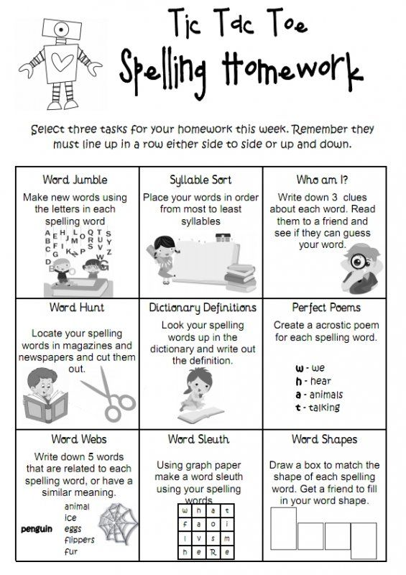](https://www.google.co.uk/url?sa=i&url=https%3A%2F%2Fwww.pinterest.at%2Fpin%2F399694535661532364%2F&psig=AOvVaw38K4uIcDqu0wScpuKu1YyX&ust=1588156964388000&source=images&cd=vfe&ved=0CAIQjRxqFwoTCPivtfD3iukCFQAAAAAdAAAAABAD)

Writing Task – Fairy Tale Planning Task

LI: *To develop a plan for my own fairy tale story.*

[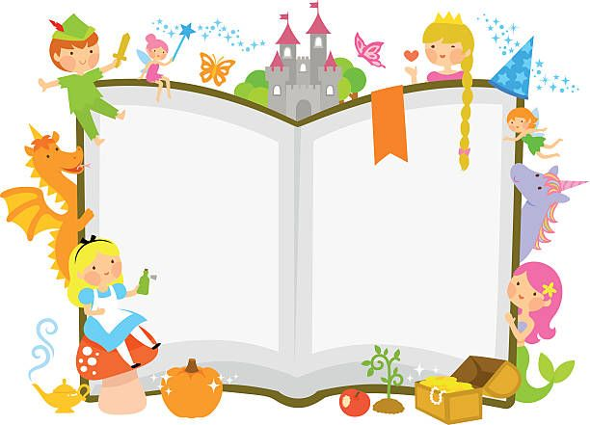](https://www.google.co.uk/url?sa=i&url=https%3A%2F%2Fwww.pinterest.co.uk%2Fpin%2F308778118202730365%2F&psig=AOvVaw3zuq3PS3BJrSlNVhBKthRW&ust=1590578687985000&source=images&cd=vfe&ved=0CAIQjRxqFwoTCMivt7210ekCFQAAAAAdAAAAABAD)TASK:

As many of you will remember, we had planned to write our very own fairy tales to give to our buddies next year. Over the next few weeks, you will be beginning to create your story. You will be given the opportunity to create your very own fairy tale OR rewrite a fairy tale that you remember from your childhood.

* Watch the Cinderella clip at <https://www.youtube.com/watch?v=DQSTlR7LtAE>

**OR**

* Watch the Three Billy Goats Gruff clip at <https://www.youtube.com/watch?v=9JXPPi2Piaw>

Consider the following questions:

What is the problem that they are solving?

What do I see that tells me this is a fairy tale?

Who is the villain?

[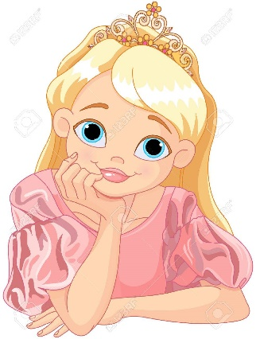](https://www.google.co.uk/url?sa=i&url=https%3A%2F%2Fwww.123rf.com%2Fphoto_40321882_stock-vector-illustration-of-beautiful-princess-are-thinking.html&psig=AOvVaw0nN5iTIgR6HbCHE9tcG7Cq&ust=1590578956507000&source=images&cd=vfe&ved=0CAIQjRxqFwoTCPi3lMO20ekCFQAAAAAdAAAAABAD)

What is easy to understand

about the tone used in this fairy tale?

What is the fairy tale trying to teach me? Is there a deeper message?

Getting Started:

Begin brainstorming ideas for each of the following headings:

* Characters

Choose/create around 3 characters. Think about how they will look/act. Typical fairy tales include a villain and a hero. Consider this when character creating.

* Problem

What is the problem for the characters in the story?

* Solution

How is the problem fixed?

* Basic plot

What are the main events? Keep it simple!

Remember… Fairy tales should include short sentences, simple words and illustrations. Keep this in mind when planning your plot.

[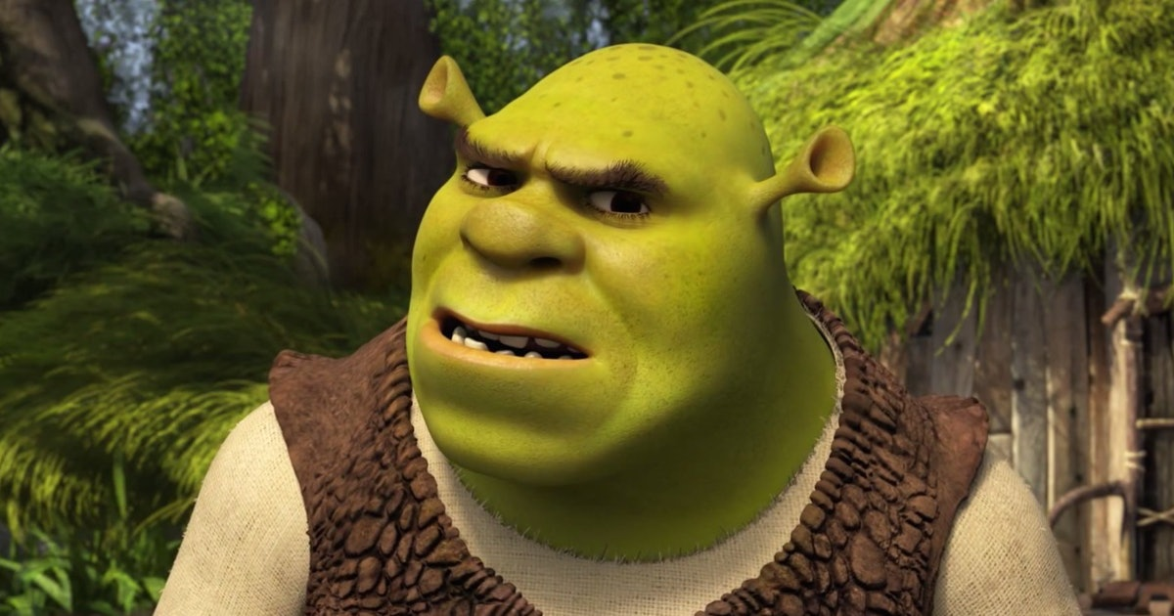](https://www.google.co.uk/url?sa=i&url=https%3A%2F%2Fwww.bustle.com%2Farticles%2F160924-5-actors-almost-cast-in-shrek-because-mike-myers-wasnt-supposed-to-voice-the-ogre&psig=AOvVaw0HVqyuC5NfFNTryFrD7llG&ust=1590579470773000&source=images&cd=vfe&ved=0CAIQjRxqFwoTCNiBjbS40ekCFQAAAAAdAAAAABAD)

**Numeracy Tasks**

**1) Mental Starter:** Set your timer for 2 minutes. Start counting backwards in 2’s from 100. (For example… 100, 98, 96…). Can you ‘beat the timer’ and get to 0 in 2 minutes?

|  |  |  |  |
| --- | --- | --- | --- |
| **Red Group** | **Blue Group** | **Green Group** | **Orange Group** |
| ***LI: To identify lines of symmetry.***  **TASK**  Complete the red symmetry flag task. Reminder: The video clip below will help recap your knowledge of lines of symmetry.    **Success Criteria:**  [Image result for star emoji](https://www.google.co.uk/url?sa=i&url=https%3A%2F%2Fwww.iemoji.com%2Fview%2Femoji%2F45%2Fanimals-nature%2Fglowing-star&psig=AOvVaw06GYxWwJ3AvNliwBAuGC65&ust=1585218982355000&source=images&cd=vfe&ved=0CAIQjRxqFwoTCLDI0YS3tegCFQAAAAAdAAAAABAD)*Note all lines of symmetry within the given flags.* | ***LI: To identify lines of symmetry.***  **TASK**  Complete the red symmetry flag task. Reminder: The video clip below will help recap your knowledge of lines of symmetry.  **Success Criteria:**  [Image result for star emoji](https://www.google.co.uk/url?sa=i&url=https%3A%2F%2Fwww.iemoji.com%2Fview%2Femoji%2F45%2Fanimals-nature%2Fglowing-star&psig=AOvVaw06GYxWwJ3AvNliwBAuGC65&ust=1585218982355000&source=images&cd=vfe&ved=0CAIQjRxqFwoTCLDI0YS3tegCFQAAAAAdAAAAABAD)*Identify flags with more than 1 line of symmetry.* | ***LI: To revise my knowledge of 2D/3D shapes.***  **TASK**  Complete the assigned shape task on Sumdog. This is tailored to your specific group.  **Success Criteria:**  *Identify given 2D/3D shapes.*  *[Image result for star emoji](https://www.google.co.uk/url?sa=i&url=https%3A%2F%2Fwww.iemoji.com%2Fview%2Femoji%2F45%2Fanimals-nature%2Fglowing-star&psig=AOvVaw06GYxWwJ3AvNliwBAuGC65&ust=1585218982355000&source=images&cd=vfe&ved=0CAIQjRxqFwoTCLDI0YS3tegCFQAAAAAdAAAAABAD)Identify the properties of 3D shapes.* | ***LI: To revise my knowledge of 2D/3D shapes.***  **TASK**  Complete the assigned shape task on Sumdog. This is tailored to your specific group.  **Success Criteria:**  [Image result for star emoji](https://www.google.co.uk/url?sa=i&url=https%3A%2F%2Fwww.iemoji.com%2Fview%2Femoji%2F45%2Fanimals-nature%2Fglowing-star&psig=AOvVaw06GYxWwJ3AvNliwBAuGC65&ust=1585218982355000&source=images&cd=vfe&ved=0CAIQjRxqFwoTCLDI0YS3tegCFQAAAAAdAAAAABAD)*Identify given 2D/3D shapes.*  *[Image result for star emoji](https://www.google.co.uk/url?sa=i&url=https%3A%2F%2Fwww.iemoji.com%2Fview%2Femoji%2F45%2Fanimals-nature%2Fglowing-star&psig=AOvVaw06GYxWwJ3AvNliwBAuGC65&ust=1585218982355000&source=images&cd=vfe&ved=0CAIQjRxqFwoTCLDI0YS3tegCFQAAAAAdAAAAABAD)Identify the properties of simple 3D shapes.* |

**2) Main Tasks:**

**Video Clips:**

Red and blue groups ‘Symmetry’ clip: <https://www.youtube.com/watch?v=MW0kDNHS6lo>

Blue Group – Reading Inference Reading Task

LI: To use evidence from the text to state what the author infers.

[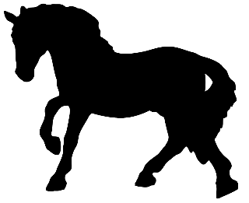](https://www.google.co.uk/url?sa=i&url=https%3A%2F%2Fwww.pinterest.com%2Fpin%2F268808671486097724%2F&psig=AOvVaw19s27alSSquKlR2oQxaLOs&ust=1590576935044000&source=images&cd=vfe&ved=0CAIQjRxqFwoTCOjejfqu0ekCFQAAAAAdAAAAABAD)

Answer the following questions from chapter 4:

1. Why do you think that Black Beauty felt better when James appeared?
2. How do you think Black Beauty and the others felt when they were rescued?
3. What do you think will happen in the next chapter? Use evidence from the text to support your answers.

*Below are some sentence starters that will help you ensure that you are using evidence from the text:*

[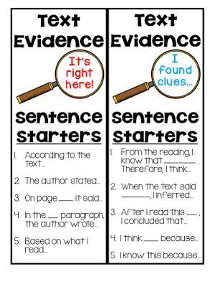](https://www.google.co.uk/url?sa=i&url=https%3A%2F%2Fwww.pinterest.com%2Fpin%2F523402787928532767%2F&psig=AOvVaw0aebYWTtW0uAI8qFxuEfnF&ust=1590576960507000&source=images&cd=vfe&ved=0CAIQjRxqFwoTCLiNs4av0ekCFQAAAAAdAAAAABAD)

IDL Task

[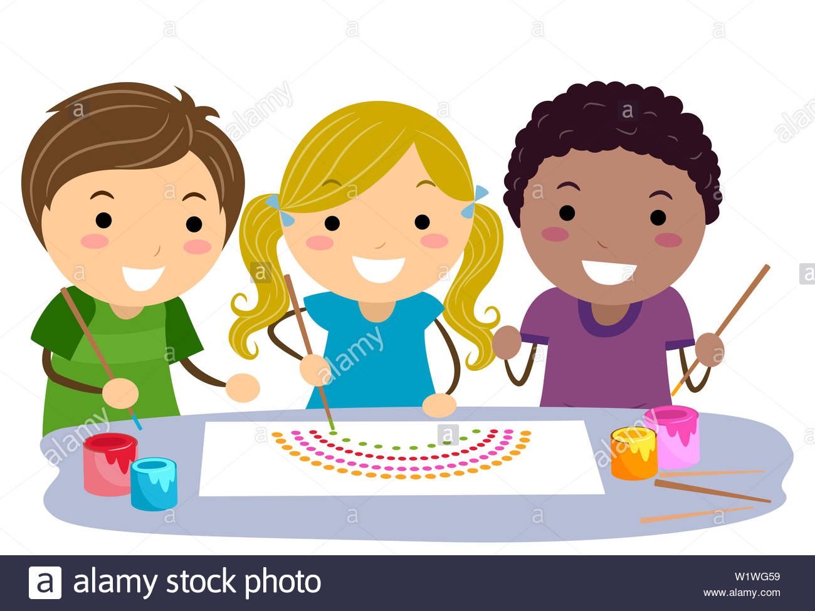](https://www.google.co.uk/url?sa=i&url=https%3A%2F%2Fwww.alamy.com%2Fillustration-of-stickman-kids-making-a-rainbow-dots-using-sticks-and-paint-to-create-australian-native-art-image259331669.html&psig=AOvVaw0n5TI3v-jb1WbA5eMwUnvK&ust=1590661686654000&source=images&cd=vfe&ved=0CAIQjRxqFwoTCOj1tNnq0-kCFQAAAAAdAAAAABAD)

**Designing a Website**

LI: To create a plan for a website design.

*As part of our Scottish Inventors topic, we have been learning about many different inventions. Like the telephone, the internet has played a huge part in connecting the world. Your task today is to begin designing your own website.*

1. What could your website be about? What are you interested in?
2. What sort of pages and features could you use on your site to make it interesting to use?
3. What does it do? *For Example: Sell things, help people, provide information or even connect people?*
4. Research some of your favourite websites. What makes them so great? Are there any ideas you could for your website?

[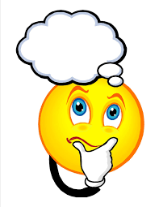](https://www.google.co.uk/url?sa=i&url=https%3A%2F%2Fclipartix.com%2Fthinking-clipart%2F&psig=AOvVaw1RGyvBrkpNe84a8zSA1XaL&ust=1590662171565000&source=images&cd=vfe&ved=0CAIQjRxqFwoTCNDf9MHs0-kCFQAAAAAdAAAAABAD)

You will be designing your own logo

and motto. Start to have a think of how you want your logo to look!

**Next Week…**