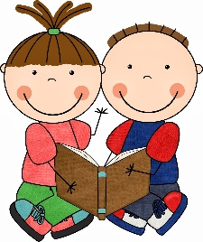
Reading
Reading materials can be accessed at www.oxfordowl.co.uk
Username: sthelensprimary2
Password: luna
Click on ‘my bookshelf’ and then search the title of your groups reading book (see below)
You can listen to the audio version of the story first then try reading it on your own! Remember to use the pictures as clues to help you.
After you have read the story, have a go at the tasks at the top of the eBook page.
Red: Spread the word (Level 9 Gold)
Orange: Bin goblins (Level 7 Turquoise)
Blue: Project X Alien Adventures - The parachute (Level 5 Green)
Green: Project X Alien Adventures – On Nok’s Trail (Level 3 Yellow)
Yellow: Project X Alien Adventures: Max’s Rocket (Level 1+ Pink)
Try reading the same story again another day for extra practice.
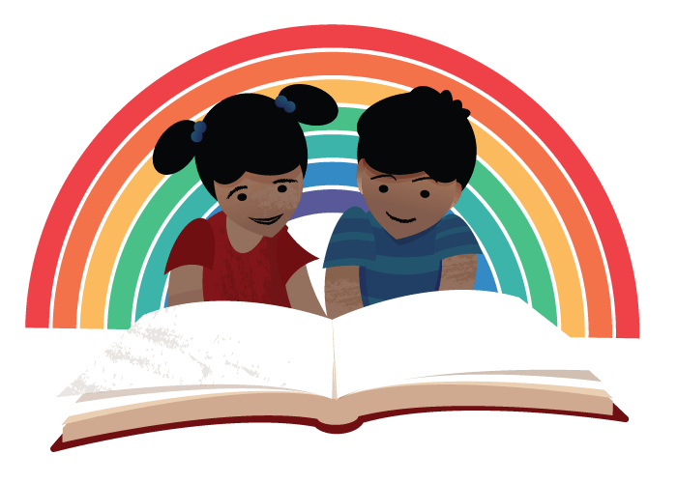
Success criteria*:
- Read common words correctly
- Sound out tricky words
- Use picture clues to help with tricky words

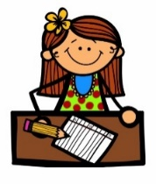
Literacy
Writing - News
Write about your time at home during ‘lockdown.’
You might chose to write about your best day, your favourite things to do at home, your new routine or compare home learning to school learning.

Remember when we write, it’s important to think about our core targets:
- Write on the line
- Finger spaces
- Capital letters
- Full stops
- Check common words
- Read over writing

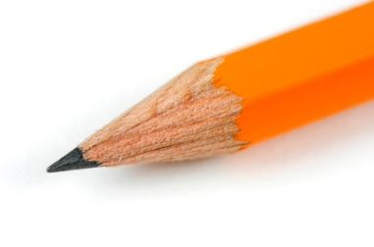
Handwriting
Children should complete handwriting activities at their own pace throughout the week.
See letter formation handwriting practice sheet Week 3
Learning intention: form each letter correctly.
Success criteria*:
- Trace letter in the air.
- Trace letter using pencil.
- Form each letter carefully and slowly.

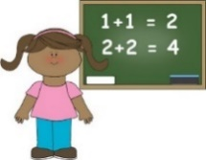
Numeracy and Maths
Squares | Triangles | Circles
Warm up: Daily 10 https://www.topmarks.co.uk/maths-games/daily10
Choose a task to practise independently using the drop down tabs at the top. Remember to challenge yourself.
Mental maths:  20 + 20 + 2 + 2 =  20 + 50 + 50 =  10 + 20 + 5 + 5 =  20 + 20 + 20 + 10 =  50 + 50 + 5 + 5 =  20 + 20 + 50 + 50 =  50 + 5 + 2 + 2 =  50 + 50 + 20 + 5 + 5 =  50 + 20 + 1 + 20 + 2 + 2 = | Mental maths:  5 + 2 + 1 =  5 + 2 + 1 + 1 =  5 + 5 + 2 + 1=  20 + 10 + 2 =  20 + 20 + 2 =  50 + 20 + 2 + 1 = | Mental maths:  1 + 2 =  2 + 5 =  1 + 10 =  2 + 1 + 1 =  1 + 2 + 1 =  2 + 2 + 5 =
Main learning:  LI: I can calculate change  SC:  - Read price tags  - Identify coins  - Add coins correctly  - Subtract from amount or count on to calculate change required  - Tick yes or no | Main learning:  LI: I can calculate change from 50p  SC:  - Read price tags  - Identify coins  - Add coins correctly  - Subtract from amount or count on to calculate change required  - Tick yes or no | Main learning:  LI: I can calculate change from 20p  SC:  - Read price tags  - Identify coins required to pay  - Add coins left over to calculate change
Pencil task(s):  - Check your change worksheet (mixed) | Pencil task(s):  - Check your change from 50p Worksheet | Pencil task(s):  - Calculating change from 20p Worksheet.
When you have completed each task self-assess your learning.
Purple: I understand my learning, could share/explain it to others, and apply it in other contexts. I can complete tasks independently.
Green: I understand my learning and could share/explain it to others. I can complete tasks independently.
Amber: I need some support to understanding my new learning. I will become more confident with practice.
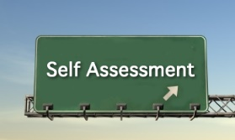
Red: I need support to understand my new learning. I would like to practise more and in different ways.

IDL
Religious Education
In our final week of May we honour Mary by creating a picture of her.
Think about what you have learned about Mary? What do you associate with Mary? (Colours, flowers, people) Could you include these things in your picture?
Are you going to look at different art pieces of Mary online and choose one to inspire you?
What materials will you need to make your picture? (Paint, pencils, pastels…)
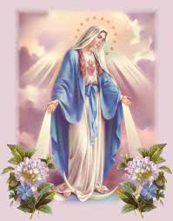
This would make a lovely addition to your May Altar at home.
Learning intention:
- I can create my own picture of Mary.
Success criteria*:
- Use pictures to inspire you (online)
- Think about statues/paintings from your Church.
- What colours will you use?
- Will you include anything/anyone else in the picture?

