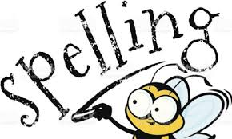
Spelling
Learning intention:
I can use spelling strategies to learn my spelling words.
Success criteria:
- Review your group’s spelling words in the grid below.
- Open and complete your group’s spelling activities worksheet using the links below.
- Post evidence of your work in the ‘assignment’ section of Teams.

Red Group  (prefix - anti) | Blue Group  (prefix - anti) | Green Group  (sh phoneme)  Representations: sh, ti, ch | Yellow Group  (ie – long /ee/ sound)
antiseptic  anticlockwise  antiaircraft  anti-climax  antisocial  antifreeze  antibiotic  antibacterial  antiviral  antidote  antihistamine  antibody | antiseptic  anticlockwise  anti-climax  antisocial  antifreeze  antibiotic  antibacterial  antiviral  antidote  antibody | shoulder  shriek  shuffle  station  option  rational  relation  brochure  chic  chiffon | brief  chief  thief  thieve  grief  grieve  priest  shield  field  shriek

Red group
https://blogs.glowscotland.org.uk/nl/public/sthelens/uploads/sites/29690/2020/05/21114015/Red-group-spelling-activities.docx

Blue group
https://blogs.glowscotland.org.uk/nl/public/sthelens/uploads/sites/29690/2020/05/21114021/Blue-group-spelling-activities.docx

Green group
https://blogs.glowscotland.org.uk/nl/public/sthelens/uploads/sites/29690/2020/05/21114028/Green-group-spelling-activities.docx

Yellow group
https://blogs.glowscotland.org.uk/nl/public/sthelens/uploads/sites/29690/2020/05/21114034/Yellow-group-spelling-activities.docx

Spelling challenge!

Pasta Spelling

Make your spelling words with pasta. Remember to post evidence of your challenge in Teams!

Comprehension Questions
Learning intention: I can answer literal and inferential questions about a passage.
Success criteria:
- Read the full passage for your group.
- Answer all the questions fully.
- Answer in full sentences, rewording the question.
- Use evidence from the passage to help you answer each question.
- Check your answers against the answer sheet.

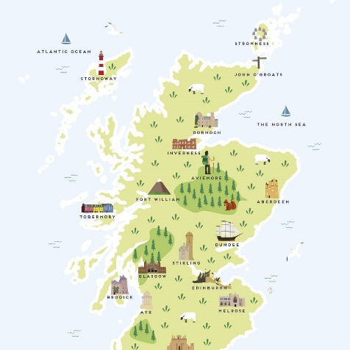
Red group - ***
Blue group - **
Green group - *

Passage & comprehension questions
https://blogs.glowscotland.org.uk/nl/public/sthelens/uploads/sites/29690/2020/05/21115533/cfe2-g-88-scotlands-landscape-differentiated-reading-comprehension-activity_ver_3.pdf

Challenge!
Draw your own map of Scotland. Label key areas, mountains,
rivers and points of interest. Use your knowledge from the comprehension passage to help you.

Number Talks
Addition/Subtraction/Multiplication Strategies
LI- I can use the NT strategies to calculate addition, subtraction and multiplication sums.
Success Criteria
- Choose your chilli challenge.
- Use a strategy for each sum.
- Show your workings.
- Check your answers with a calculator.

Addition Strategies
- Break into place value | - Compensation | - Friendly numbers
- Adding up in chunks | - Making tens | - Doubles / near doubles

Subtraction Strategies
- Break into place value | - Keeping a constant distance | - Adding up  (number line)
- Counting back | - Adjust one number to make an easier sum

Multiplication Strategies
- Friendly numbers  e.g. 2 x 99  = 2 x 100  = 200 – 2 = 198 | - Partial products  e.g. 3 x 16  = 3 x (10 + 6)  = 30 + 18 = 48 | - Doubling and halving  e.g. 4 x 9  = 2 x 18  = 1 x 36 = 36
- Breaking factors into smaller factors  e.g. 8 x 5  = 2 x 4 x5  = 2 x 20 = 40 | - Repeated addition  e.g. 4 x 9  = 9 + 9 + 9 + 9  = 36

Chilli Challenge
Mild Challenge | Medium Challenge | Hot Challenge
86 + 33 =  73 + 25 =  76 - 37 =  80 - 63 =  7 X 16 =  3 X 13 = | 345 + 267 =  727 + 547 =  858 - 375 =  434 - 293 =  39 x 4 =  26 X 5 = | 5435 + 1458 =  6449 + 3908 =  7557 - 4280 =  4570 - 3567 =  90 X 62 =  65 X 44 =

Area
Learning Intention
I can calculate the area of shapes.
Success criteria
- Watch PowerPoint
- Multiply L X B to calculate area
- Use correct unit of measurement in answer –
cm² or mm²
- Complete worksheets

- Watch this PowerPoint about calculating area.
Area PowerPoint
- Now complete these worksheets.
*** Heptagons/Red (tricky triangles – clue make them into rectangles then half your answer)
** Hexagons/Blue
*Pentagons/Green

Area worksheets
- Have some fun and play this game. This game involves using your knowledge of co-ordinates and area. Enjoy!
Area game
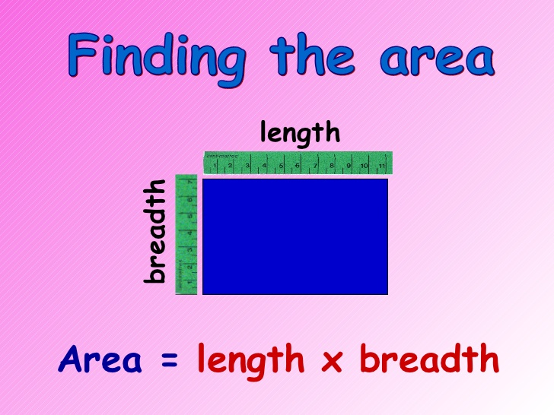

Learning about bullying
Learning intentions
- To understand how behaviour and actions make people feel isolated.
- To know about different types of bullying that exist.
Success criteria:
- Watch the antibullying PowerPoint.
- Identify feelings and behaviours associated with being alone and excluded.
- Identify and describe different types of bullying and the effect these actions have on the victim.
- Identify what you should do to help someone who is being bullied.
- Complete the antibullying activity.

Watch this PowerPoint
https://blogs.glowscotland.org.uk/nl/public/sthelens/uploads/sites/29690/2020/05/21133949/Antibullying-PowerPoint.ppt

Complete this activity
https://blogs.glowscotland.org.uk/nl/public/sthelens/uploads/sites/29690/2020/05/21133952/Antibullying-activity.pdf

Challenge!
Antibullying poster

Create your own antibullying poster.
- catchy slogan
- mentions being against bullying or pro antibullying
- eye-catching image/illustration
- colourful and nicely presented

