Writing
Write about what you did during the long holiday weekend. You should include when it was, where you went, who you were with, what you did and why you did it.
WHEN, WHERE, WHO, WHAT, WHY
You can draw a picture showing your favourite part of your holiday weekend. I have attached a template that you can use if you wish (you can edit this on the computer) or you can create your own.
*Remember to proofread your work to check it makes sense.

Learning Intention:
We are learning to write about our weekend news.

Success Criteria:
- Finger spaces
- .
- C
- abc
- sp
- Bonus point for feelings

Spelling
Learning Intention: We are learning to spell our common words and phoneme words correctly.
Success Criteria: I can:
- Sound out and spell each word correctly
- Use my words in sentences
- Self-assess my work to check if I have spelled my words correctly
Brain Boxes
Revise the following common words  old  do  going  out  now  new  one  first  little  this  that  then  with  us  so  much  of  or | Consolidation Week  wh  qu  ng | Revise the following phonemes  what  wheel  whisk  when  whiskers  why  whisper  queen  quick  quit  quiz  quack  quilt  strong  ring  bring  thing  lung  sting  string  sing

Clever Cookies
Common Words  three  room  long  tree | Phoneme  ff | Phoneme Words  off  cliff  cuff  stiff  different

Genius Gems
Common Words  Monday  Tuesday  Wednesday  Thursday  Friday | Phoneme  t (future) | Phoneme Words  future  mixture  nature  creature  capture  signature  adventure

Super Stars
oy | oi
enjoying  employment  destroyed  destroy | disjointed  choice  voice  noise  moist

Activities
Practice your common words and phoneme words in any way you wish. Some suggested ideas include:

- Rainbow writing
- Writing words 3 times
- Look, say, cover, write and check
- Writing your phoneme in a different colour e.g. phone

I have attached a copy of the spelling menu that is in your homework diary for some extra ideas.

Try to use as many of your words in sentences. This could be separate sentences, a phoneme story or a paragraph.

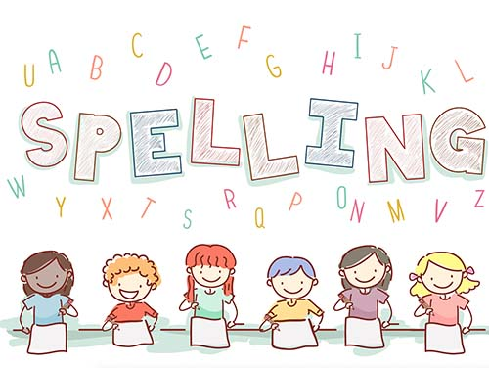

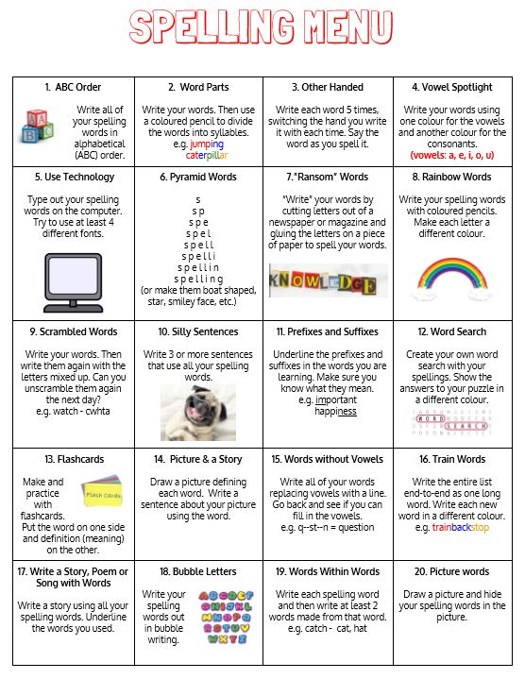

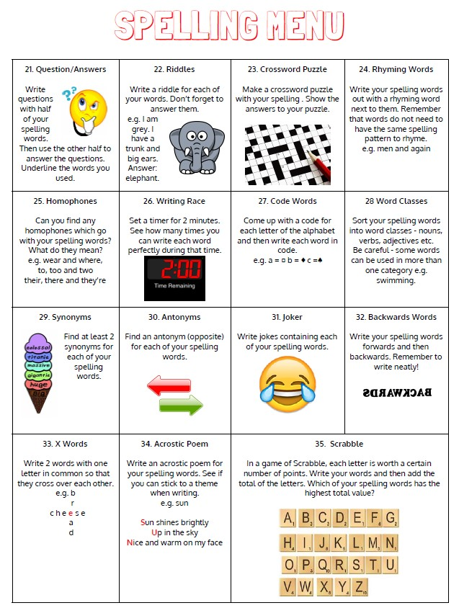

Maths
Circles | Squares | Triangles
Mental Maths  - 5 – 2 =  - 10 – 3 =  - 4 – 2 =  - 12 – 6 =  - 14 – 3 =  - 20 – 8 =  - 13 – 9 =  - 15 – 6 =  - 18 – 2 =  - 17 – 12 = | Mental Maths  - 15 – 8 =  - 25 – 7 =  - 14 – 5 =  - 30 – 20 =  - 50 – 30 =  - 17 – 9 =  - 42 – 10 =  - 35 – 20 =  - 43 – 40  - 23 – 9 = | Mental Maths  - 18 – 9 =  - 32 – 10 =  - 87 – 20 =  - 56 – 16 =  - 43 – 30 =  - 64 – 9 =  - 32 – 11 =  - 87 – 27 =  - 28 – 9 =  - 15 – 8 =
Adding amounts of money worksheet. | Adding amounts of money worksheet. | Adding amounts of money worksheet.
Here are some money games you could play to consolidate your learning.

https://www.topmarks.co.uk/money/toy-shop-money
https://www.topmarks.co.uk/money/coins-game (this one has lots of different options so you can challenge yourself lots!)
https://natwest.mymoneysense.com/students/students-5-8/coin-cruncher/
https://natwest.mymoneysense.com/students/students-5-8/the-change-game/

When you have completed each task, self-assess your learning.

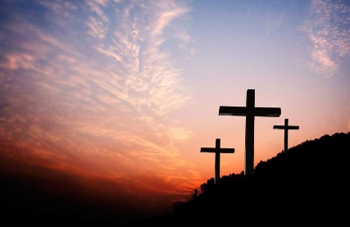
Religious Education
Learning Intention: We are learning about our responsibilities.
Success Criteria: I can:
- Explain my responsibilities when I attend Church.
- Discuss what I can do to be an active member of the Church community.

I want you to have a think about any clubs you belong to, for example:
- Tennis
- Cubs
- Brownies
- Swimming
- Dancing
Don’t worry if you are not a member of any, think about a club that someone you know attends, or you could think about an after-school club.
I want you to think about the following questions:
- How do you become a member?
- How do you know that others belong to that club?
- How do others know that you belong to that club?
- What are the rules?
- What happens if you break the rules?
Now that you have received the Sacrament of Reconciliation, you are becoming an active member of the Church community. It is a privilege and honour to be part of this community and we must take responsibility of being a member of the Church. We do this by attending Mass on Sunday, receiving the Sacrament of Reconciliation, saying our prayers and trying our hardest to live as God wants us to live.
I now want you to think about the rules we have for when we attend Mass as a class. What are they?
You are now going to complete the worksheet attached, ‘God’s Church’. On this worksheet, you will write down what your responsibilities are for being part of the Church community.
