Orange 3D Shapes Task
3D Shape | Number of Times Spotted in Environment | Names of Objects Spotted
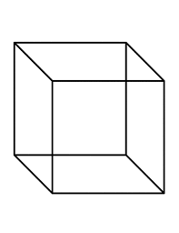

Cube

Cuboid
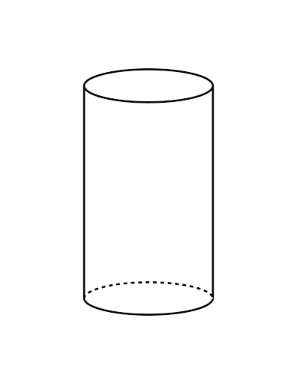

Cylinder
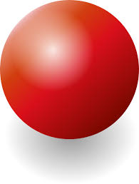

Sphere

