Reading
Reading materials can be accessed at www.oxfordowl.co.uk
Username: sthelensprimary2
Password: luna
Click on ‘my bookshelf’ and then search the title of your groups reading book (see below)
You can listen to the audio version of the story first then try reading it on your own! Remember to use the pictures as clues to help you.
After you have read the story, have a go at the tasks at the top of the eBook page.
Red: Flying Kicks. (Level 9 Gold)
Orange: Season swap (Level 7 Turquoise)
Blue: Project X Alien Adventures - Molly’s New Toy (Level 5 Green)
Green: What’s the weather like today (Level 3 Yellow)
Yellow: Project X Alien Adventures: Splat (Level 1+ Pink)
Try reading the same story again another day for extra practice.
Success criteria*:
- Read common words correctly
- Sound out tricky words
- Use picture clues to help with tricky words

Spelling
Phoneme and common words – Consolidation week
Learning intention(s):
- I can make a word web to help recall and revise my phonemes.
- I can use my phoneme makers to revise my phoneme words.
- I can recall my common words independently to complete a spell check.
Success criteria*:
- Read each phoneme and recall words with this sound in them.
- Use your spelling fingers to help you
- Take a mental picture of each word
- Ask an adult to check your words when you have finished and self-assess (S.A.)
Red/Blue  Revise ll, ss, e-e | Green  Revise ph, wh  (Revise: v, y, z, q, x)
Spill, dull, drill, allow, shallow, call, fall.  Mess, lesson, class, dress, less, moss, kiss.  These, here, eve, complete, Steve. | Phil, phone, phoneme, phonics, elephant.  What, when, wheel, whisk, whiskers, why, whisper.
Common words: father, mother, head, jump, four, miss, never, these, well, will, fell, call | Common words: old, do, going, out, now, new, one, first, little.

Tasks
- Revise phonemes using word webs.
- Revise phonemes using phonemes makers from previous weeks.
- Ask an adult to do a spell check of our common words.

Optional Challenge: Revise spelling on Sumdog Spelling Challenge.

Numeracy and Maths
Squares | Triangles | Circles
Warm up:  Counting in 2s from 0 – 150.  Counting in 5s from 0 – 200.  Counting in 10s from 100 to 250. | Warm up:  Counting in 2s from 0 – 100.  Counting in 5s from 0 – 150.  Counting in 10s from 0 to 200. | Warm up:  Count in 1s to 20 and 30.  Count in 2s to 20.  Count in 10s to 100.
*challenge yourself … can you count backwards?
Mental maths:  100 ÷ 10 =  25 ÷ 5 =  22 ÷ 2 =  40 ÷ 5 =  90 ÷ 10 =  20 ÷ 5 =  24 ÷ 2 =  80 ÷ 10 =  2 ÷ 2 = | Mental maths:  5 ÷ 5 =  15 ÷ 5 =  55 ÷ 5 =  10 ÷ 5 =  35 ÷ 5 =  40 ÷ 5 = | Mental maths:  6 + 4 =  7 + 3 =  __ + 5 = 10  __ + 0 = 10  __ + 9 = 10  __ + 8 = 10
Main learning:  LI: I can apply my knowledge of multiplication and division facts to solve problems.  SC:  - Read each sum carefully  - Recall times tables aloud  - Work forwards/backwards - read sign carefully | Main learning:  LI: I can apply my knowledge of multiplication facts to solve problems.  SC:  - Read each sum carefully  - Recall times tables aloud  - Change order when answering wheels | Main learning:  LI: (1) I can subtract within 20 using strategies of my choice  SC:  (1) Count on  (2) Count back  (3) Count the pictures and cross them off to help you.
Pencil task:  - Times Table Hunt: 2x, 3x, 5x and 10x Table  - 2, 5, 10 times table missing number worksheet. | Pencil task:  - 2, 5, 10 times table missing number worksheet.  - 2 times table Multiplication wheels worksheet. | Pencil task:  - Function machines subtraction within 20.  - Number shape subtraction to 10  - Number shape subtraction to 20
When you have completed each task self-assess your learning.
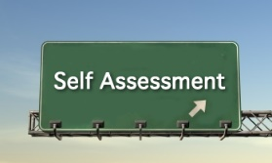
Purple: I understand my learning, could share/explain it to others, and apply it in other contexts. I can complete tasks independently.
Green: I understand my learning and could share/explain it to others. I can complete tasks independently.
Amber: I need some support to understanding my new learning. I will become more confident with practice.
Red: I need support to understand my new learning. I would like to practise more and in different ways.
IDL
Italian
Learning intention(s):
- To learn Italian vocabulary for different parts of the face.
- To learn to sing Head, shoulders, knees and toes in Italian.
Success criteria*:
- Use introduzione and ascolta to help you remember how to say/spell each word.
- Use the links below to help you to practise singing head, shoulders, knees and toes -
https://www.youtube.com/watch?v=WrfIFNaRUZw
https://www.youtube.com/watch?v=dObfqRo0Twg
To complete the activities above you need to log in to https://www.linguascope.com/
Username: sthelens Password: lomond
- Log in to Linguscope
- Select beginner and click on the Italian flag.
- Select SELF AND FAMILY ‘la mia famiglia ed io’
- Practice vocabulary and activities for clothes La faccia
- Listen to and practise singing along to Youtube clips. (see links above.)

Other
This is an optional task each week.
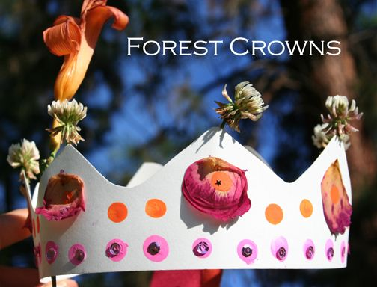
It may be in the form of a challenge or an activity to complete at home.

This week’s challenge: to create a forest/spring crown.

Use a piece of card and collect things you find outdoors (possibly on a nature walk) and stick them to your crown. Post a photo to show your friends.

