Reading
Reading materials can be accessed at:
www.oxfordowl.co.uk
Click on ‘my class login’ and enter the following:
Username: sthelensp3
Password: sthelens
Click on ‘my bookshelf’ and type in the title of your book in the ‘search bar’. Book titles are listed below.
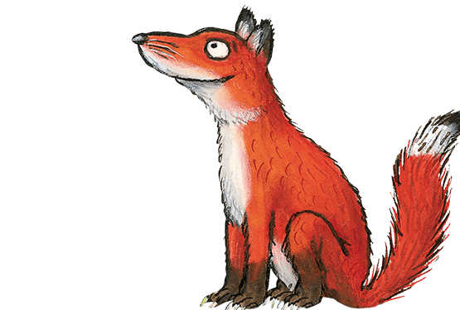

Foxes – False Alarms
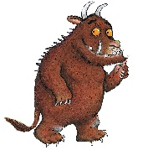

Gruffalos – Into the Pyramid
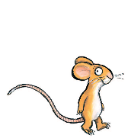

Mice – Dino Danger
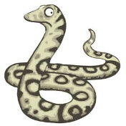

Snakes – Kipper and the Trolls
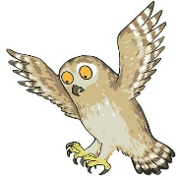

Owls – The Stinky Plant

You can listen to the audio version of the story and try reading it aloud. Once you have finished reading, try the activities that are at the top of the page.

Summarise Book
Summarise your book identifying the main points. Remember that a main point is something significant that has happened in the story, if you miss it out then the story might not make sense!

I have attached a ‘beginning, middle, end’ template that might help you lay out your book summary. There is space for you to draw a picture of the main points too.
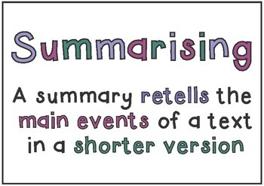
Learning Intention:
We are learning to summarise a book.
Success Criteria:
- Identify the main points from my book.
- Retell a story in my own words.

Here is something that might help you when summarising a book.
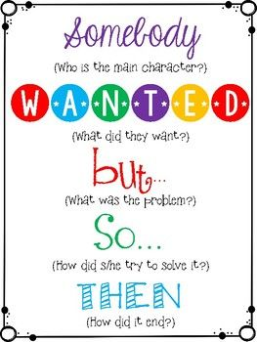

Maths
Circles | Squares | Triangles
Mental Maths  - 5 – 1 =  - 10 – 6 =  - 15 – 5 =  - 12 – 2 =  - 14 – 3 =  - 20 – 6 =  - 13 – 9 =  - 19 – 7 =  - 9 – 5 =  - 12 – 3 = | Mental Maths  - 20 – 7 =  - 24 – 9 =  - 12 – 4 =  - 32 – 6 =  - 44 – 2 =  - 39 – 9 =  - 48 – 10 =  - 50 – 30 =  - 23 – 20 =  - 36 – 10 = | Metal Maths  - 20 – 10 =  - 45 – 30 =  - 20 – 15 =  - 40 – 20 =  - 36 – 16 =  - 45 – 14 =  - 87 – 27 =  - 56 – 16 =  - 72 – 12 =  - 99 – 39 =
Coin detective worksheet. If you don’t have a printer, you could tell an adult which colours you should be colouring in each coin. Or you could use coins at home and tell an adult what each coin is. | Write down as many ways as you can, using different coins to make the following amounts:  - 3p  - 6p  - 9p  - 10p  - 17p  - 25p  - 33p  - 50p | Write down as many ways as you can, using different coins to make the following amounts:  - 12p  - 38p  - 45p  - 57p  - 68p  - £1  - £1.25  - £2
I have attached a PowerPoint for you on recognising money and paying for items to try.

Here are some money games you could play to consolidate your learning.

https://www.topmarks.co.uk/money/toy-shop-money
https://www.topmarks.co.uk/money/coins-game (this one has lots of different options so you can challenge yourself lots!)
https://natwest.mymoneysense.com/students/students-5-8/coin-cruncher/
https://natwest.mymoneysense.com/students/students-5-8/the-change-game/

COVID-19 Time Capsule
Although it may not seem like it, we are living through history just now! In the years to come, people will talk about the coronavirus and children will learn all about it in school! You will be able to tell stories about what you did during this time and what you did to keep yourself busy whilst at home. Therefore, I thought it would be nice for you to create a time capsule that would remind you of what you did. This will be something that you can keep and it will remind you of everything from this time as you will forget some things!

I have attached a time capsule booklet for you to fill out. There is no rush for this to be done and it is for you to keep so you don’t need to upload it for me to see. If there is parts of it you do want to upload then I would love to see them, but you don’t need to!

If you wanted, you could keep this in a box and add different things to it that you would like to look back on. For example, the recipe for your favourite dinner or cake, a picture of your favourite book or film, pictures of what you did throughout lockdown, some artwork that you have done, family photo, a photo of you just now, a list of your favourite games to play and a piece of string that is the same height as you!

I hope you have lots of fun doing this !

*If you cannot print this, you could fill it out on the computer or you could make your own!
