Writing

Research another animal of your choice. Remember to organise your facts under suitable headings. Think about the animals natural habitat, its characteristics and what its diet is.

L.I- I can research and take notes.

S.C- * to use research skills to search for information.

* to take short and consise notes.

* to organise your notes under suitable headings.

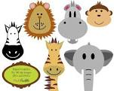

Spelling

Green/ yellow group

.I- I can choose a fun spelling task to help me spell my common words.

S.C-* correct spelling

*a suitable fun spelling task

Take a look at the spelling grid below and choose a fun spelling task.

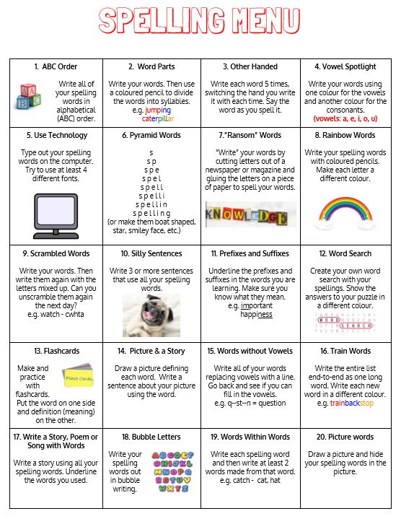

|  |  |  |  |
| --- | --- | --- | --- |
| Green | Yellow | Red | Orange |
| happy  world  lady  paper  window  floor  shoe | writing  yelled  your  yours  upon  while | Common words  Put  Different  Light  Sentence  stop  Phoneme words u  push  pull  cushion  full  bush  awful  bull | Common words  Consolidation  father  head  mother  jump  four  miss  never  these  Phoneme consolidation  e-e  ss  ll |

Reading

Green/Yellow

Please login into oxford reading owl.

Class user name: st helens p5

Password: School123

Green/Yellow – Mythical Beast and Fabulous Monsters

<https://www.oxfordowl.co.uk/api/digital_books/1336.html>

Listen to chapter 1-2 of the book again. Now try to read it by yourself or to an adult. Make a visualiser of the character Snorri. Remember to make a statement about the character. Use evidence from the book and record the page number.

L.I- I can use a visualiser to create a visual image of the character.

Snorri was a peaceful man.

‘Snorri had never been very keen on fighting.’

Pg 28

S.C-*to listen to the audio version of the book.

* to read it by yourself.

* create a visualiser about Snorri. –Statement, evidence, page number

.

Red and Orange- Dinosaur safari

<https://www.oxfordowl.co.uk/api/digital_books/1242.html>

Listen to the audio version of the story. Now try to read it by yourself. You could ask an adult or older sibling to read with you. Now complete **play activity** 2.

Choose one dinosaur from the book and make a fact file about them.

L.I- I can find and select important information from the text.

Success Criteria: *to read your book to an adult.

* to complete play activity 2.
* To create a factfile about one of the dinosaurs.

Numeracy

Each day try to practise your mental maths skills on the Topmarks -daily 10

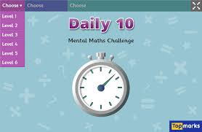

Success criteria:

* Use N.T. strategies to work out sums when required
* Answer each question
* Use the most efficient N.T. strategy

Circles/Triangles

Watch the bbc bitesize clip <https://www.bbc.co.uk/bitesize/topics/zkfycdm/articles/zcrmqty>

Try some of the tasks below the video. Then complete the converting time worksheet. This worksheet is asking you to convert between the 12 hour clock and 24 hour clock.

L.I- I can convert between the 12 hour clock and the 24 hour clock.

S.C- * to watch the video clip about the 24 hour clock.

*to complete the games below the video for practise.

* to write the time using the 12 hour clock.

*to write the time using the 24 hour clock.

Squares

Watch the video clip about 5 mins. Now complete the worksheet.

.L.I- I can write the time in five minute intervals.

S.C * to watch the video clip about 5 mins intervals.

* to apply what you have learned to complete the worksheet.

Health and well being

Listen to the song ‘Poor Unfortunate Souls.

<https://www.youtube.com/watch?v=Gi58pN8W3hY>

Now complete the task to follow.

**See sheet attached**

L.I- I can listen to the lyrics of a song and understand that each of us has a unique blend of abilities and needs.

S.C. *listen to the song on the utube link

* give your responses to the questions.

