Literacy Task:
LI: To research interesting facts about a historical figure and create parts of their autobiography.
Task:
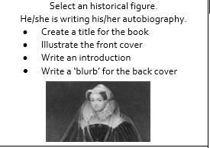
The introduction should include interesting points about the person, give as much detail as you can in your own words. You can choose to write more if you want to challenge yourself, maybe you could write the first chapter too. See the autobiography PowerPoint to help.
Possible ideas of historical figures (although you can choose your own):
- Amelia Earhart
- Agatha Christie
- Anne Frank
- Frederick Douglass
- Pelé
- Wolfgang Amadeus Mozart
Helpful websites:
https://www.brainpop.com/socialstudies/famoushistoricalfigures/
https://www.ducksters.com/biography/
https://www.bbc.co.uk/teach/famous-people/zdqdscw

