Spelling Test
Red Group  (mathematics words) | Blue Group  (mathematics words) | Green Group  (sh phoneme)  Representations: sh, ti, ch | Yellow Group  (ee)
rotation  symmetrical  triangle  triangular  vertical  volume  weight | rotation  symmetrical  triangle  triangular  vertical  volume  weight | should  shoe  shopping  nation  collection  fraction  operation  machine  chef  chalet | eel  fee  heel  leek  peel  beef  beep  beet  feet  tree
Learning intention:
I can test my knowledge of my spelling words.
Success criteria:
- Review your weekly spelling words from the list below.
- Get a family member to test your knowledge of your spelling words. They should say one word at a time, whilst you write them down.
- Mark your spelling test.
- Post your results in the ‘assignment’ section of My Teams.

Sumdog’s NLC Maths Contest
How it works
To take part, simply play Sumdog's maths games.
Scores are based on accuracy, and questions tailored to each student's level - so everyone has a fair chance.
Each contest runs from 8am local time Friday to 8pm the following Thursday - but you can play at any time during this period. The current contest will close this Thursday 21st May 2020.

Rewards for students
As a reward for taking part, each student who answers 100 questions will receive an item for their Sumdog House.
For a class to qualify for the leaderboards, at least 10 students from that class must play in the contest.

Login to Sumdog https://www.sumdog.com/user/sign_in
and get playing!
Mrs Moore’s class currently have 7 players. We need 3 more to qualify!
Mrs Campbell’s class currently have 10 players and have qualified!

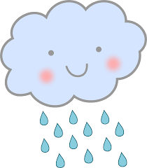
The Weather

Learning intention:
I can apply my knowledge of my class weather topic, to complete a range of learning tasks.
Success criteria:
- Select at least 1 task of your choosing from the weather activities grid below.
- Post your work in the ‘assignment’ section of My Teams.

Write an imaginative story about a storm. Think of your setting and include lots of figurative language.  e.g. the rain hammered on the widows; lightening flashed in the dark, grey sky; thunder roared like an angry lion. | You have been collecting weather information each day. Take this information and display it as a graph (line or bar). You could use the daily temperature over the last week and daily rainfall from information you gather from your rain gauge.
Weather forecast -  Write a weather forecast and film yourself presenting it. Make a weather map, weather symbols and have some fun.  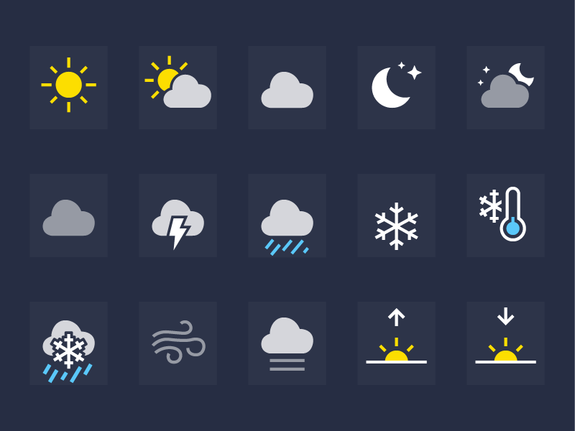 | Write an information report about extreme weather. Research extreme weather and write a report about it.  e.g. hurricanes, tornadoes etc  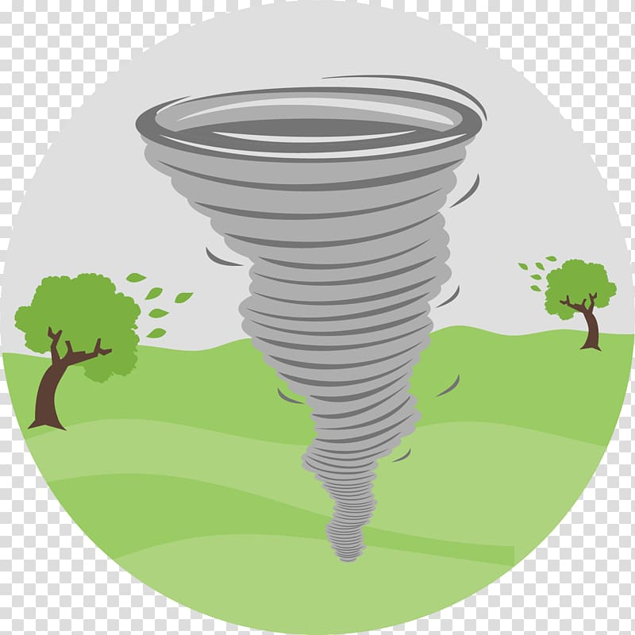
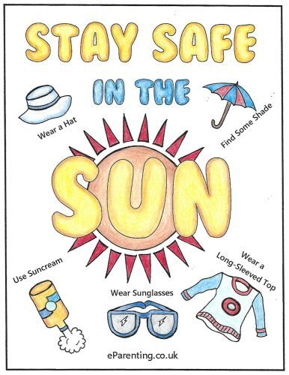  Sunshine – design and make a poster about how to stay safe in the sun. | Make a picture that shows how a scene can change throughout our four seasons.

