**3D Shape Nets**

LI: *To explore the relationship between 3D objects and their nets.*

The net of a cube has been cut into two. It could be put together in several ways so that it could be folded into a cube.

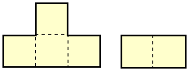

Here are the nets of 9 solid shapes. Each one of these has been cut into 2 pieces, like the net of the cube.

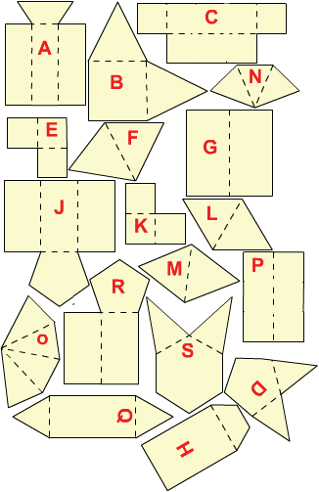

Can you see which pieces go together?

**Revision Section**

1)



2)