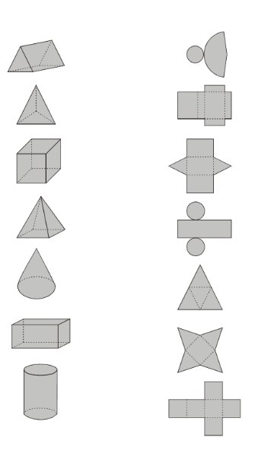
Name of shape | What shapes are the faces? | Which net?
Triangular prism | 2 triangles, 3 rectangles | C
A

B

C

D

E

F

G

Date: L.O. To identify nets of 3D shapes.

