LC: Can I find the net of a 3D shapes by using the properties?
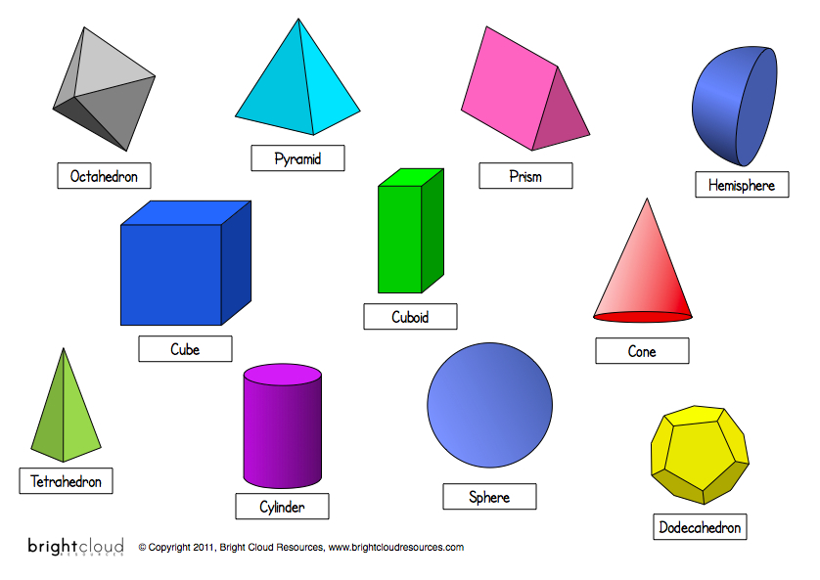
In the table below, describe the faces of each shape:
Shape name | The shape of its faces | The number of faces
Octahedron | Triangular (equilateral) | 8
Pyramid (Square based)
Triangular prism
Cylinder
Cuboid
Cube
Cone
Tetrahedron (Triangular based pyramid)
Now, using this information can you link the 3D shape with its net?
e.g
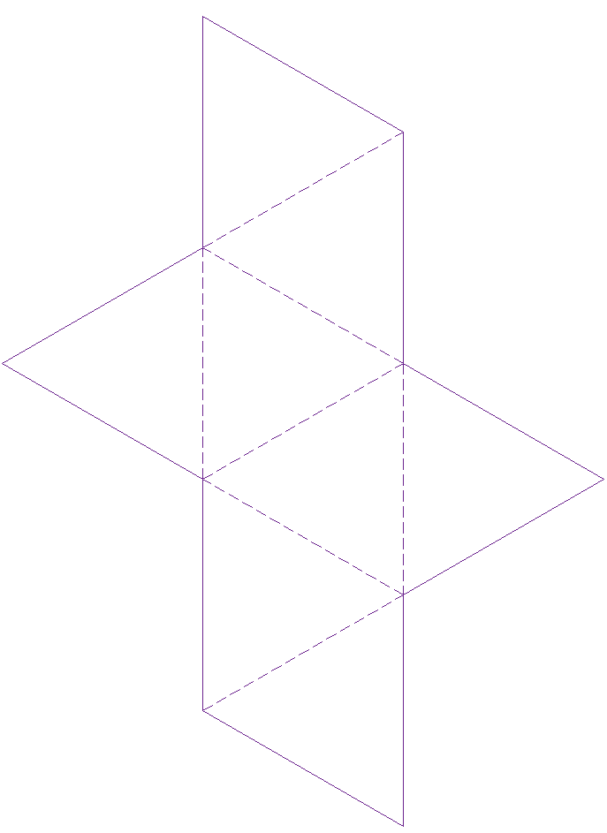The 8 faces that make up an octahedron are all equilateral triangles, so this must be the net of an octahedron.
1.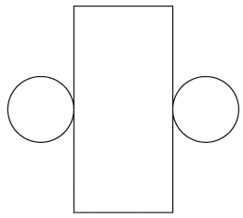 2. 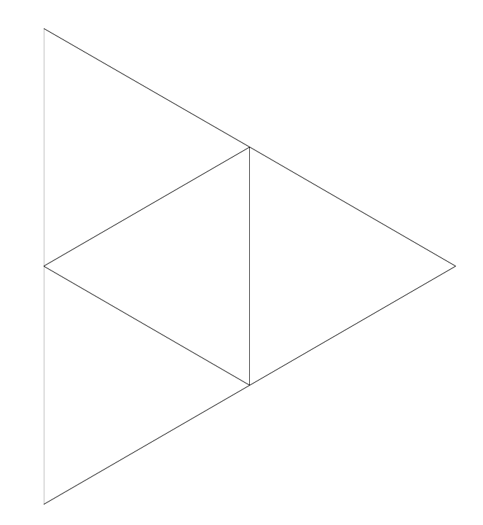

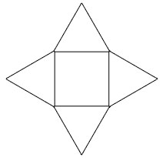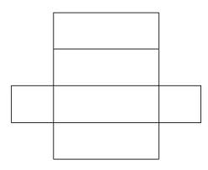
3. 4.
5.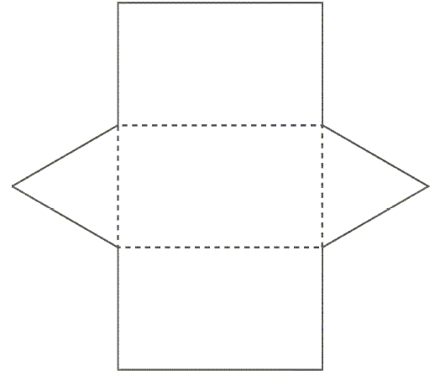 6.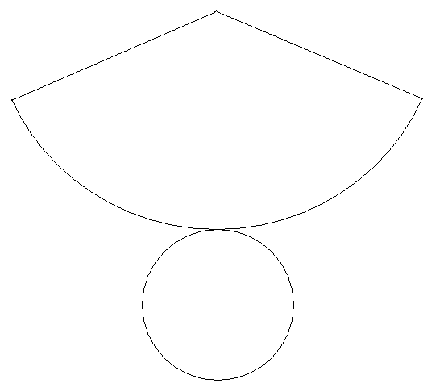

7. 