Recount Writing
LI – I can write a recount using genre targets.
Success Criteria
- Opening paragraph
- Time connectives to link paragraphs
- Past tense
- Figurative language to keep reader interested
- Conclusion

When this is all over…
Write a recount about lockdown and how you have managed to spend your time.
Remember to include your thoughts and feelings about this strange time we are experiencing.
Also include a paragraph about what you want to do when this is all over.
Self-Assessment
When you have finished writing your story highlight any good descriptions you have used and using the success criteria assess your writing.

Missing punctuation
Learning intention:
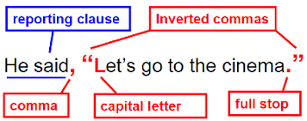
I can punctuate direct speech.
Success criteria:
- Watch the Punctuation: Introduction to speech marks video.
- Open the missing punctuation worksheet and complete the one allocated to your group.
Red group – 3 stars ***
Blue group – 2 stars **
Green group – 1 star *
- Add speech marks to the start and end of direct speech.
- Use a capital letter at the start of your direct speech, if it is a full quote and lower case if it is a partial quote.
- Use a comma to separate what is being said, from the rest of the sentence.
- End each piece of direct speech with the appropriate punctuation: full stop, question mark, explanation mark (before the direct speech).

This direct speech song might help you remember the rules for using direct speech!
https://youtu.be/j5vOsIuX8rc

Watch this video
https://youtu.be/6-YFmLctwDY

Open your worksheet

https://blogs.glowscotland.org.uk/nl/public/sthelens/uploads/sites/29690/2020/05/14144139/Missing-punctutation1.pdf

If you want some further practise, you can play this direct speech game!

https://blogs.glowscotland.org.uk/nl/public/sthelens/uploads/sites/29690/2020/05/13105529/Direct-speech-game.pdf
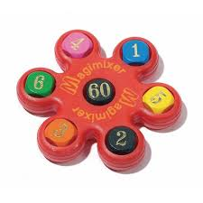
Magimixer

Learning intention:
I can use the four operations to reach a target number, using a set of given numbers.

Success criteria:
- Use the four operations to reach the target number (+ - x ÷).
- Use the six numbers given.
- Only use each of the six numbers once.
- Show your workings.

Can you reach our target number using all operations and all given numbers?

Target number is

The numbers you can use are

School timetable

Learning intention: I can identify and infer information from a timetable.
Success criteria:
- Open the timetable pdf.
- Answer the questions at the bottom of the timetable.
- Answer the questions in full sentences, giving your opinion when prompted.
- Calculate duration of periods.
- Identify what subject you are in at certain times.
- Identify what each part of the timetable means.

It won’t be long until you are starting secondary school. You will need to apply your knowledge of timetables and time skills, to navigate your way around your new school timetable. This task will help you practise and hopefully ease some of your worries about getting lost!
Timetable pdf
https://blogs.glowscotland.org.uk/nl/public/sthelens/uploads/sites/29690/2020/05/13112851/Timetable.pdf

When you are finished, you could try creating your own timetable.
https://blogs.glowscotland.org.uk/nl/public/sthelens/uploads/sites/29690/2020/05/13123530/Design-my-own-timetable.doc

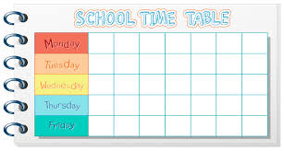

French
Success Criteria
- Revise your numbers – count aloud to your parents
- Complete worksheets
- Challenge yourself

Bonjour la classe!
Learning intention
I can say and write numbers to 20 in French.

Practise counting aloud to 20 with your parents and play the 10 game (we played this in class). Remember first to say dix loses.
French numbers to 20
French Crossword
Here is a puzzle to challenge you even more.
Puzzle
