Reading
Reading materials can be accessed at:
www.oxfordowl.co.uk
Click on ‘my class login’ and enter the following:
Username: sthelensp3
Password: sthelens
Click on ‘my bookshelf’ and type in the title of your book in the ‘search bar’. Book titles are listed below.
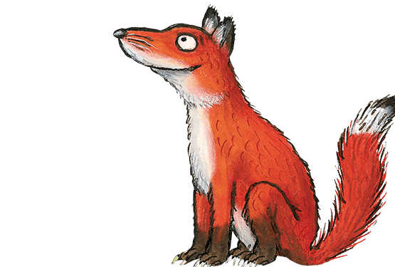

Foxes – Power Races
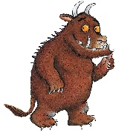

Gruffalos – Dinosaur Safari
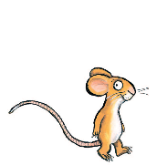

Mice – The Flying Machine
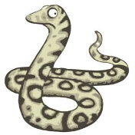

Snakes – Flying High
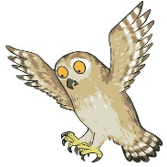

Owls – The Scarf

You can listen to the audio version of the story and try reading it aloud. Once you have finished reading, try the activities that are at the top of the page.

Book Review
Write a book review, this could be on a book you have read whilst you have been off school, or it could be on the book that I have assigned for you.

I have attached a book review template but you could also make up your own one.

Learning Intention:
We are learning to write a book review.
Success Criteria:
- Write the title, author and illustrator
- Rate the book (say whether you liked it or not)
- Re-tell your favourite part of the book
- Draw your favourite part of the book

Book Cover
Redesign the front cover of your favourite book or the book I have assigned for you. Remember to include the title, author and illustrator and make sure that the cover gives an idea of what the book will be about.
It would be great if you could upload these onto Glow for me to see if you can, or post on Twitter and tag our school @StHelensNLC.
I look forward to seeing these as this is an activity you are all fantastic at!

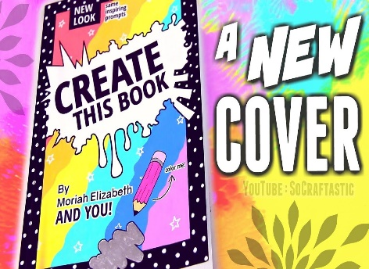
Learning Intention
We are learning to design a front cover for a book.
Success Criteria:
- Include the book title, author and illustrator
- Draw a picture related to the book

Maths
Circles | Squares | Triangles
Use daily 10 to build your confidence in mental maths.
https://www.topmarks.co.uk/maths-games/daily10
Practice counting forwards and backwards in 1s, 2s, 5s and 10s starting from any number in the sequence. | Practice counting forwards and backwards in 1s, 2s, 3s, 5s and 10s starting from any number in the sequence. | Practice counting forwards and backwards in 1s, 2s, 3s, 4s, 5s and 10s starting from any number in the sequence.
Look at the ‘2D Shape Property PowerPoint’ to remind yourself of the properties of 2D shapes.  Complete the ‘2D Shape Properties Table’ worksheet – use the PowerPoint to help you if needed. I have also attached a poster with the properties of each shape on them if required. Try your best not to use this to see how much you remember. You can use this when self-assessing your work. | Look at the ‘3D Shape Property PowerPoint’ to remind yourself of the properties of 3D shapes.  Complete the ‘3D Shape Properties Table’ worksheet – use the PowerPoint to help you if needed. I have also attached a poster with the properties of each shape on them if required. Try your best not to use this to see how much you remember. You can use this when self-assessing your work.  *Remember that vertices is the same as corners.

Restaurant
Over the next week or so, I want you to create your own restaurant at home. I want you to decide on a name for your own restaurant and you could even design a logo for it!
If possible, I want you to create a lovely table display for your restaurant (if you don’t have a table this could be on the floor in the living room, if it is sunny you could do this outside as a picnic or wherever you normally eat your dinner!) This could include nicely designed name cards for your family, brightly coloured placemats and you could even create an eye-catching menu.
I then want you to help an adult prepare a meal. This could be breakfast, lunch or dinner. I want you to write down the name of the meal you are making and write down the ingredients that you need to make it.
You are then going to serve your meal in your own specially designed restaurant!
