Primary 6/Miss O’Toole – Home Learning 14th of May
Every Tuesday and Thursday (before 10am) I will be posting home learning tasks for you to work through. New spelling words will be posted every Tuesday.
Reading Tasks
Red Group | Blue Group | Green Group | Orange Group
LI: To identify meanings of new words and language.  TASK  Read chapters 7-8 of ‘Double Exposure’ (Oxford Owl – link below). Complete the ‘Metalinguistics’ task (This can be found on the last page of the home learning grid).  Oxford Owl Login  Username:sthelensp6  Password: school  Success Criteria:  Read given chapters and understand plot.  Identify tricky words within chapter and find meaning. | LI: To evaluate the setting.  TASK  Read chapters 7-8 of ’20,000 Leagues Under the Sea’  (Oxford Owl – link below). Does the setting of the book enhance the story? Why or why not? Write in full sentences.  Oxford Owl Login  Username:sthelensp6  Password: school  Success Criteria:  Read given chapters and understand plot.  Create at least 3 sentences which state your opinion of the setting. | LI: To express my thoughts and opinions of a given chapter.  TASK  Listen to chapters 12 and 13 of ‘Kid Normal’ story (audio version – link below). Complete the ‘CSI’ task at the end of the home learning grid. Choose a colour, symbol and image that you think represents chapter 13 and explain why.  Success Criteria:  Identify a colour, symbol and image to represent chapter 13.  Create a sentence for each that explains why. | LI: To use my word attack strategies.  TASK  Read ‘Code – Dino Danger (pg14-32) (Oxford Owl – link below). Complete the ‘before’ and ‘after’ reading tasks.  Oxford Owl Login  Username:sthelensp6  Password: school  Success Criteria:  State the given words.  Highlight the blended sounds.
Link to Clips:
Red Grouphttps://www.oxfordowl.co.uk/api/digital_books/1392.html
Blue Group https://www.oxfordowl.co.uk/api/digital_books/1336.html
Green Group https://stories.audible.com/pdp/B07533YSBN?ref=adbl_ent_anon_ds_pdp_pc_cntr-1-1 Orange Group https://www.oxfordowl.co.uk/api/digital_books/1330.html

Spelling Task - OPTIONAL
LI: To spell my weekly words correctly.

Task – Spelling Check-Up
Ask an adult to read out your spelling words whilst you write them down for a ‘mini check-up’ (just like we do on Fridays in class). This will give you an idea of the words that you may need to practise more.

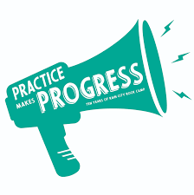

Writing Task
LI: To write a letter to your future self.
Task
Write a letter to your future self, telling them about lockdown and what it has been like for you. Remember to include thoughts and feelings and use the correct layout for a letter (see image below).
Dear______________________

Introduction – Explain why you are writing.

Paragraph 2 – Share some of the things that you have been doing.

Paragraph 3 – You may want to note the people that you miss and how lockdown compares to your normal routine before the pandemic.

Conclusion – Include one last special message for your future self. It may be a piece of advice.

Success Criteria
Use this to help evaluate your work:
Have you…
Used a letter format?
Written in full sentences and paragraphs?
Included thoughts and feelings (emotive language)?
Given examples of some activities you have carried out during lockdown?
Numeracy Tasks
1) Mental Starter: Set a timer for 1 minute. Count in groups of 2s (starting from 0). Let’s see how high your number is when the timer ends.
2) Number Talks: Try to aim to solve your chosen question within 5 minutes (use a timer). If you manage to solve the problem with time to spare, try to use a different Number Talks strategy like we do in class. See the grid below to recap your strategies.
Hot | 612 ÷ 12 =
Spicy | 462 ÷ 11 =
Mild | 81 ÷ 9 =
Number Talks Strategy Examples – Division
You may recognise some of these sums from our Maths wall. I have created this grid to recap your memory of the different division strategies we have learned in class.
Repeated Subtraction  25 ÷ 5 = 5  25  -5  20  When you reach 0, count up how many 5’s you have used to complete the sum.  -5  15  -5  10  -5  5  -5  0 | Sharing/Dealing Out  25 ÷ 5 = 5 | Multiplying Up  308 ÷ 14 = 22  10 x 14 = 140  10 x 14 = 140  2 x 14 = 28  140 + 140 + 28 = 308. When you reach the starting point in the sum, the last step is to add your circles (ie 10 + 10 + 2).
Partial Quotients  308 ÷ 14 = 22  14 308  -140 10  168  -140 10  28  -28 2  0 | Proportional Reasoning  308 ÷ 14  ÷ 7  ÷ 7  44 ÷ 2 = 22  Find a common multiple in each of the numbers. Remember, if it is an even number, try dividing by 2 if you are struggling. This is a good first step. | Final Number Talks Hints  - Choose the strategy you feel most confident in to begin with.  - Afterwards, you can begin to think about the strategy that is most efficient for your given sum. (This is a top goal of ours in class).  - Show your working.
3) Main Tasks
Red Group | Blue Group | Green Group | Orange Group
LI: To identify the properties of 3D shapes.  TASK  3D shape revision. Complete the ‘red’ 3D shape worksheet.  Before completing task, watch video below.  Success Criteria:  Name each given 3D shape.  State their given properties. | LI: To identify the properties of 3D shapes.  TASK  3D shape revision. Complete ‘blue’ shape worksheet.  Before completing task, watch video below.  Success Criteria:  Identify the correct properties of each shape (from 3 possibilities). | LI: To identify the properties of 2D shapes.  TASK  2D shape revision. Complete the ‘green’ shape worksheet.  Before completing task, watch video below.  Success Criteria:  Match the shapes to their correct properties. | LI: To identify the properties of 2D shapes.  TASK  2D shape revision. Complete the ‘orange’ shape worksheet.  Before completing task, watch video below.  Success Criteria:  Name the given shapes.  State the number of sides and right angles the shapes have.

Video Clips for Red and Blue Groups:
https://www.bbc.co.uk/bitesize/topics/zjv39j6/articles/zgqpk2p
Video Clips for Green and Orange Groups: https://www.bbc.co.uk/bitesize/topics/zjv39j6/articles/ztpwdmn

I.D.L
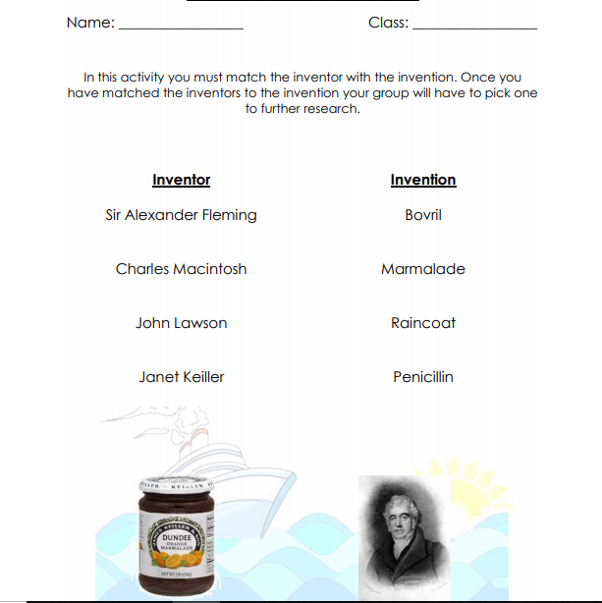

Metalinguistics Grid - Reading (Red Group)
LI: To identify meanings of new words and language.
Metalinguistics Strategies
RO: Read On RB: Read Back TD: Teacher Discussion
FW: Familiar Word D: Dictionary PD: Partner Discussion
Remember… Try to use a RANGE of these strategies!

Words I need to clarify (include page number) | Steps I have taken to clarify my understanding | I have checked the meaning and now I can share it
For Example:  Capability (pg 12)  gazing (pg 62)  mimicked (pg 63)  scowled (pg 66)  cajoling (pg 70)  exasperated (pg 70)  Add your own tricky words here if you wish. | ‘D’ step | The power or ability to do something.

Chapter CSI – Reading (Green Group)
LI: To express my thoughts and opinions of a given chapter.
CSI Example:
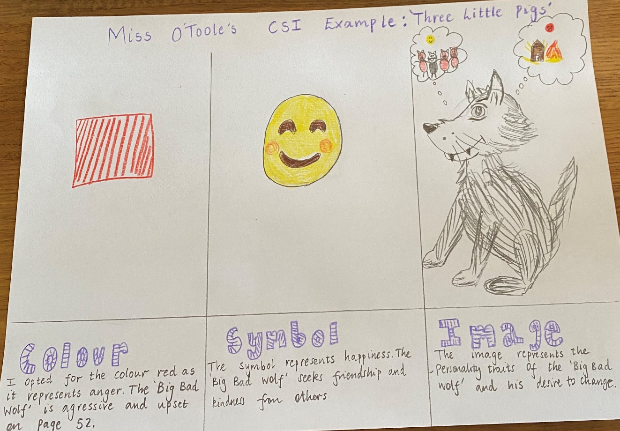
Template:
Colour | Symbol | Image

