Homophones – Their, there and they’re
L.I – To correctly use their, there and they’re in sentences.
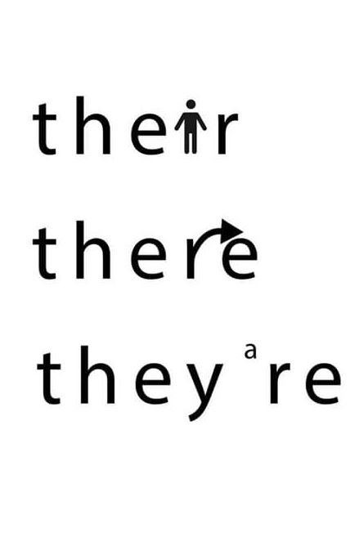
There = a place, a direction. The park is over there.
Their = Shows ownership, belonging to. People can’t lick their own elbows.
They’re = Short for ‘they are’. They’re all at the park.

Complete the following sentences:-
- The girls were going to the park over ________.

- ________ was a girl and a boy at the shops.

- The family were going on a road trip in ________ brand new car.

- ________ going to the cinema after school today.

- The children complete ________ homework when they get home from school.

- Olivia and Jacob went to visit ________ auntie after dinner.

- “Can you please get my bag for me?” asked Jemima. “It’s over ________”.

- They went to the gym and then ________ going to get some shopping.

