Task – Name each shape then try to find the shape around you. When you find the shape take a note of what the item is and how many you found. A tally is a line you write for each item found, when you get to 5 you write a line through it and start again, for example: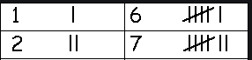
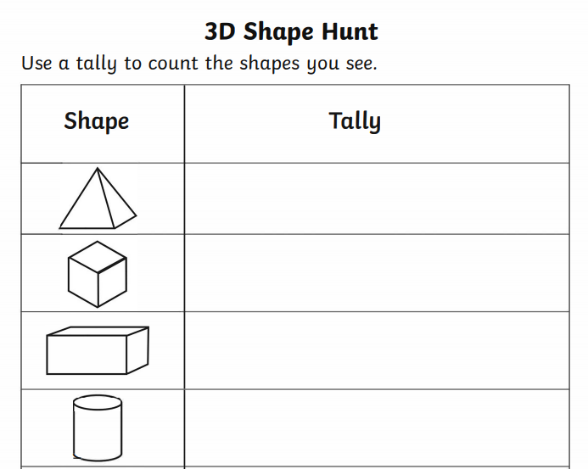
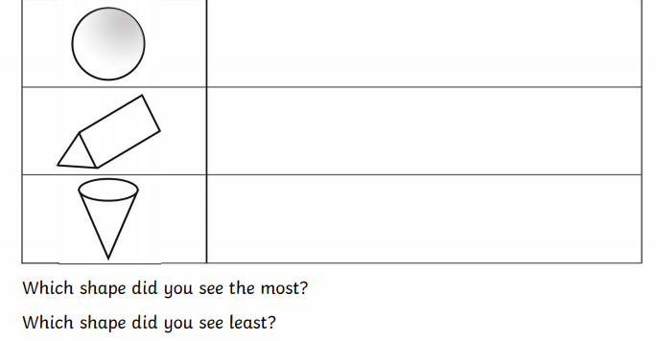Was there any you couldn’t find? If so, why do you think this was?
Can you name any shapes you found that are not listed above and what the item you found was?

