Writing
Write a diary entry on your home learning experience so far. You can include:
- What you have done so far.
- Have you enjoyed it?
- What you have spent your free time doing?
- Descriptions of how you are feeling.
- What you have missed most about school.
- What are you looking forward to most when you can come back to school?
- Anything else you wish to mention.
- You may also want to include a drawing.
*You may also want to include what you got up to over the long weekend. I know that it would’ve been very different from what you were thinking of but it would be nice to include what you and your family did. Perhaps you enjoyed daily exercise, baking, arts and crafts, drawing competitions etc.
It will be interesting to see if you are feeling differently from your first diary entry!

Learning Intention:
We are learning to write a diary entry about our home learning experience.

Success Criteria:
- Finger spaces
- .
- C
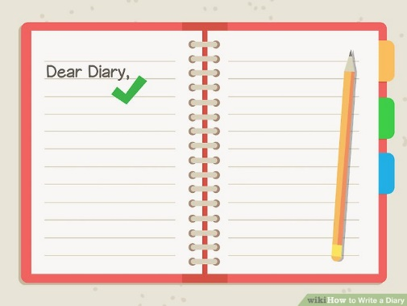
- abc
- sp
- Bonus point for feelings

Spelling
Learning Intention: We are learning to spell our common words and phoneme words correctly.
Success Criteria: I can:
- Sound out and spell each word correctly
- Use my words in sentences
- Self-assess my work to check if I have spelled my words correctly
Brain Boxes
Common Words  make  like  made | Phoneme  ck | Phoneme Words  sack  pack  rack  deck  peck  neck  pick  bucket  rocket  lock

Clever Cookies
Revise the following common words  five  time  life  line  home  more  school  Mrs.  take  gave  cold  don’t  every  find  want  girl | Consolidation/Assessment Week  i-e  o-e  a-e  u-e | Revise the following phonemes  side  white  smile  hide  shine  home  rope  stole  awoke  hope  smoke  cake  came  spade  brake  name  sale  June  ruler  rude  flute  rule

Genius Gems
Common Words  put  different  light  sentence  stop | Phoneme  u (push) | Phoneme Words  pull  push  cushion  full  bush  awful  bull

Superstars
Words ending in -ed
One Syllable Words e.g. hop, need the final consonant to be doubled before adding endings that start with a vowel.
hop + ing = hopping
hop + ed = hopped
- Find at least 10 more words that fit this Spelling Rule

Activities
Practice your common words and phoneme words in any way you wish. Some suggested ideas include:

- Rainbow writing
- Writing words 3 times
- Look, say, cover, write and check
- Writing your phoneme in a different colour e.g. phone

I have attached a copy of the spelling menu that is in your homework diary for some extra ideas.

Try to use as many of your words in sentences. This could be separate sentences, a phoneme story or a paragraph.
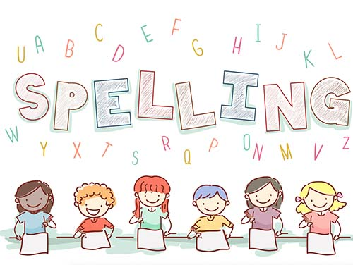

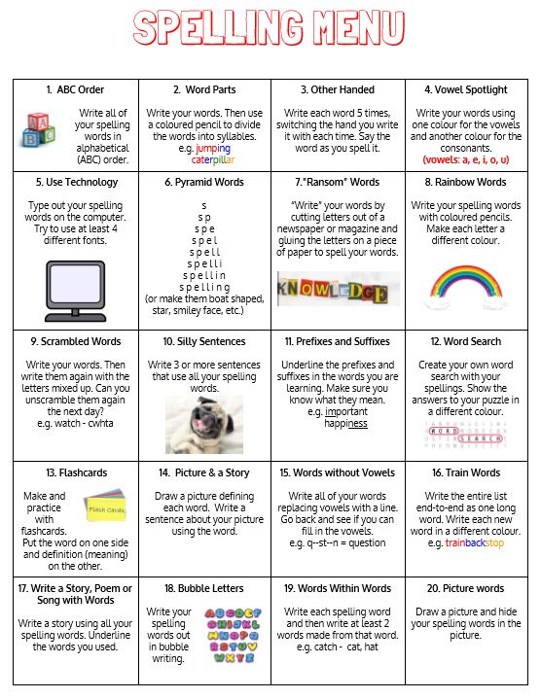

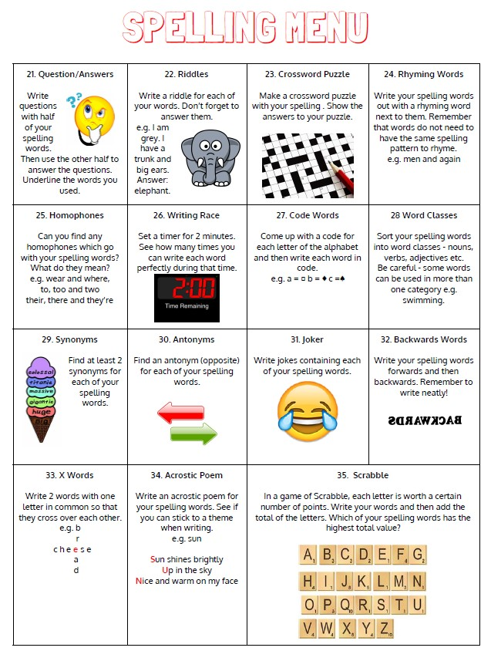

Maths
Circles | Squares | Triangles
Use daily 10 to build your confidence in mental maths.
https://www.topmarks.co.uk/maths-games/daily10
Practice counting in 1s, 2s, 5s and 10s starting from any number in the sequence. | Practice counting in 1s, 2s, 3s, 5s and 10s starting from any number in the sequence. | Practice counting in 1s, 2s, 3s, 4s, 5s and 10s starting from any number in the sequence.
Have a look at the ‘Everyday 2D Shapes’ PowerPoint I have attached. Can you find items in your house (or outside) that are these shapes?  You are looking for as many as you can of the following shapes:  - circle  - square  - triangle  - oval  - rectangle | Have a look at the ‘Everyday 3D Shapes’ PowerPoint I have attached. Can you find items in your house (or outside) that are these shapes?  You are looking for as many as you can of the following shapes:  - sphere  - cube  - pyramid  - cuboid  - cylinder  - cone  - triangular prism

I have attached a worksheet for you to write your answers on but you could make up your own on paper.
When you have completed each task, self-assess your learning.

Religious Education
Learning Intention: We are learning to pray the Rosary.
Success Criteria: I can:
- Pray the Our Father.
- Pray the Hail Mary.
- Pray the Glory be to the Father.

I have attached a Rosary worksheet for you to read and colour in. This tells you when to say the Glory be to the Father, Hail Mary and Our Father.
Can you remember without looking at the worksheet first?
How many Hail Marys do we say?
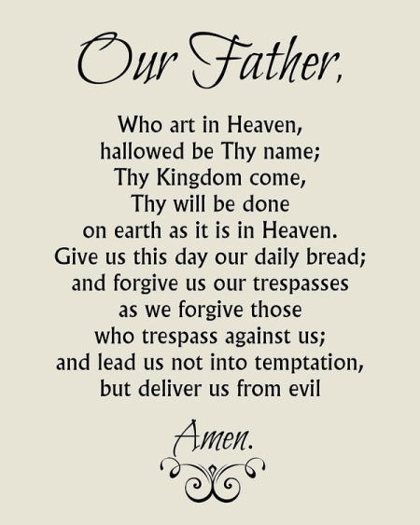

Challenge
I thought it would be good if I set you a challenge/activity every week that is a good life skill for you to learn! You might already be able to do some of them. Once you complete them, perhaps you could upload a picture on Teams to show me and the rest of the class, or you could post a picture on the school Twitter @StHelensNLC.
I thought it would be good to begin with something that we always talk about in class. It is something that I need to do for people on a Tuesday and Thursday. Can you guess?
Tie your tie!

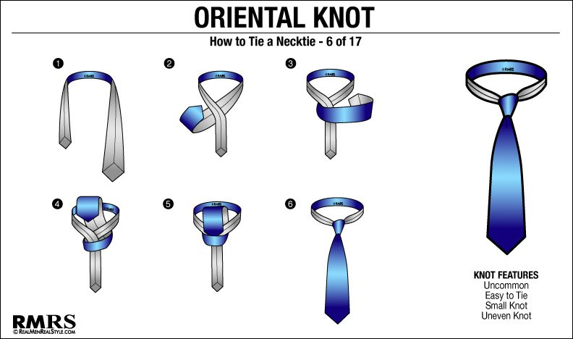
https://www.youtube.com/watch?v=jKYTVxoaMQA

