Today’s Home Learning Summary

|  |  |  |
| --- | --- | --- |
| TASK | Primary 3 | Primary 2 |
| TASK 1 - Reading | Main points | Comprehension |
| TASK 2 –  Writing | Dictation | Dictation |
| TASK 3 –  Spelling | Spelling Menu | Spelling Menu |
| TASK 4 –  Maths | Division | Division |
| TASK 5 –  IDL | Italian Lingascope | Italian Lingascope |

Please upload your tasks to Microsoft Teams by Wednesday evening if possible.

A more detail explanation of the tasks can be found below.

**Self- assessment**

After completing your work today, maybe you could try self-assessing your work to show me how you got on with it?

Red – It wwas tricky for me. I needed lots of support from an adult to complete it.

Amber/yellow – It got on ok. I asked an adult for help when I needed it.

Green – I got on very well. I completed this independently (on my own).

1. Reading Tasks (Main points/Beginning-Middle-End)

Learning Intention: to think about what I have read and extract important information/events.

Success Criteria: I can:

* Understand what I have read.
* Write the main points of the story (P3) Write what happened at the Beginning/Middle/End (P2)

TASK 1:

P3: Read chapter 1-4 of your book. Choose one chapter and write the main points of the chapter. (Reminder: A main point is something significant that happened. If you were to retell the story and you missed out one of the main points it might not make sense)

P2: Read the book and answer the comprehension questions at the back of the book. Remember to write in sentences.

**P3/2 Reading Groups are:**

*If you are unsure what group your child is in please ask.*

|  |  |  |
| --- | --- | --- |
| Room on the Broom | The Gruffalo  Image result for the gruffalo | Snail on the Whale |
| Your Oxford Owl Book is:  Eric’s Talking Ears  (Read chapters 4-6 this week). | Your Oxford Owl Book is:  No Way  Answer comprehension questions on Page 15. | Your Oxford Owl Book is:  Toads in the Road  Do ‘after reading’ task on Page 17 + play activity 1 at the top of the page. |

Reading materials can be accessed at [www.oxfordowl.co.uk](http://www.oxfordowl.co.uk)

REMINDER: Username: sthelensp32 Password: Workathome2020 (case sensitive for both UN and PW)

The website can be temperamental, if it doesn’t work you can create your own username and password for free.

1. Writing Tasks (Dictated sentences)

Learning Intention: to listen to a dictated sentence and write what I hear, remembering core targets.

Success criteria: I can use capital letters, spaces and full stops.

: I can spell my common words and phoneme words correctly.

TASK 2

P3 and P2: Please listen to someone at home read out the sentences below (you can read it aloud 3 times for your child). Write what you hear! Try to remember core targets and try to sound out unfamiliar words. When turning in your work show me how you got on first time without correcting your mistakes – try to be honest and see if you can improve each week!

*If you are not sure of your spelling group, please ask.*

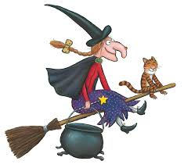P3

1. My mother works in a small chesmist shop every morning.

2. The road at the side of my house gets very icy in the winter.

 P2

1. You can use glue to stick the blue boat onto the card.
2. I saw a green straw hat on the lawn.
3. We went to see the garden to put some seeds in the soil.

P2

1. My little sister is one.
2. She got her first phone.
3. I can see an elephant.

3.Spelling Tasks (New phoneme and spelling words)

Learn your words in any way that suits you. Then, look at the **spelling menu** on the page below to practise your words.

TASK 3: choose one way to practise your common words and one way to practise your phoneme words from the spelling menu.

Ask someone at home to test you on Friday to see if you have remembered how to spell your words.

**SPELLINGING GROUPS**

*New words will be issued each* ***Tuesday****.*

|  |  |  |
| --- | --- | --- |
| Room on the Broom  (P3 only) | The Gruffalo (P2)  Image result for the gruffalo | Snail on the Whale (P2) |
| Common words: through, sing, morning, colour, kind.  Phoneme: y (as in gym) | CONSOLIDATION WEEK  Focus on the words and phonemes you are unsure of from the past four weeks.  Common words: five, time, life, line, home, more, school, Mrs. Take, gave, cold, don’t, every, find, want, girl  Phoneme:  i-e (fire), o-e (more), a-e (gave) u-e (as in true) | CONSOLIDATION WEEK  Focus on the words and phonemes you are unsure of from the past two weeks.  Common words: out, now, new, one, first, little  Phoneme:  wh (as in whip)  ph (as in phone) |

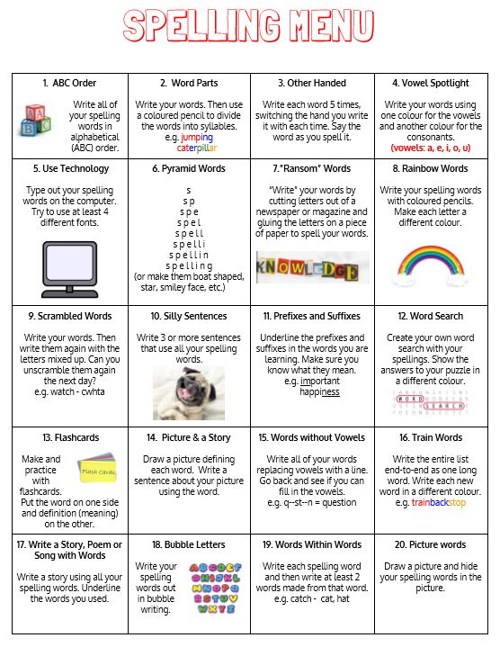

1. Numeracy Tasks (Introduction to division)

|  |  |
| --- | --- |
| Circles (P3 and some P2) | Squares (P2) |
| **Number Fluency**  Practise counting forwards and backwards from any number within 1000 and beyond.  Choose any number within 1000 and identify the number before and after/10 before and after that number. | **Number Fluency**  Practise counting forwards and backwards from any number within 100.  Choose any number within 100 and identify the number before and after/ 2 numbers before and after. |
| **Mental Maths**  Practise all times tables learned so far (2,3,4,5,10).  Choose a daily 10 that challenges you at home and complete this on a piece of paper.  <https://www.topmarks.co.uk/maths-games/daily10> | **Mental Maths**  Practise all times tables learned so far (2,5,10).  Choose a daily 10 that challenges you at home and complete this on a piece of paper.    <https://www.topmarks.co.uk/maths-games/daily10> |
| **Topic – Subtraction**  Learning intention: to divide a number into groups of 2 and 10.  Success Criteria: sort amounts of objects into equal groups.  TASK 4: solve the problems below by using a set of objects in your house and divide them equally into groups of 2 and 10 (you could use pasta, pebbles, matches, stones, sticks *etc*.)   |  |  | | --- | --- | | 1. **6÷2≈** | 1. **8÷2≈** | | 1. **10÷2≈** | 1. **14÷2≈** | | 1. **20÷2≈** | 1. **50÷10≈** | | 1. **20÷10≈** | 1. **40÷10≈** | | 1. **80÷10≈** | 1. **90÷10≈** | | **Topic – Multiplication**  Learning Intention: to divide a number into groups of 2.  Success Criteria: sort amounts of objects into equal groups.  TASK 4: solve the problems below by using a set of objects in your house and divide them equally into groups of 2 and 10 (you could use pasta, pebbles, matches, stones, sticks *etc*.)   |  | | --- | | 1. **6÷2≈** | | 1. **8÷2≈** | | 1. **10÷2≈** | | 1. **12÷2≈** | | 1. **14÷2≈** | |

**To support explanation of new concept of division:**

**BBC Bitesize:** <https://www.bbc.co.uk/bitesize/topics/zqbg87h/articles/z9jxhv4>

**Twinkl:** **..\..\Downloads\Introducing-Division-Activity-PowerPoint.pptx**

1. IDL Task – Lingascope



TASK 6: Try logging on to Lingascope and trying out the colours ‘i colori’ activities.

To complete the activities above you need to log in to <https://www.linguascope.com/>

Username: sthelens Password: lomond

1. Log in to Linguscope
2. Select beginner and click on the Italian flag.
3. Select The Basics ‘le basi’
4. Then Select Numbers ‘i numeri’
5. Practise vocabulary and activities for NUMBERS ‘i numeri’
6. You could make a poster, video or picture with the new Italian numbers you have learned.