There are 60 minutes in one hour -> 60 minutes = 1 hour (if I counted all the small lines on a clock I would get up to 60 and this is what the small hand moves around in one full hour)
So if I wanted to find out how many minutes are in 2 hours I could do the calculation 60 minutes + 60 minutes because there are 60 minutes in each hour and I want to find out how many are in 2 hours >>> 60 + 60 = 120 or I could have used multiplication >>> 60minutes x 2 = 120minutes.
There are 60 seconds in one minute >>> 60 seconds = 1 minute
So if I was asked how many seconds in 5 minutes I could add 60 five times (60+60+60+60+60=300 seconds) or I could use multiplication (60 x 5 = 300 / 6 x 5 = 30, 30 x 10 = 300).

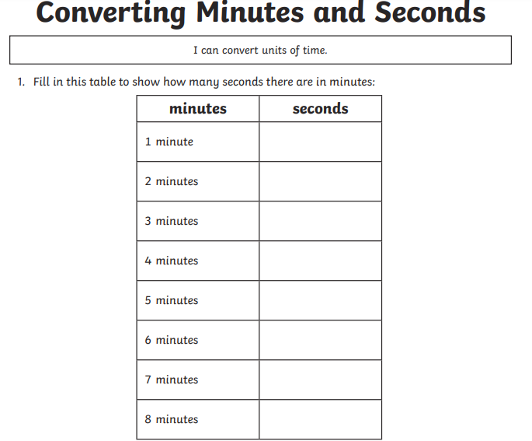

For this first example they have worked it out by:
60 seconds x 6 (because they want to find out how many in 6 minutes) = 360 seconds, and then added on the 30 seconds = 390 This answer is in seconds only.
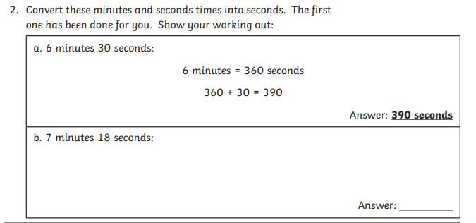
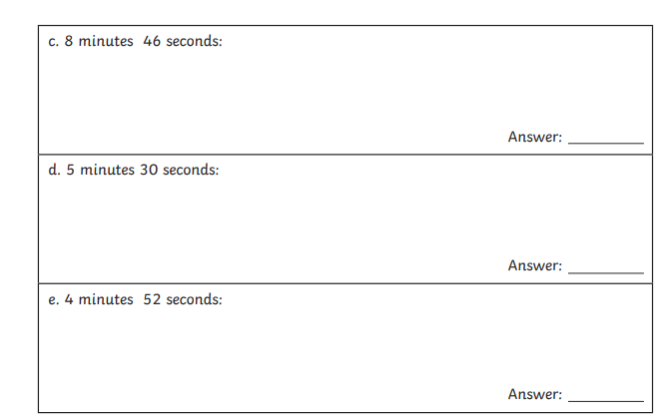

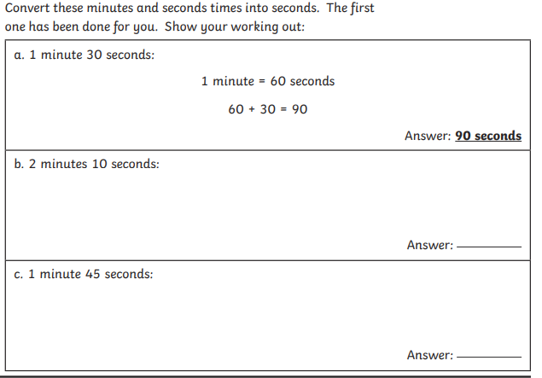
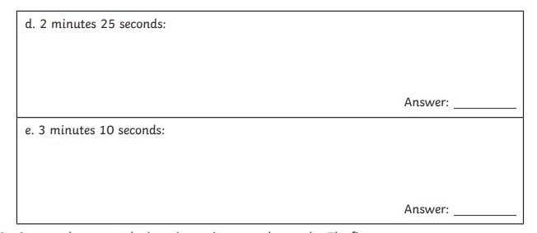

These questions now ask for your answer to be in minutes and seconds. There are 60 seconds in each minute.

