Use the first clock to help you throughout this task. It shows the minutes past one hour and minutes to one hour.
Each line on the clock face stands for one minute, so if you start at o’clock then count the small lines, when you get to the 1 on the clock face you will have counted five minutes (so five minutes past), if you do the same until you get to the 2 on the clock face you will have counted 10 lines and so it is 10 minutes past.
Q1 – Write what times are shown Q2 – Draw the time on each clock
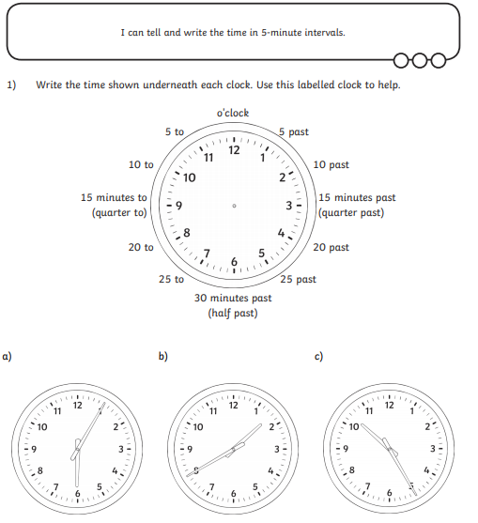

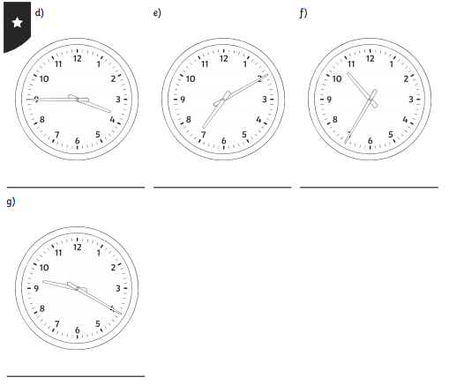
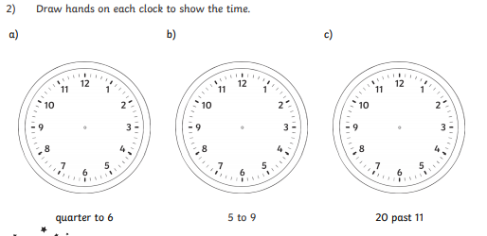

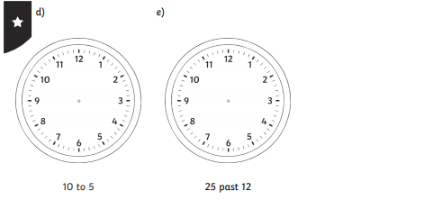
EXTRA – CHALLENGE
