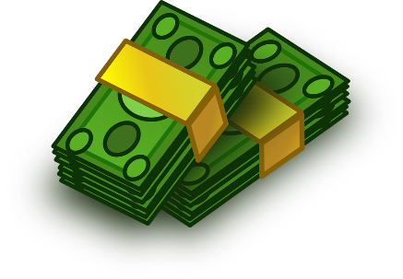

Addition of Money – Triangles Group

L.I – To use my knowledge of Column Addition to solve calculations using money.

Kite = £15.45 Trampoline = £57.12 Football = £7.90
Basketball = £5.43 Hula Hoop = £11.32
Paddling Pool = £19.34 Basketball Hoop = £33.34
MiniGolf = £45.22 Bike = 79.99 Goals = £25.25

Using the prices above, find out how much it would cost to buy:
- A kite and a bike
- A Basketball Hoop and a Basketball
- A paddling Pool and a Bike
- A Football and Goals
- A Hula Hoop and a Mini Golf set
- A Bike and a Football
- A Basketball and a Football
- A Mini Golf set, a Bike and a Hula Hoop
- A Kite, A Paddling Pool and a Football
- A Basketball, Basketball Hoop and a Hula Hoop.

Addition of Money – Circles Group

L.I – To use my knowledge of Column Addition to solve calculations using money.

Mountain Bike = £157.86 IPad = £335.67 Phone =578.45 Bouncy Castle = £223.45 Electric Car = £456.23 Xbox = £657.88 Nintendo Switch = £731.34

Using the prices above, find out how much it would cost to buy:

- A Mountain Bike and an Xbox
- A Bouncy Castle and a Nintendo Switch
- An Ipad and a Phone
- An Electric Car and a Bouncy Castle
- A Nintendo Switch and a Mountain Bike
- A Phone and an Xbox
- An Electric Car and a Mountain Bike
- An IPad, a Bouncy Castle and a Nintendo Switch
- An Xbox, a phone and an Electric Car
- A Mountain Bike, an IPad and an XBox

Addition of Money – Squares Group

L.I – To use my knowledge of Column Addition to solve calculations using money.

Car = £4537.87 Holiday = £9689.43 Jet-Ski = £5413.86
Boat = £8792.45 Hot Tub = £6413.22
Motorbike = 3587.77 Helicopter = £8458.22

Using the prices above, find out how much it would cost to buy:

- A Holiday and a Jet-Ski
- A Motorbike and a Helicopter
- A Hot Tub and a Car
- A Boat and a Holiday
- A Helicopter and a Car
- A Hot Tub and a Motorbike
- A Jet-Ski and a Helicopter
- A Car, a Holiday and a Helicopter
- A Motorbike, A Boat and a Hot Tub
- A Helicopter, a Holiday and a Motorbike

