Victory in Europe Day

Victory in Europe Day is usually called VE Day.

What Is VE Day?

- VE Day is a day to remember the end of the fighting in Europe in the Second World War.
- It is a day to remember the bravery and suffering of those who lived during the war.
- It is a day to remember the courage of the soldiers who fought during the war.

Time to Celebrate
- On May 7th 1945, Germany surrendered the war.
- The first VE Day took place on May 8th 1945.
- At 3pm on May 8th 1945, the Prime Minister, Winston Churchill, made a speech to announce the end of the war.

How Did People Celebrate the First VE Day?
People travelled to London for parades, dancing, singing and fireworks. The centre of London was filled with people wearing red, white and blue and waving flags. There were street parties all over the country.

Glossary (to help us understand the meaning of tricky words)
Announce – to tell people about something important
Celebrate – to do something special for a special occasion
Surrender – to agree to stop fighting

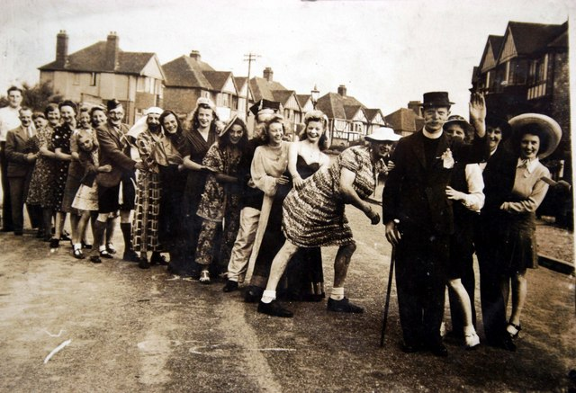

Comprehension Questions
L.I – To show my understanding of what I have read.
Success Criteria
- Use my own words
- Write in full sentences

- Complete this sentence:

Victory in Europe Day is usually called _________________.

- What do we remember on VE Day? Tick one.
The end of fighting in Europe in the First World War
The end of fighting in Europe in the Second World War
The end of fighting in Europe in the Third World War

- What happened on May 7th, 1945? Tick one.
People in London had parties
Germany surrendered the war
Winston Churchill made a speech

- Write two ways people celebrated the end of the war.
______________________________________________________________________________________________

- Match the word to the correct meaning.

Announce To do something for a special occasion.

Celebrate To tell people about something important.

Surrender To agree to stop fighting.

