Victory in Europe Day
Victory in Europe Day is also known as VE Day. VE day is a day to commemorate the end of the fighting in Europe in the Second World War. We remember the courage, suffering and endurance of those who lived during the war. We also remember the soldiers who fought in the war and those who lost their lives.

Did You Know?
The Second World War lasted for nearly six years. It was a war that involved countries from all around the world. The war started in Europe in 1939, when Nazi Germany invaded the country of Poland. The people of Britain fought Nazi Germany for their freedom.

Time to Celebrate
On May 7th 1945, Germany surrendered the war. The first VE Day took place on May 8th 1945, after Prime Minister, Winston Churchill’s, speech.

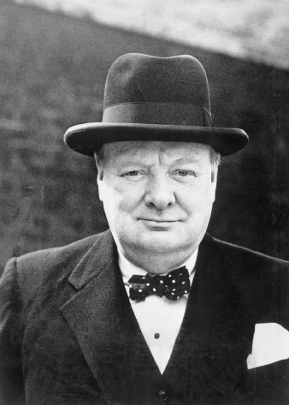

At 3pm on May 8th 1945, the Prime Minister, Winston Churchill, made a speech to announce the end of the war. He said: “My dear friends, this is your hour. This is not victory of a party or of any class. It’s a victory of the great British nation as a whole.”

How Did People Celebrate the First VE Day?
People travelled to London for parades, dancing and singing. The centre of London was filled with people wearing red, white and blue and waving flags. There were street parties all over the country. Fireworks filled the sky with flashes of light. Princess Elizabeth and Princess Margaret even slipped out of Buckingham Palace to join in with the celebrations in London!

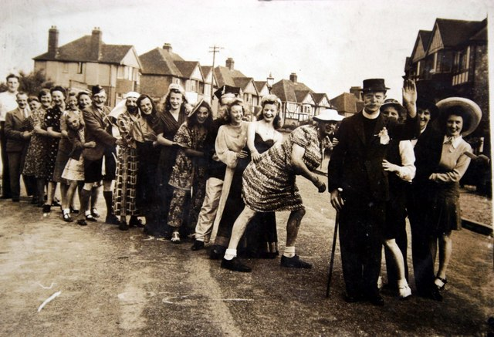

Comprehension Questions

L.I – To show my understanding of what I have read.
Success Criteria
Use my own words
Write answers in full sentences

- What is Victory in Europe Day also known as?
_______________________________________________

- What do we remember on VE Day?
_____________________________________________________________________________________________________________________________________________

- How long did the Second World War last for?
_______________________________________________

- When was the first VE Day?
_______________________________________________

- Who was the Prime Minister in 1945?
_______________________________________________

- Why do you think people travelled to London for the celebrations?
_____________________________________________________________________________________________________________________________________________

