Primary 4b – Home Learning Tasks
Thursday 7th May 2020

Reading
Reading activities this week this week will be based on a very special celebration happening on Friday – VE Day. This year marks the 75th anniversary of VE Day. Each group has a reading comprehension attached. Read over the information provided in the text and then answer the questions.
This celebration is a landmark in our history and it is important for us to have an understanding of it.

All Groups - Extension
If you are currently reading a book of choice at home, please share this with me and let me know if you are enjoying it.
You could always complete a book review when you complete the book to let your classmates know if you recommend the book or not.

Writing – A Narrative Story
For your writing this week, I would like you to create a narrative story based on the following video. This video shows us all about VE Day and explains how people felt as the events progressed on that day.

Here is the link for the video:
https://www.youtube.com/watch?v=NEavcsrMoMw

I want you to imagine that you are one of the people in the crowd as the news is announced that the war is over!
- How do you feel?
- What role have you played in the war? (Child, Mother/Father etc.)
- What has the war cost you? (Your job, family, home)
- How will you celebrate?
- What are your future plans?

Remember to include as much detail as possible to make your story interesting for your reader.

L.I – To create a narrative story based on a given video prompt.

Success Criteria
- An interesting title to capture your reader’s attention
- Use of paragraphs throughout
- An appropriate opening, middle and ending that follows a story mountain structure.
- Use of appropriate punctuation throughout – full stops, capital letters, and speech marks etc.
- Include character thoughts and feelings throughout.

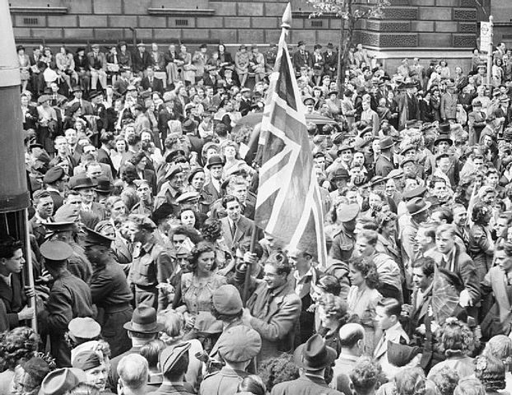
Numeracy Tasks
For our Numeracy tasks, I have attached some worksheets which follow on from the Money information from Tuesday. Each sheet states what group it is for. Please try your own group worksheet first before challenging yourself with another group’s worksheet.

Number Talks

35 + 35 56 + 54 87 + 85

135 + 136 356 + 354 487 + 486

2134 + 2136 3356 + 3356 4486 + 4484

As always, these chilli challenges are in groups. They get harder as you move down the line. See how many you can do, using our number talks strategies we have learned in class – Partitioning and Doubles/Near Doubles. Challenge yourself!

See – Think – Wonder

Our thinking routines that we have been using in class help us to look deeper at things and understand how other people may see things a little bit different to us. By working together and sharing these ideas, however, we begin to build on our own ideas and can come up with a full picture.
I would like you to take a look at the following picture and apply the See-Think-Wonder thinking routine to it.

See – List all the things you can see in the picture.
Think – What does the picture, and everything in it, make you think?
Wonder – What wonders/puzzles do you have about the picture or the people in it?
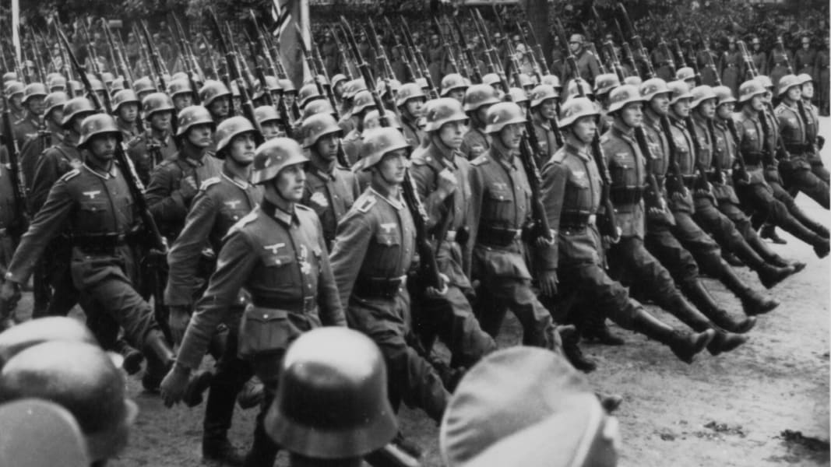

See | Think | Wonder

