Spelling
Learning intention: I can identify and highlight my spelling words.
Success criteria:
- Find all spelling words on word search.
- Circle or highlight spelling words.
- Self-correct using the answer sheet.
- Traffic light your work. Use the traffic light reflection to help you identify if you should choose red, amber or green.

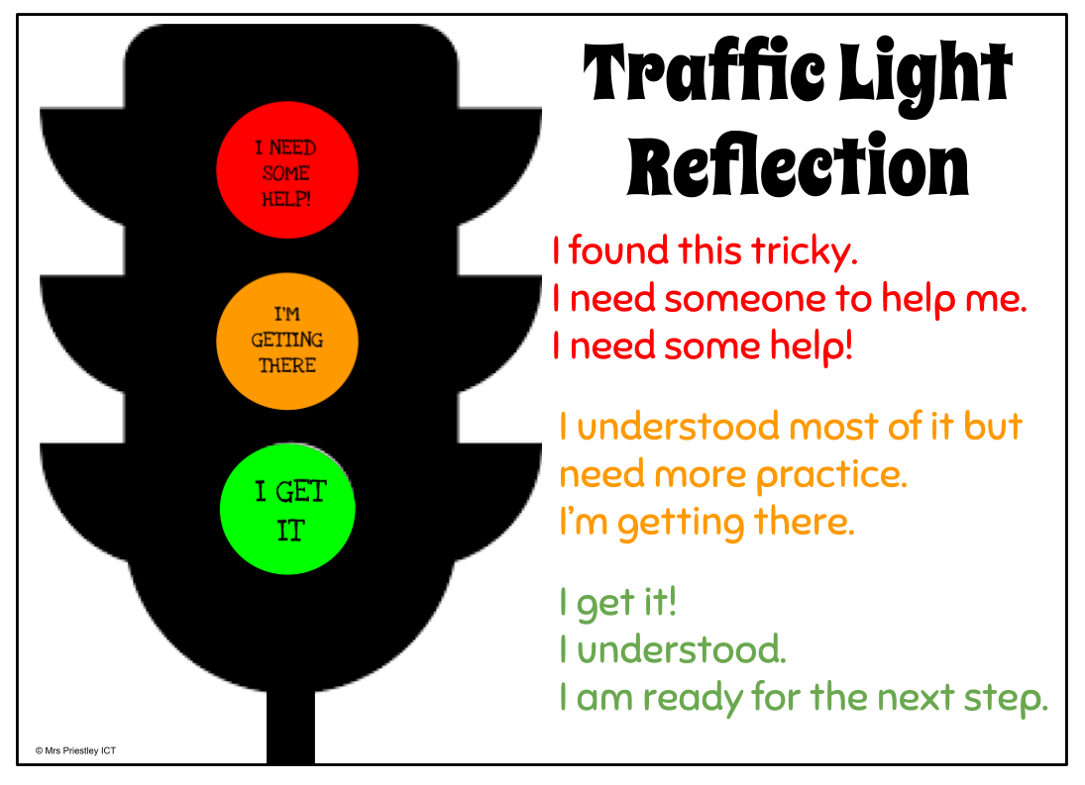

I have created a word search for each spelling group. You will need to print your wordsearch. Identify and circle/highlight all of your spelling words. Be careful, you might have to use a letter more than once!

Red group word search – https://blogs.glowscotland.org.uk/nl/public/sthelens/uploads/sites/29690/2020/05/06104053/Red-Group-Mathematics-Words-Word-Search.pdf

Blue group word search – https://blogs.glowscotland.org.uk/nl/public/sthelens/uploads/sites/29690/2020/05/06104100/Blue-Group-Mathematics-Words-Word-Search.pdf

Green group word search – https://blogs.glowscotland.org.uk/nl/public/sthelens/uploads/sites/29690/2020/05/06104105/Green-Group-Set-10-Word-Search.pdf

Yellow group word search - https://blogs.glowscotland.org.uk/nl/public/sthelens/uploads/sites/29690/2020/05/06104110/Yellow-Group-EA-Words-Word-Search.pdf

Sumdog competition

Learning intention: I can apply my knowledge of mathematical concepts to answer related questions.
Success criteria:
1. Log in to Sumdog.
2. Click on the ‘Sumdog Competition’ and begin.
3. Apply knowledge of a variety of mathematical concepts to answer related questions.
4. Complete all questions before deadline of competition.
This competition will open on at 9am and close at 4pm on Thursday 7th May 2020.
The competition can be accessed via this link: https://www.sumdog.com/user/sign_in
I have created a Sumdog competition that has been tailored to your skillset, so may be challenging.
The competition will cover a variety of mathematical concepts, so be ready for any type of question!

Your login details were glued into the back of your school diary.
If you have misplaced these, let me know and I will re-send you them.

When I think of Mary…

Learning intention: I can reflect on Our Lady and write down my thoughts.
Success criteria:
- Sit somewhere peaceful and take time to reflect on Our Lady.
- Write down what thoughts came to mind about Our Lady.
- You may wish to end your reflection with a prayer to Our Lady or a recital of the Rosary.

In the Catholic faith, the month of May is set aside to honour Mary, Mother of God. What do you think of when you think of Mary? I want you to take some time to think of Mary and write down your thoughts. I have attached a worksheet that you can use.
Our Lady
Many Catholics erect a special May altar with a statue or picture of Mary as a reminder of Mary’s month. Why not do this in your home? You could put a statue or picture or any sort of representation of our Blessed Mother. Make it appealing and a real tribute to her beauty and virtue.

