Draw these times as they would appear on an analogue clock. Next to the clock, write whether the time would be ‘am’ or ‘pm’.

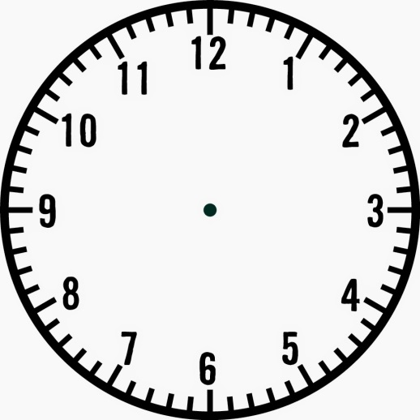
12 o’clock in the afternoon | Quarter past 1 in the morning
Half past 11 in the morning | Quarter to 6 in the evening
9 o’clock in the morning | 20 minutes to 3 in the evening

