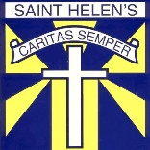 Primary 6/Miss O’Toole – Home Learning 7th of May
Every Tuesday and Thursday (before 10am) I will be posting home learning tasks for you to work through. New spelling words will be posted every Tuesday.
Reading Tasks
Red Group | Blue Group | Green Group | Orange Group
LI: To create a visualisation of a given character.  TASK  Read chapters 3-4 of ‘Double Exposure’ chapters 3-4 (Oxford Owl – link below). Using evidence from the text, create a visualisation of Sophia.  Oxford Owl Login  Username:sthelensp6  Password: school  Success Criteria:  Read given chapters and understand plot.  Create a visualisation of Sophia using evidence from the text (page numbers). | LI: To identify the main ideas in given chapters.  TASK  Read chapters 3 and 4 of ’20,000 Leagues Under the Sea’  (Oxford Owl – link below). List the main ideas within the chapters.  Oxford Owl Login  Username:sthelensp6  Password: school  Success Criteria:  Read given chapters and understand plot.  Identify main ideas for each chapter.  Include only ‘key’ parts of chapters. | LI: To read given chapters and explore given plot.  TASK  Listen to chapters 8 and 9 of ‘Kid Normal’ story (audio version – link below).  Success Criteria:  Use prior knowledge to understand given plot. | LI: To highlight what the author means.  TASK  Read ‘Code – Into the Pyramid’ (pg13-31) (Oxford Owl – link below). Complete the before and after reading tasks on pg 14 and 32.  Oxford Owl Login  Username:sthelensp6  Password: school  Success Criteria:  Identify descriptive phrases.  State what the author infers.
Link to Clips:
Red Grouphttps://www.oxfordowl.co.uk/api/digital_books/1392.html
Blue Group https://www.oxfordowl.co.uk/api/digital_books/1336.html
Green Group https://stories.audible.com/pdp/B07533YSBN?ref=adbl_ent_anon_ds_pdp_pc_cntr-1-1 Orange Group https://www.oxfordowl.co.uk/api/digital_books/1330.html

Spelling Tasks
On Tuesday, spelling words for each group were posted with tasks. Over the next few days all groups should…

Ask an adult to read out your spelling words whilst you write them down for a ‘mini check-up’ (just like we do on Fridays in class). This will give you an idea of the words that you may need to practise more.

Choose at least one of the tasks from the grid below:
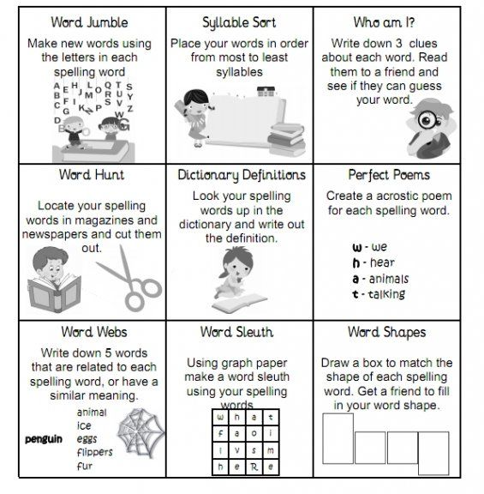
Numeracy Tasks
Red Group | Blue Group | Green Group | Orange Group
LI: To solve time word problems.  TASK  Time revision. Complete the ‘red’ time worksheet.  Success Criteria:  Use correct operation (eg: addition/ subtraction) to identify durations. | LI: To investigate and order timed events.  TASK  Time revision. Complete ‘blue’ time investigation worksheet.  Success Criteria:  Identify given time frames for each event.  Rearrange the events in the correct order. | LI: To identify given analogue time.  TASK  Complete the ‘green’ time worksheet.  Success Criteria:  Use the clock diagram and note the given time. | LI: To illustrate given analogue time.  TASK  Complete the ‘orange’ time worksheet. If you are unable to print the worksheet you can draw the clocks in your jotter.  Success Criteria:  Understand given written times.  Draw appropriate time on the clock diagrams.

Green and Orange Group Video Clip:
https://www.bbc.co.uk/bitesize/topics/zhk82hv/articles/zcmdwxs

REMINDER:
- challenges for this week can be found on the ‘Sumdog’ website for our class. Well done to those of you who have already participated.

- This is a fantastic website for extra revision/games/resources on time https://www.teachingtime.co.uk/. Have a go if you wish!

Geography
LI: To compare different time zones across the globe.
Since we have been revisiting time in Maths, it will be beneficial to compare different times across the world.
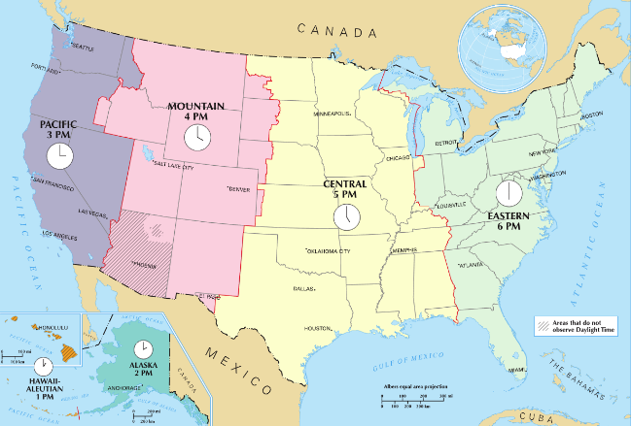
Watch the introduction video: ‘Terrific Scientific: Fleur East Investigates Time Zones’ https://www.bbc.co.uk/programmes/p04sccwc This explains the difference in time zones across the globe.
Task
Make a comparison timeline for a person in the UK and India. Draw or write what you would be doing at this time. Then, research what another child may be doing at this time.
Hint: India is 4hours and 30 minutes ahead of the UK.

When it is 8am in the UK | When it is 12pm in the UK | When it is 4pm in the UK | When it is 8pm in the UK
It is 12.30pm in India | It is ____ in India | It is ____ in India | It is ____ in India
R.E
LI: To explore the different titles of Mary.

As you know, May represents the Month of Mary. Mother of God, Queen of Angles and Star of the Sea are three examples of the many titles Mary has. Your task is to discover other titles of Mary. Ask your family members to help you. Choose one title and illustrate it.

Challenge – ‘Month of May’ Alter
In class, we would normally create a ‘Month of May’ alter which would feature Our Lady. It is a popular tradition for many people to also create a ‘Month of May’ alter in their homes. Perhaps you could create a small area to honour Mary in your home? You could decorate it with your image of Mary that you have completed as part of this task and with flowers. I would love to see your images!
What do you think of the one I created below?
