Timetable Task
LI: To use and interpret timetables effectively.

Here is part of a train timetable
Ramsgate | 10.05 | 10.40 | 11.15 | 11.55 | 12.05 | 12.20 | 12.30
Canterbury West | 10.40 | 11.15 | 11.50 | 12.30 | - | 12.55 | -
Ashford Int | 11.05 | 11.40 | 12.15 | 12.55 | 13.05 | 13.20 | 13.30
St Pancras Int | 11.40 | - | 12.55 | 13.35 | - | 14.00 | -
Waterloo | 12.10 | 12.55 | 13.10 | 13.50 | 14.00 | 14.15 | 14.25

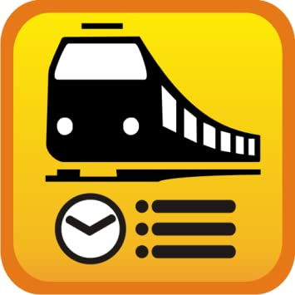

- How long does the first train from Ramsgate take to travel to Waterloo?
- How much later does the second train from Ramsgate leave than the first?
- If I catch the 10.40 train from Ramsgate, how many stops are there until I reach Waterloo?
- How many trains pass through Ashford Int between 11.30 and 13.00?
- I arrive at Ashford Int at 12.00. I want to travel to Waterloo. I catch the next train. What time will I arrive at Waterloo?
- I want to be in Waterloo by twenty past two. What is the time of the latest train I can take from Canterbury West?
- I want to go to Waterloo. If it faster to catch the 10.40 train from Canterbury West or the 11.15 train from Canterbury West?

