Play Activities at Home
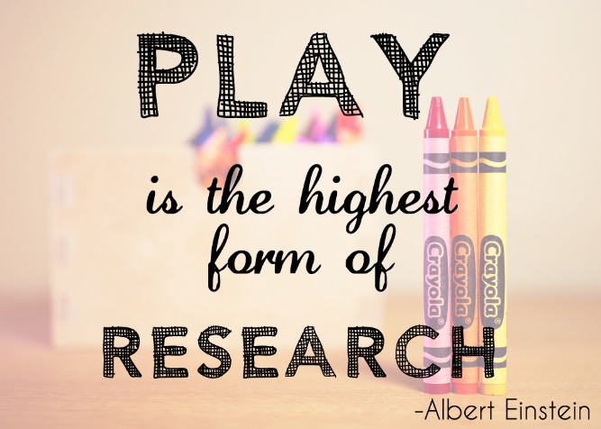
During play activities, fine motor, gross motor, visual perceptual, cognitive, social, emotional, and self-regulation skills can all be developed and nurtured.

Water Play
Water play enables children to experiment with basic concepts such as volume.

Play Dough
Play dough has immense potential for learning. Not only does it strengthen fingers in preparation for a lifetime of writing, it teaches fine motor skills, creativity, and hand-eye coordination.

Dress-Up and Role Play
Dressing-up helps children to begin to make sense of the adult world, roles, and interests, as well as boosting social interaction. Not least, dressing-up helps to reinforce the self-care aspects of self-dressing which is essential for primary school life.

Building a Den
Use anything you can find lying around the house – sofa cushions, towels, sheets, cereal boxes etc. Why not read a story to your favourite teddy whilst you’re inside.
Doll and Character Play
Providing characters in the form of mini-figures and dolls allows children to develop their social play. It encourages imagination and the expression (and labelling) of feelings.

Drawing and Painting
Letting children experiment with paints and drawing tools allows them to experience their world in a sensory way and develop self-expression, whilst also developing writing skills. Furthermore, it’s an invitation to learn about colours, mixing, and good-old tidying up!
Blocks, Jigsaws, and Shape Sorters
Playing with blocks, jigsaws, and shape sorters all lay the foundations of spatial thinking, logical reasoning, ordering, and recognising various shapes, sizes, and colours.

Music, Dancing, and Singing
Singing and music hugely help to develop language and form the basis of literacy skills, as well as basic mathematical concepts such as counting. Furthermore, they begin to develop rhythm, whilst also refining their listening skills. Dancing helps the child develop strength and coordination, and flexibility.

Imaginative Play
All play should be imaginative, but we’re referring to the type of play that comes naturally to many children. Leave a small child with nothing but a random selection of objects and you’ll soon find them lost in a world of make-believe. Giving a child time and space for imaginative play is essential. It develops their imagination, which is important for literacy skills and intellectual reasoning. Additionally, it increases their sense of self, and self-esteem, as well as making sense of the world around them, as well as ability to handle boredom.

Running, Jumping, Climbing, Swinging
Young children have a compulsion to move. Allowing them to do so, and providing safe and age-appropriate challenges, allows them to increase their confidence as well as develop their resilience through risk-taking. Of course, gross motor skills also receive a mighty boost.

Nature Play
Children’s learning is fuelled when you take the play space out in to the great outdoors. Not only is it healthy, it teaches a respect for the environment, and the beginnings of biology. It also helps children to become more independent and inquisitive.

Sensory Play
In a nutshell, sensory play is any play activity which involves touch, smell, taste, sight and hearing. This can be provided with a plate of jelly, aqua beads, ice, rainbow rice, or even small world tubs. Sensory play stimulates exploration and the building blocks of science and investigation.

Basic Board Games
There are so many board games available for even the youngest players, and these should be embraced – not only for their fun factor, but for their learning potential. In addition to the themes of numbers, colours, shapes, and early phonics, these games are vital for teaching children turn-taking and sharing.

Cooking and Pretend-Cooking
Cooking, and pretend cooking, serving, and shops, are great play scenarios for kids. Cooking itself combines elements of sensory play, mathematical concepts, home safety, and following processes. Pretend cooking, serving, and toy shops also teach basic mathematical ideas as well as social interaction, and how to be thoughtful to others.
Find more ideas of family games to play indoors here:
https://www.parentclub.scot/articles/games-cure-cabin-fever
*sources – Parent Club Scotland and Sitters.co.uk

