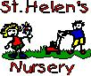
St Helen’s Primary and Nursery
Aim high and be all you can be in St Helen’s.

In St Helen’s we believe learning is so much fun! If you follow @NLCLearningHub on Twitter you will be able to participate in daily challenges starting from Monday 23rd March. Here are some websites, apps and activities that could support learning further.

Website | Curricular Areas | Level
https://www.bbc.co.uk/bitesize/primary | A website with an extensive range of resources to support learning across the curriculum | Primary 1-7
https://www.duolingo.com/ | Modern Languages – French and Spanish resources for all ages | Primary 1-7
https://www.prodigygame.com/ | Numeracy – an American website to support learning in Maths | Primary 1-7
https://www.topmarks.co.uk/ | A website with an extensive range of resources to support learning across the curriculum | Primary 1-7
https://www.bbc.co.uk/newsround | A News website to keep children and young people up to date with the latest stories and events happening at home and abroad | Primary 1-7
https://www.oxfordowl.co.uk/ | Literacy – eBook Library and educational games | Primary 1-7
https://www.youngwriters.co.uk/ | Literacy – competitions for every age | Primary 1-7
https://www.twinkl.co.uk/resources/parents | A website with an extensive range of resources to support learning across the curriculum | Primary 1-7
https://pages.sumdog.com/ | Numeracy – All children in St Helen’s have a username and password to access Sumdog Maths games | Primary 1-7
https://www.starfall.com | Literacy – talking library and lots of phonics games  Numeracy – addition, subtraction, place value, division and much more | Suitable for infant classes
https://www.doorwayonline.org.uk/literacy/ | Literacy – memory and matching games, letter formation, phonics, spelling  Numeracy – number, counting, time and money | Suitable for infant classes
http://www.primaryhomeworkhelp.co.uk/maths/ | Numeracy – number, shape, data, measure, investigations | Most games support learning for infants  Some games support learning for upper school
https://www.ictgames.com/mobilePage/literacy.html | Literacy – spelling, letter formation, reading and writing games  Numeracy – games linked to lots of Maths topics including multiplication, fractions, number facts | Games to support learning for P1-P4 pupils
https://blockly.games/ | ICT – computer programming skills | Upper stages of Primary school
https://scratch.mit.edu/ | ICT – creative computer programming | Upper stages of Primary school
https://mysteryscience.com/ | Science – resources linked to planet earth, electricity, biological systems and materials | Upper stages of Primary school

Web Address or App | Content
https://education.gov.scot/parentzone/learning-at-home/ | A variety of fun ideas and resources for parents to do at  home with their child including literacy, numeracy and  health & wellbeing
https://www.khanacademy.org/parent | 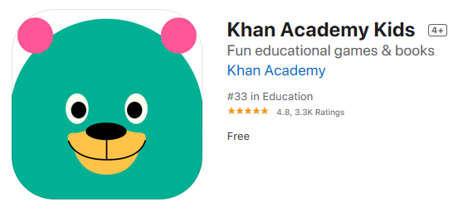4 years + Free on-line educational games
https://www.e-learningforkids.org/

https://www.bbc.co.uk/sounds/series/p02pnn9d | 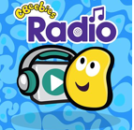
Free on-line Apps for early years | 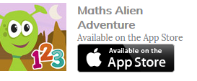  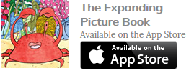  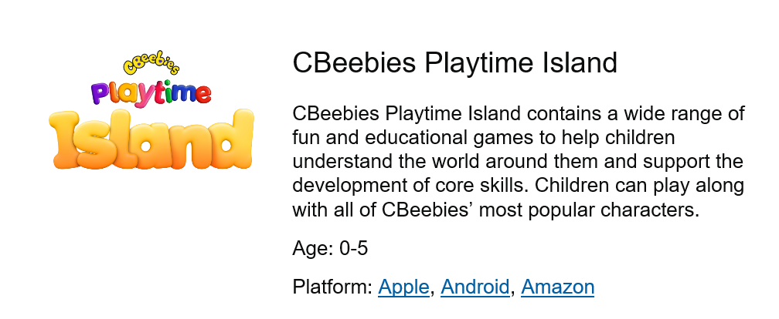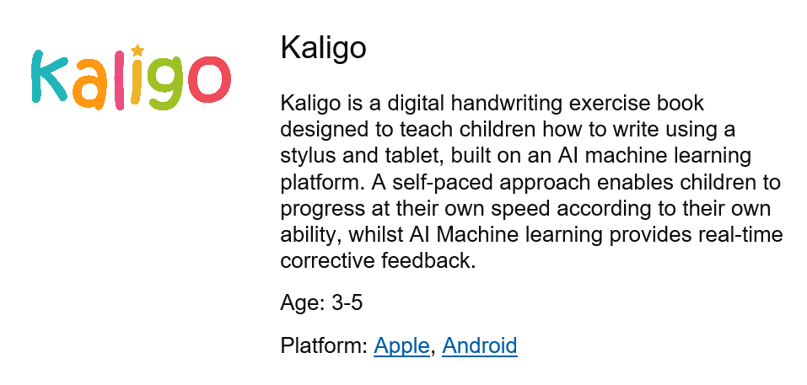  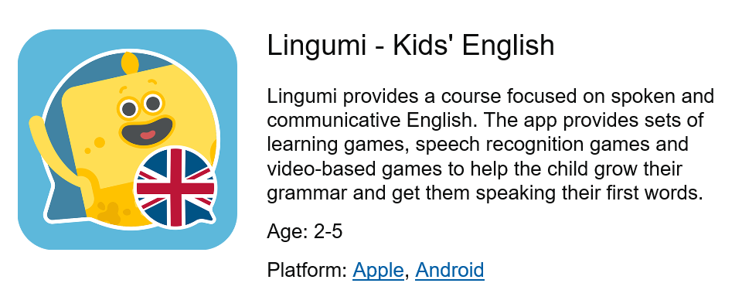
https://famly.co/blog/inspiration/10-sensory-play-ideas-to-develop-motor-skills/ | 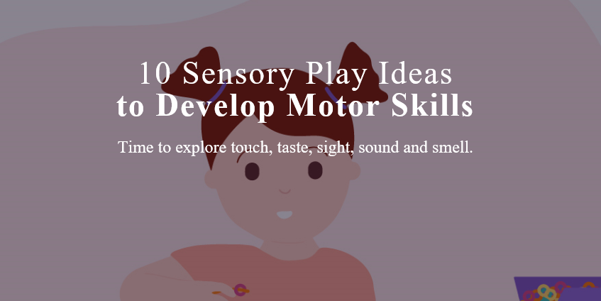
https://family.gonoodle.com/
A range of home activities to keep moving!
https://www.scottishbooktrust.com/reading-and-stories/bookbug/bookbug-app?utm_source=twitter&utm_medium=organic_social&utm_campaign=bookbug&utm_content=post | 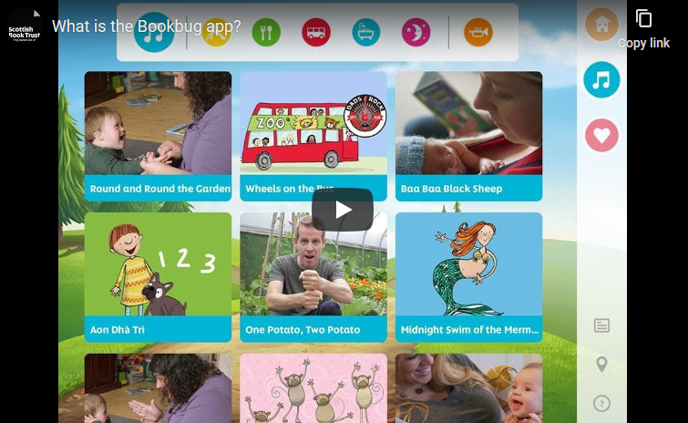

Early Level Literacy Home Activities
Teach an adult how to form as many letters as you can. Remember to use the letter rhymes!  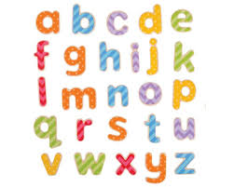 | Use play-doh to create as many lower and upper case letters as you can.  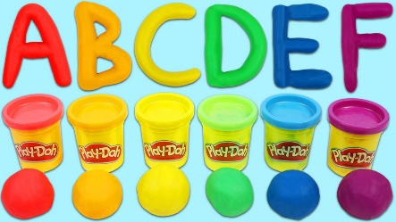 | Find different examples of letters and words you recognise around your house. | Practise singing the letters of the alphabet song to and adult.
Draw a picture of everyone in your family, try to sound out their name and write it above the picture. | Choose a book to read to read with an adult. Point out and explain the spine, title, author and illustrator. | Draw a picture and ask an adult help you to post it to a local care home.  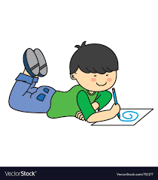 | Use chalk to write as many spelling words as you can outside.
Retell your favourite story using puppets – you could make your own puppets out of socks.  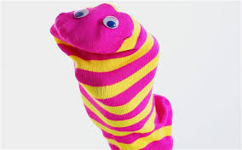 | Draw a picture of your favourite toy. Try to write a few sentences about it.  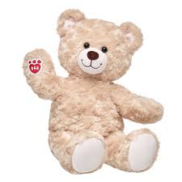 | Draw a picture of yourself and try to label your body parts.  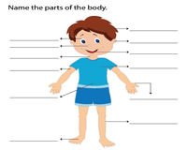 | Try and find/spell as many things in your house beginning with a. Each day you can choose a new letter.  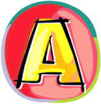

Early Level Literacy Home Activities
Write pairs of rhyming words in your jotter. | Read/Listen to a story. | Read a story and retell the main actions/events in a logical sequence. Use the picture clues. | Using puppets put on a puppet show for your family.  You could think of some traditional tales/ fairy tales.  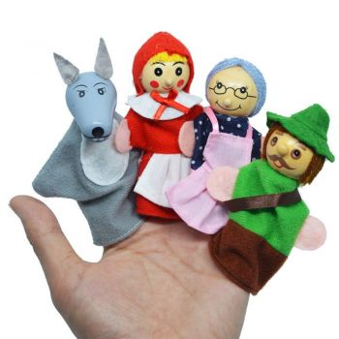
Choose a story & discuss what you enjoyed. Write about what you liked and disliked. | Log on to Topmarks.co.uk and play a Literacy game. | Practise your letter formation. Write your common words and try to use them in a sentence. | Make letters and words using a variety of materials. Paint, pipe cleaners, playdough etc.  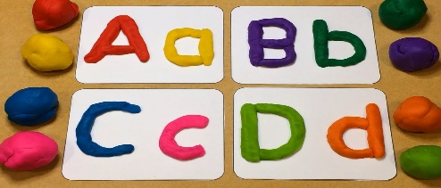
Make/Write a card for someone.  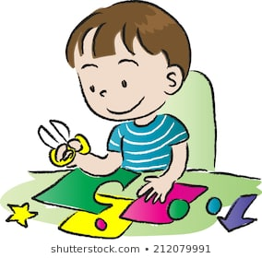 | Select your favourite cartoon or T.V. character and create a book for this character.  - Create a title for the book  - Illustrate the front cover  - Write a ‘blurb’ for the back cover | Talk to a family member and describe tasks/activities which you have been doing during the day. Ask questions about what other people have been doing. | Choose an item in your home and talk/describe this to someone.  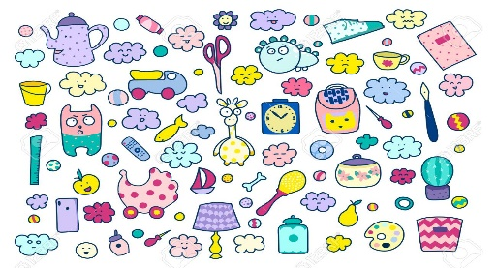

Early Level Speech and Language Home Activities

Think of as many words as you can which rhyme with:  Cat  Key  Ball  This means they sound the same at the end, e.g. cat-bat | How many syllables are there in these words?  Bunny  Teapot  Crocodile  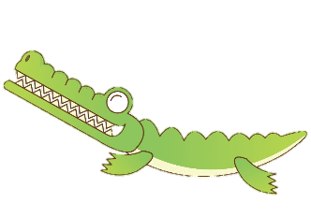  Can you clap them out? | Category Game - In one minute, name as many….  Animals  Fruit  Colours  …as you can think of | 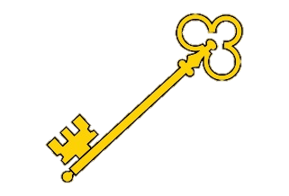  You have a Magic Key which opens a castle door. Describe what it might look, feel and smell like. Can you draw it?
Read a short story together. Now talk about:  Who was in the story?  Where was the story set?  What happened?  What happened at the end? | Can you solve these riddles?  Who uses a hose to put out fires?  Who has a red cape and can fly?  Who is pink with a curly tail?  Who wears a pointy hat and rides a broomstick? | How many doing words can you think of?  What do you do when you get up in the morning?  What do you do when you get home from school?  What do you do at the weekend? | Go around your house and collect a number of items:  What did you collect?  What does it look like?  (colour, shape)  What could you use it for?

First Level Literacy Home Activities
Take a minute to see how many words you can write beginning with the letter a. Choose a different letter every day. | Use play-doh to create as many of your spelling words as you can. | Try to write a news report about what happened in St Helen’s during Health Week. You can also write a weekly report at the end of the week. | Keep a diary and write down what you do and how you feel each day.
Write a report about everyone in your family. | Choose a book and read it to an adult. Try to write short summary of the book. | Make a card and write a nice message inside. Ask an adult help you to post it to a local care home. | Use chalk to write as many spelling words as you can outside.
Write an acrostic poem for Spring  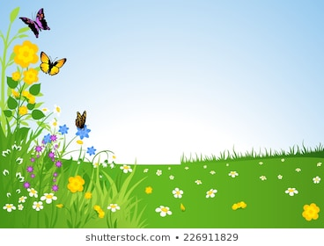 | Write a report about your favourite place to visit. | Write a narrative about going on an exciting adventure. | Try and find/spell as many things in your house beginning with a. Write a sentence for five words. Each day you can choose a new letter.

First Level Literacy Home Activities
Listen or logon to Newsround on CBBC. Listen to/read one news article. Note the main points/facts and use them to retell to a member of your family. | Choose a short book or a chapter of a book and read aloud for a member of your family to enjoy. | Retell a story, in your own words and in the correct sequence. Tell someone what you enjoyed, found interesting and why you liked/disliked the text. | Retell a story in your own words, using drama, props & puppets.
Create your own story with a beginning, a middle and an end. | Log on to Topmarks.co.uk and play a Literacy game. | Create a menu, birthday/special occasion card, postcard, letter, invitation, sign or label. | Keep a diary for five days. Write three paragraphs telling your reader what you did in the morning, the afternoon and in the evening.
Select a few stories from the news and make notes then write about these in your own words. | Write a rhyming poem about any subject of your choice.  Re-write it as a ‘Shape Poem.’  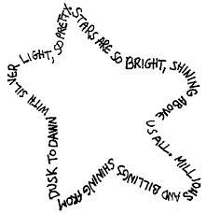 | Write a letter to a friend or relative  Giving details of what you have been doing and find out what they have been doing. (Include illustrations or diagrams) | Choose a short story or a chapter from a book.  Make a comic strip with pictures and sentences to describe main points of the story/chapter.  Give it to a family member to read/and or read aloud.  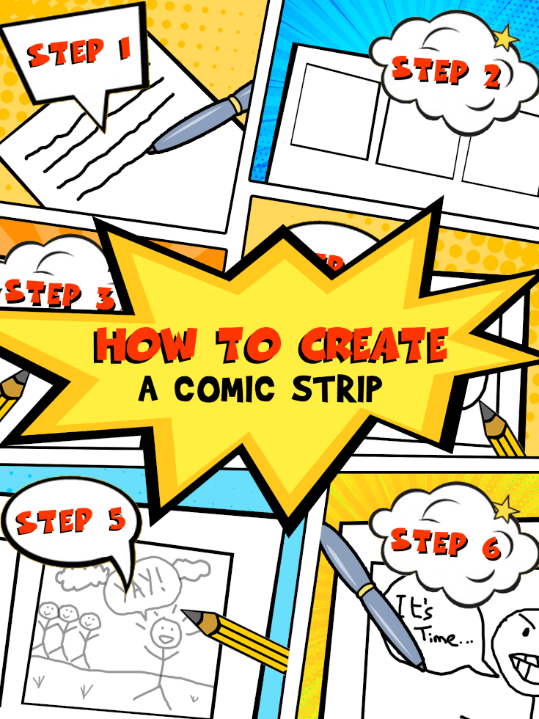

First Level Speech and Language Activities

Barrier Game: Take it in turns to describe items from your house – can you guess what the other person is describing? Talk about colour, shape, size, use | Think of as many words beginning with ‘b’ as you can. You have one minute!  Bb  Now choose another letter and play again! | Baking with an adult – can you follow the adult’s instructions to make something delicious?  Make sure you listen carefully! | Read a short story and see if you can answer these questions:  Who was in the story?  Where was the story set?  What happened?  How did it end?
Come up with an exciting story about an astronaut. Remember to talk about:  Who is in the story?  Where is the story set?  What happens?  How does the story end? | Work together to build a Lego model. Each person should pick a job  Engineer: describe the pieces and give the instructions  Builder: listen carefully and build the model. | Look at these words and see if you can work out:  How many syllables are there?  Does it rhyme with another word?  What is the sound at the beginning of the word?  Dinosaur  Caterpillar  Flower | Ask a friend or adult to think of an object. Try to guess the object by only asking where questions:  E.g. Would I find this object in my room?  Would I find this object in a school?  It’s tricky!

Second Level Literacy Home Activities
Write a report about someone influential you have learned about in school or at home. | Write an acrostic poem for a word that inspires you. You can choose a different word every day.  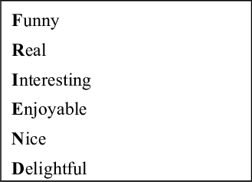 | Create your own newspaper to include news and updates about your family and friends. | Keep a diary and write down what you do and how you feel each day.
Use a dictionary to look up the definition of five tricky words from a book you are reading. | Choose a new book to read. Write a book review when you are finished. | Write an uplifting letter to someone in your community who you would like to cheer up. Ask an adult help you to post it. | Create, write and illustrate a comic book for a younger child in the school.  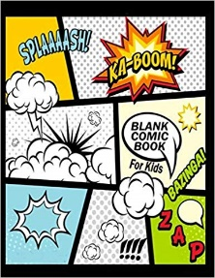
Prepare a solo talk about your hobby or something that interests you and. Present it to your family. | Write a letter to thank someone who has inspired you (a parent, relative, friend, teacher etc.) | Write a narrative about going on an exciting adventure. | Learn a Scottish poem or song and recite it for your family.

Second Level Literacy Home Activities
Listen or logon to the news. Listen to/read two news items. Note the main points in your jotter and use them to retell the items to a member of your family. | Select a chapter from a book. Having read it carefully, create five questions about it which you could give to one of your friends.  You should include different types of questions e.g. literal and inferential. | Select a book of your choice. Having read a chapter or a few chapters begin to create a visualiser, continue to develop this as you read on. | Select an historical figure.  He/she is writing his/her autobiography.  - Create a title for the book  - Illustrate the front cover  - Write an introduction  - Write a ‘blurb’ for the back cover
Think of an environmental issue which interests you – e.g. plastic pollution; recycling etc.  Do some research and make a three-minute documentary where you are the presenter. Record yourself (and family member you might interview) and keep it for use in school at a later date. | Log on to Topmarks.co.uk and play a Literacy game. | Write a rhyming, acrostic poem about any subject of your choice. | Select a few stories from the news. Design the front page of your own newspaper. Remember to include:  - Title  - Price  - Date  - Pictures  - Headlines  - Adverts
Keep a diary for your days at home, detailing events and activities you are doing. | Write a letter to a friend or relative  Giving details of what you have been doing and find out what they have been doing by asking relevant questions. | Select words from books/newspapers/magazines and select appropriate spelling strategies such as syllabification, phonological knowledge, word patterns, mnemonics, spelling rules etc to ensure correct spelling. | Create a text, select a genre, audience and purpose of your choice. You could even word process this and save to share at a later date.

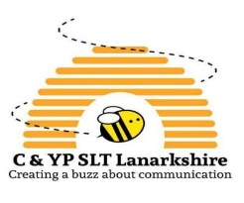
Second Level Speech and Language Home Activities
How well do you know your concepts such as big, small, long, short, curved, straight etc? Work with a partner to see if you can take turns to find bricks to match the descriptions – for example “find me the long, rectangular green brick”. | Read a story together with someone at home. Once you have read the story talk about who was in the story; what the characters were doing in the story and what they were doing it with (for example - playing on the swings); and where the story happened. This helps develop your sentence structure and vocabulary; as well as helping you to better understand WH- questions! | Quick name!  Name as many words as you can within a category in 60 seconds!  Ideas could include: different foods, different methods of transport, countries around the world etc. | 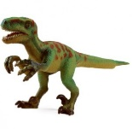  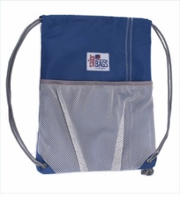  Collect a mixture of random items from around the house and put them into a bag. Peek into the bag and describe one of the objects using as many adjectives as you can and see if your partner can guess what it is!  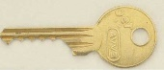
Pick a word – can you make up a visualiser word map about the word, for example:  What is the start sound of the word?  What is the end sound of the word?  How many syllables are in the word?  What is the meaning of the word?  Can you use the word in a sentence?  What type of word is it, e.g. verb/noun/adjective?  Can you draw a picture to match?  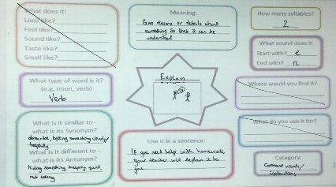 | Make a recipe together! Can you give your partner instructions about how to bake a cake? Can you listen to instructions from a partner and decorate a biscuit in a certain way? | Play “who am I?” or “where am I?” with a partner.  Example: “I work in a school and help children to learn – who am I?”; or “I am somewhere that is very quiet and I can see lots of people reading – where am I?”. | 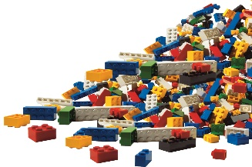  Work with a partner and sit across from each other. One person hold the instructions so that your partner can’t see them and explain (using only your describing words – no pointing!!) what bricks are needed and where to put them to build a model. Your partner has to listen carefully to the instructions to find the correct bricks and put them in the correct places!

Early Level Maths & Numeracy Home Activities
Create a pattern using a variety of shapes and numbers.  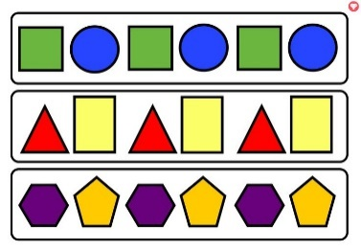 | Use play-doh to create as many numbers as you can.  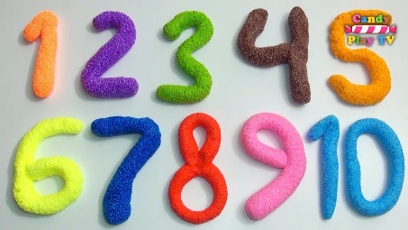 | Find as many different examples of numbers and shapes around your house. | Practise the days of the week. Youtube has videos and songs to help you.  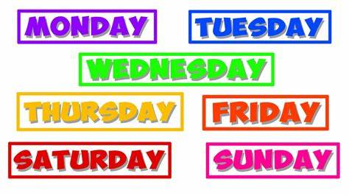
How many people are in your house? How many hands? How many eyes? Etc. | Log on to Sumdog. How many questions can you answer correctly? | Collect loose items from your garden or house. Count and sort them.  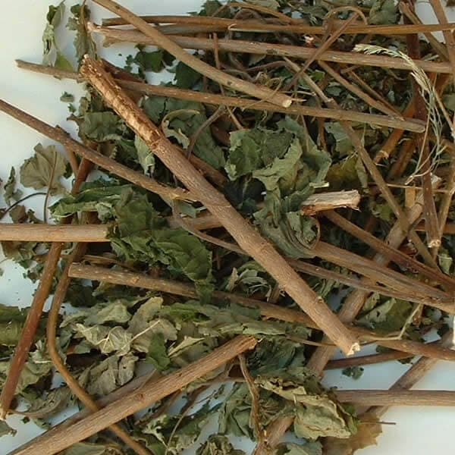 | Practise counting forwards and backwards. Also say the number before and the number after.  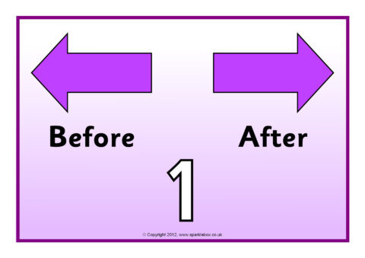
Measure different items in your house using your hands. E.g. how many hands long is your table? | Draw/paint a picture which has shapes and numbers in it.  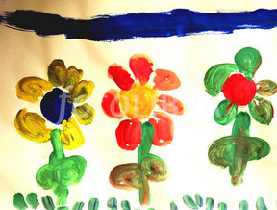 | Practise your number bonds to 10. Use objects to help you.  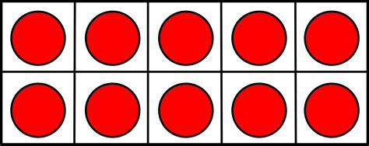 | Play snap with number cards.  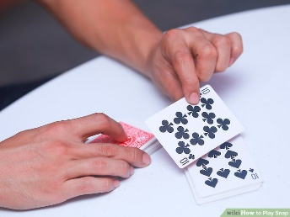

First Level Maths & Numeracy Home Activities
Create a repeating pattern using a variety of 2D shapes or 3D objects. | Create an addition/subtraction board game. Play it with your family.  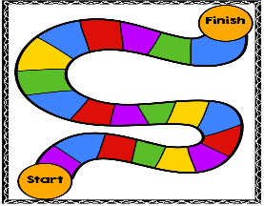 | Find as many different examples of numbers within the environment as you can.  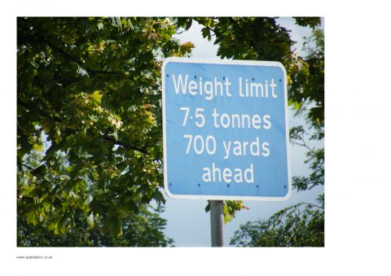 | Use a calendar to plan out some events for your family throughout the year. How many days or weeks are between events?
Estimate the length of different items in your house. Measure them with a ruler and check if you were correct.  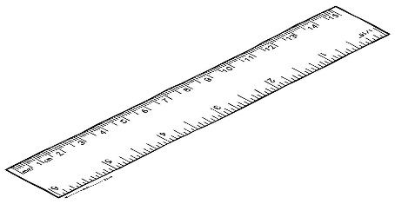 | Log on to Sumdog. How many questions can you answer correctly? | Carry out a survey on a subject of your choice. E.g. favourite TV programme, favourite chocolate, eye colour. Display the information using a graph.  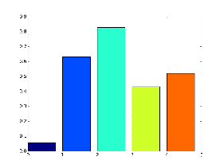 | Get someone to give you random numbers. Practise saying the number before and the number after.  99
Imagine you have £10. Choose three sweets to buy. Work out the total cost and how much change you would have. | Draw/paint a picture which has at least one line of symmetry. | Practise time tables facts. Focus on the times tables that you find most challenging.  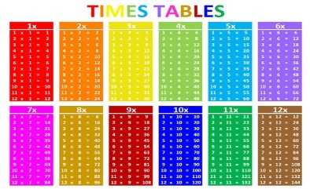 | Gather some items from your house. Sort them from lightest to heaviest.

Second Level Maths & Numeracy Home Activities
Research a famous mathematician. How did they impact the world?  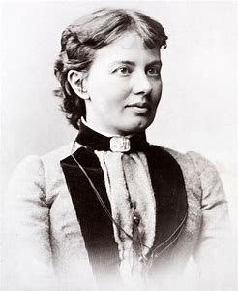 | Create a multiplication/division board game. Play it with your family. | Find as many different examples of numbers within the environment as you can. | Build something out of Lego bricks. Work out the fraction of each coloured brick.
Estimate the perimeter and area of your garden or local park in metres. Convert it to cm and mm. | Log on to Sumdog. How many questions can you answer correctly? | Look through a catalogue or a website and find as many special offers as you can. E.g. 25% off or Buy One Get One Free. Work out if the offer is a good deal. | Get someone to give you random numbers. Practise saying the number before and the number after the number.  999
Use the internet to plan a weekend away for a family of 4. You must include transport and accommodation. You have a budget of £450.  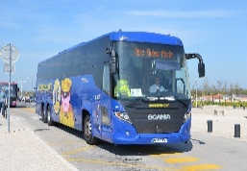 | Using a TV magazine or a TV Planner choose different TV programmes or films. Note the start time, the end time and the duration of each one. Which lasts the longest? | Practise time tables facts. Focus on the times tables that you find most challenging. | Choose a famous landmark and draw it to scale.

