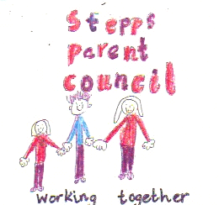

Stepps Parent Council Action Plan
AGM
13th September 2022

Date | Action | Owner | Update
13-9-22 | Local Councillors to be invited to PC meetings. Issues outstanding:  - Dining space  - Playground space  - Access to community lets  - Road safety  - Modular units/ community hubs and children’s safety | Diane Delaney | Invitations have been made.  Cllr McLaren has never been able to attend a meeting.  Cllr Williams attended one meeting.  Cllr Cairns could not attend a PC meeting but met with PC office bearers outwith the PC meeting.  All issues remain outstanding.
 | PC membership details to be sent to the Parent Involvement Officer NLC | Diane Delaney | Done
 | Communication strategy to be reviewed | All | Done – Parent Forum Surveyed and results posted to Twitter and shared in the school newsletter.
 | A list of questions arising from the ongoing building works to be compiled and sent to Mr McKeever as per outcome of formal complaint to the local authority | Lorraine Kerr | Done
 | Parents can write to local councillors raising their concerns about  - Road safety  - School capacity issues  - Lack of information on modular units  - Playground size and use  - Dining room space | All | Done
 | Councillors contact details and template letter will be made available to all | Diane Delaney
 | Consideration of a Freedom of Information Request to find out more information about the playground assessment | All | Considered but we decided not to proceed with this on the basis of discussions with Cllr Cairns.
 | Consideration of positive/ proactive work for the PC going forward this year | All | Done
 | Consideration of some workshops/ information sessions on money advice | All | This was considered but not acted upon. Up for consideration again this new school year.
 | Meeting arranged by the local authority on 27th September to discuss school building works and return of the community hub for day lets | Diane Delaney, Lorraine Kerr and Mr McKeever | Done

