Welcome to Stepps Primary first
Values Newsletter!

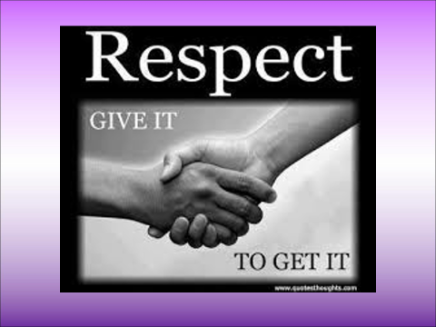

We start the term and the month of April/May focusing on the value of ‘Respect’. This value is at the core of everything we do in school. It underpins learning through behaviour and one’s attitude to the people and the world around them. We are extremely lucky that our school community is a very positive, supportive and respectful one.

We discussed the first of our values ‘Respect’ at assembly and the fact that:

You can have respect for someone because you admire something about them.
You can have respect for someone’s feelings, their wishes or their rights.
You can have respect for things other than humans or things that aren’t living.

We explored a number of ways we can show respect, the other values that help us to show respect and questions were discussed in relation to respect:

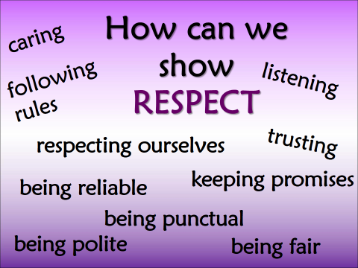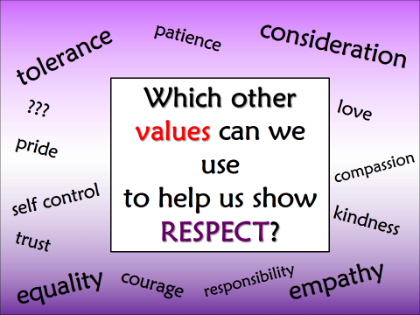
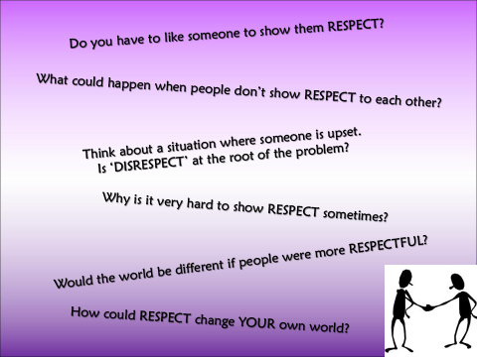

Following this our ‘Respect Me’ Committee held an assembly. They asked children if they would like to design a poster, write a song or rap or make an information leaflet about showing respect in school. Some will be displayed around the school or maybe published on the school blog or Twitter feed.

Children also viewed a number of ‘Respect Me’ movies made by and starring the pupils of Stepps. The short movies reminded us not to point out anyone’s differences, not to ‘join in’ when children are having disagreements and demonstrated ways older children can help to correct the behaviour of our younger children.

Look out for children receiving awards or stickers when they demonstrate the value of ‘Respect’ in school.

One of the most important things you can teach a child is RESPECT.
Keep in mind that RESPECT is not the same as obedience. Children might obey because they are afraid. If they RESPECT you, they will obey because they know you want what's best for them.
The best way to teach RESPECT is to show RESPECT. When a child experiences RESPECT, they know what it feels like and begin to understand how important it is.

Treat people the way you want to be treated.

Speak to people the way you want to be spoken to

RESPECT IS EARNED NOT GIVEN

What having RESPECT means at Stepps Primary:

RESPECT means doing what you are told, sticking to the school rules, helping your friends and not being nasty.
Rebecca McElveen P2KL

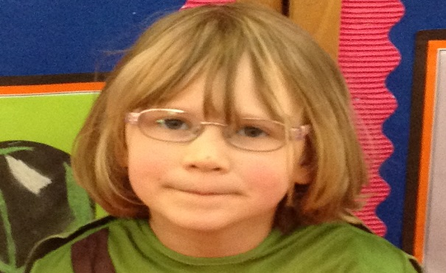

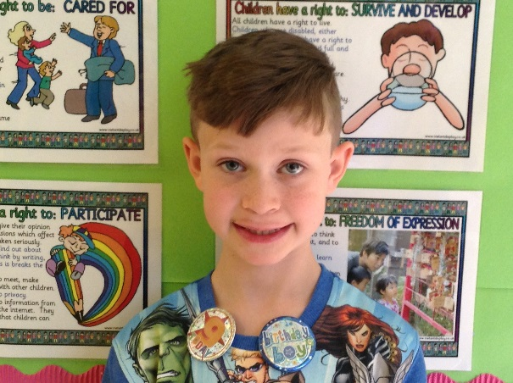
RESPECT means showing others that you like them by being nice and complementing them and by doing what you are asked to do by your teachers.
Lewis Maxwell P4/3

RESPECT means not bullying others, helping people if they are in difficulty and caring about everyone. Accepting what people look like and wear.
Beth Lambert P6B

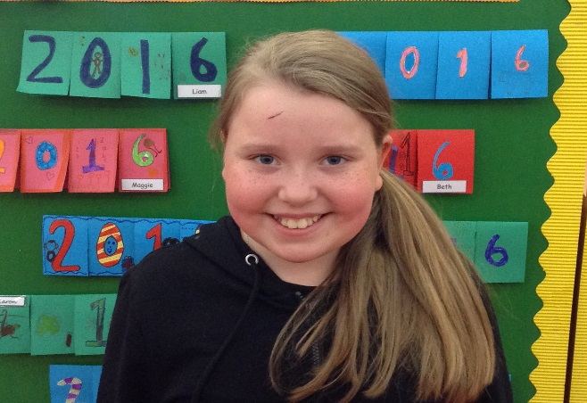

And finally – for the adults...

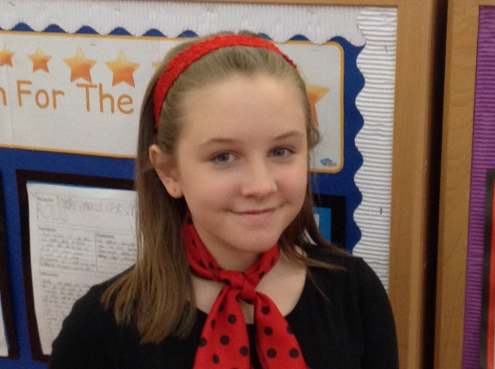
RESPECT means just really caring for others, not judging them, including everyone and not pointing out differences in people.
Lily Mills P7M

HOW YOU CAN HELP AT HOME

One of the most important things you can teach your child is respect.

Schools teach children about respect, but parents have the most influence on how respectful children become. Until children show respect at home, it's unlikely they will show it anywhere else.

Respect is an attitude, being respectful helps a child succeed in life. If children don't have respect for peers, authority, or themselves, it's almost impossible for them to succeed.

A respectful child takes care of belongings and responsibilities, and a respectful child gets along with peers.

How can you show respect to your child?
Be honest - If you do something wrong, admit it and apologise.
Be positive - Don't embarrass, insult or make fun of your child. Compliment them.
Be trusting - Let your child make choices and take responsibility.
Be fair - Listen to your child's side of the story before reaching a conclusion.
Be polite - Use "please" and "thank you". Knock before entering your child's room.
Be reliable - Keep promises. Show your child that you mean what you say.
Be a good listener - Give your child your full attention.

