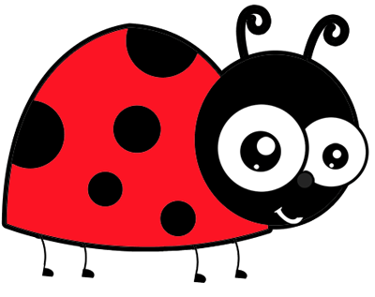

Cleaning Policy

Cleaning Policy
Aim
In Stepps Nursery class we aim to provide children with a high quality, clean and safe environment. In light of the current Coronavirus pandemic, staff are carrying out additional cleaning measures in order to prevent potential transmission of the virus by touch.
Cleaning
The daily cleaning schedule will be completed at the end of each day to confirm what cleaning has been carried out. Throughout the day, all of the frequently touched objects and surfaces used by children and staff will be cleaned using Toucan spray provided by cleaning staff. These areas consist of, but are not limited to-
- Children’s toys and resources
- Worktops, table tops and chairs
- Door handles and light switches
- Window ledges and handles
- Children’s pegs in cloakroom
- Laptops and keyboards

Cleaning staff will also come in to clean the nursery twice a day to focus on the following:
- Full toilet clean
- Clean sinks and worktops
- Hoover carpet
- Empty bins
- Brush and clean floors
Children’s paint aprons will be cleaned in the washing machine at the end of the week, or earlier if required. Soft toys and furnishings will be limited and cleaned according to instructions regularly.
The following will be completed at the end of the week and signed and dated by a staff member on the cleaning record sheets:
- Microwave cleaned with anti-bacterial cleaner
- Fridge emptied of any out of date products and cleaned using an anti-bacterial cleaner
- Oven cleaned using an anti-bacterial cleaner

Cleaning materials
All cleaning materials MUST be stored out of reach of children, in locked cupboards. All cleaning materials used will meet advice provided in Infection Prevention and Control measures to prevent cross contamination.
- Red rimmed cloths will be used to wash toilets
- Blue rimmed clothes will be used to wash kitchen work surfaces
- Plain clothes are used for general areas
- Red handled mops will be used to wash toilet floors
- Blue handled mops will be used to wash all other floors

Procedures for dealing with broken toys
Small toys in the nursery which are broken or lost should be placed in the fix or ditch box. This will be emptied for fixing or ditching at the end of each week. Larger broken toys e.g. bikes should be placed in the area of the large cupboard and again a decision should be made at the end of the week as to whether it can be repaired or should be disposed of.

Reviewed November 2020

