Stepps Primary Nursery Class
2020-2021
Newsletter March 2021

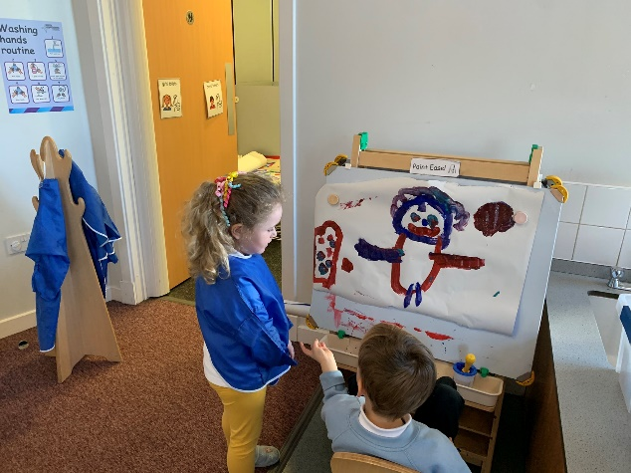
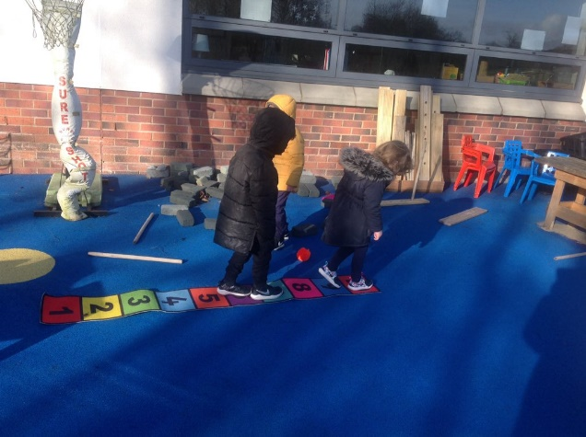
Outdoor Learning Friends Reuniting

Team Work Lunch Time
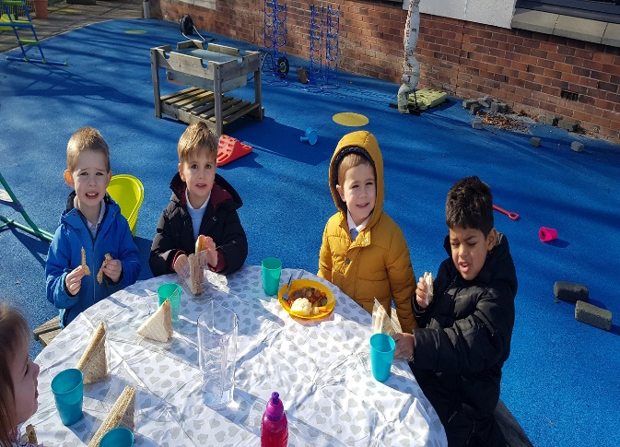
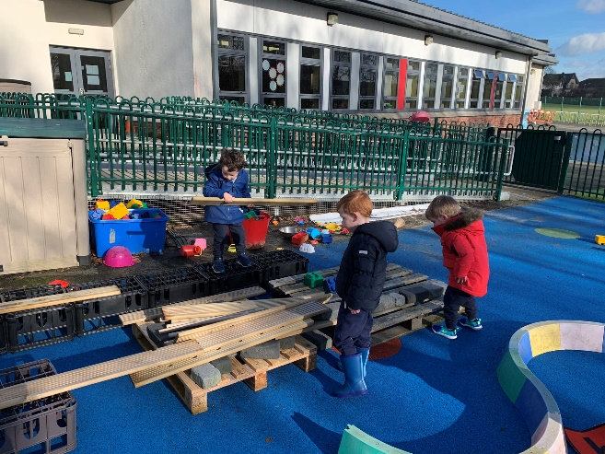

Welcome Back
We would like to say welcome back to all of our children and families. It has been a difficult few months and we have missed you all. We would also like to thank you all for your engagement in our digital learning and we hope that Teams and our Virtual Playroom are platforms that we will continue to use to enhance your child’s learning and communication between families and nursery.

Bubble Groups
The children are in 3 Bubble groups and are moving around the nursery throughout the day with the same keyworker. This is to minimise the contact between adults and children.

Parent Club return to school and nursery campaign
Parent Club have developed a campaign aimed at helping parents to abide by all current restrictions (both themselves and their children) throughout the phased return to schools and ELC settings. The key messages of the campaign are:
- Adults wear face coverings at drop off/pick up
- One adult at drop off/pick up
- Adults keep 2m apart
- Avoid car sharing
- Self-isolate if anyone in your household has symptoms
Twitter
We update our Twitter page regularly so please follow us to see what your children get up to in nursery! @SteppsNursery

Donation

Your weekly donation of £3.00 is used to purchase snack for your child as well as nursery resources throughout the year. As always your healthy donations to the snack table are more than welcome!
Learning Journals
Please remember that you can access your child’s learning journal as this will provide an insight into your child’s learning at nursery. There are some great photographs of the children and opportunities for you to add your own comments. You can also add your child’s learning from home. Thank you so much to all parents who have already accessed the system.

Lunches
We understand not all children will enjoy the hot option provided at lunch however there is always a choice of a sandwich. A dessert of fruit/yogurt is provided three times a week and a biscuit/cake twice a week. If neither of these options meet your child’s dietary requirements you are welcome to send one main course and one dessert. If you are providing a lunch for your child please label it and place it in the box provided outside at the nursery door. Please keep in mind we are a health promoting nursery. All food must be nut free due to allergies.

Planner
For our first two weeks back at nursery we are doing a consolidation of all of our home learning tasks based around Healthy body healthy mind. We will then be moving on to learn about Easter and new growth.

Dates for your diary
World Book Day: Thursday 4th March
To celebrate World Book Day your child can come to nursery in their pyjamas or dressed up as their favourite character from a story and bring along a book to share with their friends at story time. Please ensure books are labelled with your child’s name. To support the importance of literacy development and reading stories we will be doing a sponsored read to raise funds for our nursery. Please find attached a copy of your child’s reading log and sponsor sheet. The sponsored read will begin on Thursday 4th March and will run for 1 week. All sponsor sheets and donations should be returned on Monday 15th March.
Red Nose Day: Saturday 13th March
We will be celebrating Red Nose Day on Friday 12th March. All children can come to nursery wearing Red or in pyjamas for a fun filled day. Suggested donation £1.
Easter celebrations
We will be having a Daffodil Tea in nursery on Wednesday 31st March. Children are welcome to make and wear and Easter bonnet.
Spring Break
The nursery will close on Thursday 1st April at 2.45pm for the holiday period and will reopen on Monday 19th April at 8.45am
Practical Science Week: Monday 19th April – Friday 23rd April
During Practical Science Week your child will have opportunities to develop their learning throughout this curricular area by learning through stories, using technology for research and participating in science experiments.

We would like to say a huge thank you to all parents/carers for your continued support and patience over the last few very challenging months.

The Nursery Team

