Stepps Primary Nursery Class
2020-2021
Newsletter Term 2

Outdoor Learning Forming Friendships

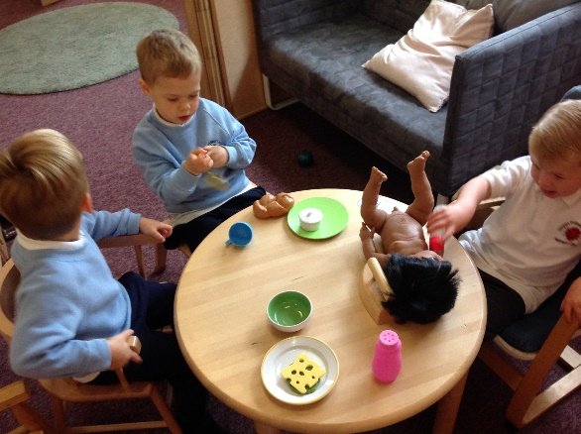
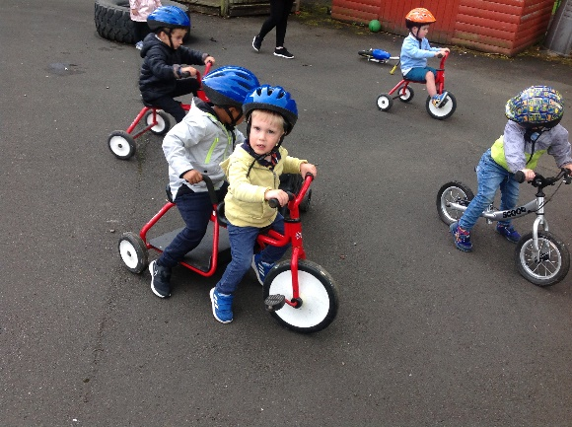

Blowing Bubbles Ribbon Dancing
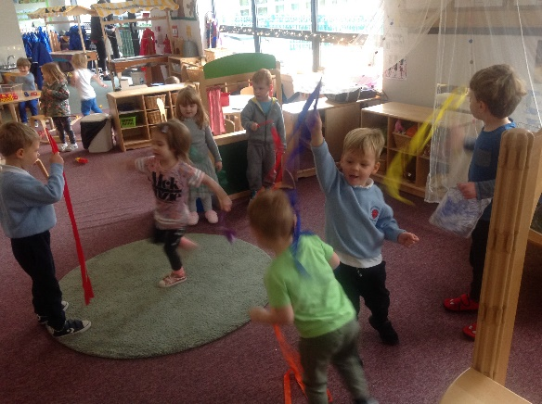
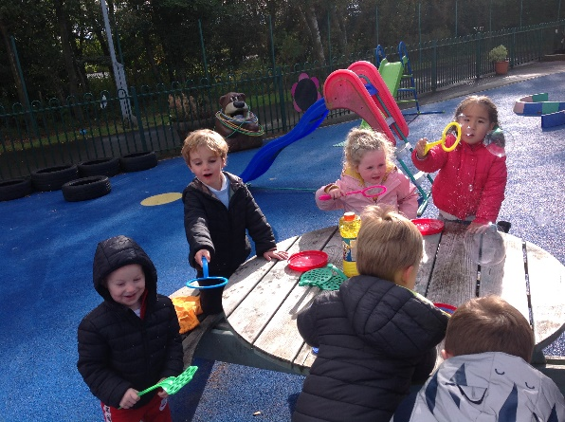

Bubble Groups
As we have now moved to tier 4 there have been some changes to the nursery routine. The children are in 3 Bubble groups and are moving around the nursery throughout the day with the same keyworker. This is to minimise the contact between adults and children.

Drop off times
In order for staff to spend maximum amount of time with the children can we respectfully ask parents to adhere to the drop off and collection times. Drop of time is between 8:45-9.00am and if you would like to collect your child after lunch could you please come between 12:15-12:30.

Winter Clothing
As we are outdoors everyday can we ask you to remember to send your child to nursery wearing warm and suitable clothing such as hats, gloves and boots etc. Also due to the virus we require to have windows open all day in the playroom for ventilation so can you please ensure your child has layers on for warmth.

Twitter
We update our Twitter page regularly so please follow us to see what your children get up to in nursery! @SteppsNursery

Donation
Your weekly donation of £3.00 helps us to purchase a varied and exciting snack for your child as well as nursery resources throughout the year. As always your healthy donations to the snack table are more than welcome!

Learning Journals
Just a reminder that you can access your child’s learning journal as this will provide an insight into your child’s learning at nursery. There are some great photographs of the children and opportunities for you to add your own comments. You can also now add your child’s learning from home. Thank you so much to all parents who have already accessed the system.
If you have not yet been added to the system, please leave your full name and email address with staff.

Lunches

We understand not all children will enjoy the hot option provided at lunch however there is always a choice of a sandwich. A dessert of fruit/yogurt is provided three times a week and a biscuit/cake twice a week. If neither of these options appeal to your child you are welcome to send one main course and one dessert. If you are providing a lunch for your child please label it and place it in the box provided outside at the nursery door. Please keep in mind we are a health promoting nursery. All food must be nut free due to allergies.

Planner
Our November/December planner is now on display in the nursery foyer. The children have been super busy this term and have been enjoying going on autumn walks looking at and collecting leaves. We have also been exploring different styles of dance, listening to various stories, learning about fire safety during marshmallow toasting and much more! For the second half of term 2 we will shift our focus towards Christmas. The children will take part in various Christmas activities, they will help to create our Christmas shop, decorate our tree, make their Christmas lists, make various Christmas art and learn about the Christmas story. Unfortunately this year due to the virus we are unable to have parents in to help with activities and wrapping presents etc. If you have anything you would like to hand in for Christmas it would be greatly appreciated.
Our SHANARRI focus for this term is ‘nurtured’. Here in the nursery we are committed to valuing the children’s ideas and opinions. We encourage the children to talk, listen and make healthy choices for themselves. As well as recognising and rewarding their achievements

Dates for the diary!
School Closes for Christmas – Tuesday 22nd of December @2.30pm
Crazy Christmas Jumper Day - Tuesday 22nd of December
Nursery Returns after the New Year – Wednesday 6th of January

