Stepps Primary Nursery Class
2020-2021
Newsletter Term 1
It’s been a busy few weeks at Stepps Primary Nursery Class. Our new starts are settling in well and our returners are feeling right at home. We’ve allowed the children some time to acquaint or re-acquaint themselves with the nursery routines and resources and have some fun!
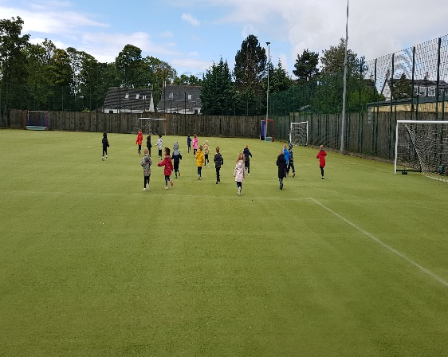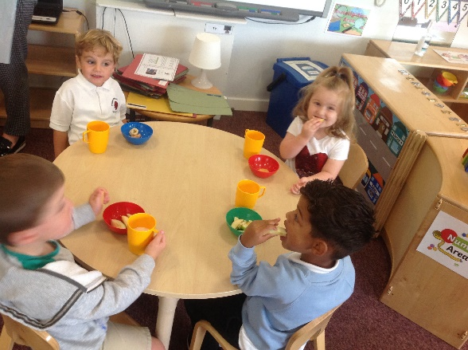
Exploring our environment: PE Exploring tasty and healthy snacks
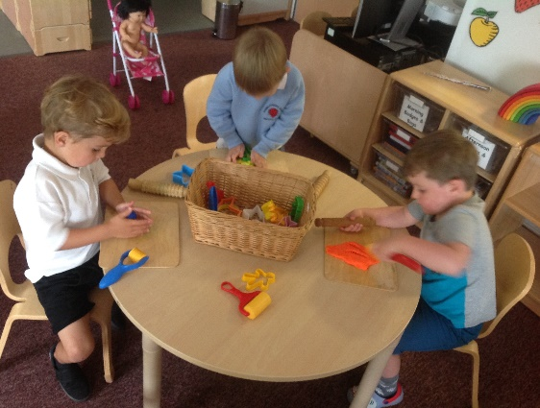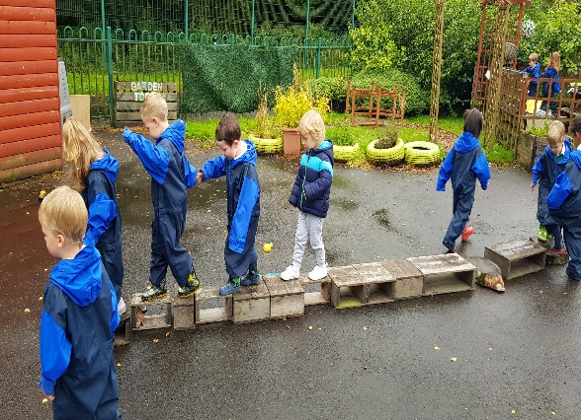
Developing friendships Assessing and managing risk

Planner
Our September/October planner, along with the children’s suggestions, is now on display in the nursery foyer. Our learning context for the start of this session is “Getting to know me & my Environment” and this will enable the children to become familiar with the nursery and school environment and our routines. It will also allow staff to get to know your child as we work together on their “All about Me” booklet.

Twitter
Stepps Nursery class has a Twitter account. Please feel free to follow our account @SteppsNursery to keep up to date with nursery news and events.

Learning Journals
Just a reminder that you can access your child’s learning journal as this will provide an insight into your child’s learning at nursery. There are some great photographs of the children and opportunities for you to add your own comments. Thank you so much to all parents who have already accessed the system.
If you have not yet been added to the system, please leave your full name and email address with Staff.
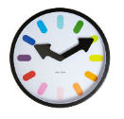

Nursery Hours & Routines
8.45-9.00 – The children arrive & are welcomed into nursery
9.00-.9.45 – The children have the opportunity to learn through free play.
9.45-10.00 – The children take part in circle time
10.00- 10.15- Snack time (water/milk, fruit, toast/cereal)
10.15-10.30- The children brush their teeth
10.30-12.30 – Planned learning experiences from curriculum/ Outdoor learning
12.30-1.00- Children have lunch (menus have been issued to parents)
1.00-1.30 – Rest/quite time
1.30-2.45 - Focus group learning (three read, ICT, music/drama, PE, languageland)
2.45 – Home time

Collection Procedures
Please remember that we are only able to hand over children to authorised adults. If you wish someone else to collect your child, you must inform a member of staff, either in person or by telephone.
Could we respectfully ask parents/carers to please adhere to nursery collection times which are by 2.45. You can collect your child at any time as long as you inform a member of staff.

Donation
As your child now attends nursery full days we ask for a £3 weekly donation. Your weekly donation of £3.00 helps us to purchase a varied and exciting snack for your child as well as nursery resources throughout the year. As always your healthy food donations to the snack table are more than welcome! At drop off time the donation board will be left outside the nursery with each child’s name where you can leave your donation.

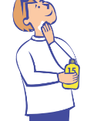

Sun cream
During hot weather we ask you to put sun cream on your child before arriving at nursery. We also ask you leave a sun cream in your child’s bag labelled which can be applied through the day if need be. A roll on sun cream is preferred as this is easier for the children to apply themselves, they will be assisted by staff if need be.

Nursery Staffing
We would like to take this opportunity to formally introduce our staff.
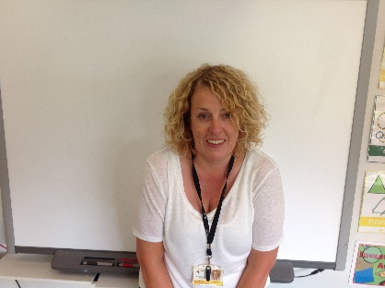

Mrs Burns Miss Traynor Mrs Young
(Lead Practitioner) (Early Learning Practitioner) (Early Learning Practitioner)
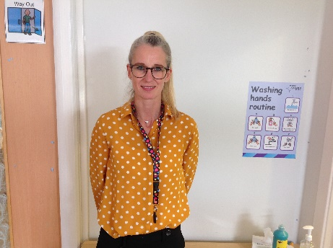

Miss 0’Byrne Mrs Ward
(Early Years Practitioner) (Support Worker)
If you have any questions or queries, please feel free to approach a member of staff at the beginning or end of your child’s session. If you would like to make an appointment, please contact the school by telephone and you will be directed through to the Nursery.

Outdoor Play
As always, your children are having wonderful experiences outdoors. They are encouraged to freely explore all aspects of our garden, so they will most probably get dirty/wet. With this in mind, please do not send your child in any clothing which you do not want to be used for this purpose. Can you also please leave a change of clothing on their peg?
Wellington Boots
As your child will be outside in all weathers, please make sure they have a pair of wellies with them at nursery. Remember to label them! Can we also ask that the children have soft indoor shoes or slippers which they can take off and put on independently as this saves time?

Lunches
As you will be aware the children are being provided with hot lunches during the nursery session. A copy of the lunch menu was issued to all parents and there is a daily chart displayed in the foyer which shows how much each child has eaten. If your child chooses not to eat any of the hot lunches they will always be offered a sandwich. As the children are now in full days it is important children do eat either of these.

1140 hours Update
Everyone should now have received their email with the update that we are providing 1140 hours provision to all of our children.

Holidays: Children Returning From Countries Not Exempt From Self – Isolation
The Health Protection (Coronavirus) (International Travel) (Scotland) Regulations 2020 require all those returning to Scotland from non-exempt countries to self-isolate at home or another appropriate location for 14 days. A current list of exempt countries can be found by visiting the following website:
https://www.gov.scot/publications/coronavirus-covid-19-pblic-health-checks-borders/pages/exemptions/
If you are planning to take your child out of nursery for travel, we will ask you to specify the destination.

Dates for the diary!
September In-service day (children do not attend): Thursday 24th September
September Weekend – Friday 25th September & Monday 28th September
October Week – Monday 12th to Friday 16th October
November- In-service day Monday 16th November

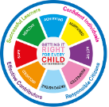

Safe
The wellbeing of every child is important to us. The SHANARRI indicators from the Scottish Government ensure that we support each child in our care. During September and October the nursery will be focusing on the ‘Safe’ indicator. We will be exploring how to keep ourselves safe and protected, at nursery and at home. We will be learning about how rules keep us safe in our playroom. We will also be in the community learning about road safety so give us a wave if you see us!
In the nursery we are always looking to improve our teaching and learning. We would love to hear your feedback and suggestions about how you feel your child is being kept safe.
Shanarri Suggestions & Comments – Please return to nursery staff

Name:

