Stepps Primary Nursery Class
2015-2016
Newsletter Term 4

Welcome back
We hope you all had a lovely Spring break. The children have returned eager to share stories about their holidays and fun family outings. Lots of fun was had at the Easter party, the children took part in exciting activities and went on a Easter egg hunt.

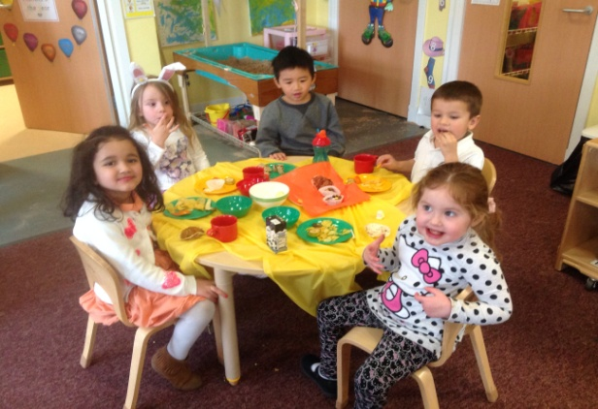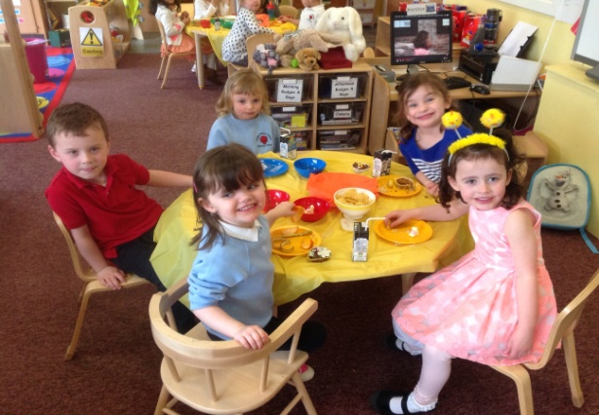
Easter party fun!
Online Learning Journals
Thank you again for taking the time to look at your child’s online journal. The profiles are an ideal way to follow their nursery learning journey and progression. Staff will continue to add significant observations each month. Updates about what is happening daily or weekly in the nursery can be found on the blog and the learning wall.
Science week
During the first week back the children have been very busy taking part in Science Week. They have been conducting experiments, such as melting ice, making volcanoes, mixing paints and learning about floating and sinking. The children have also been making predictions and recording the results.

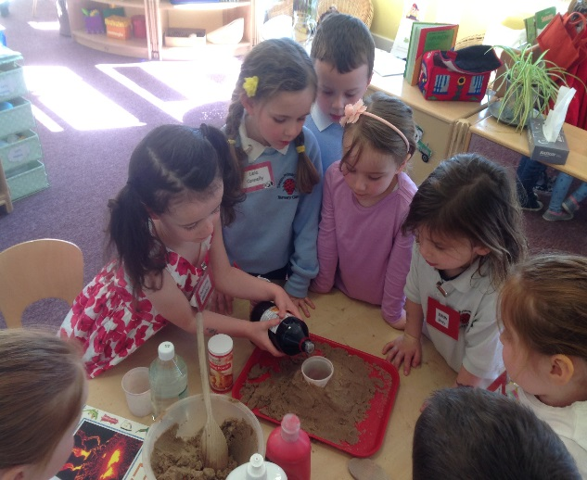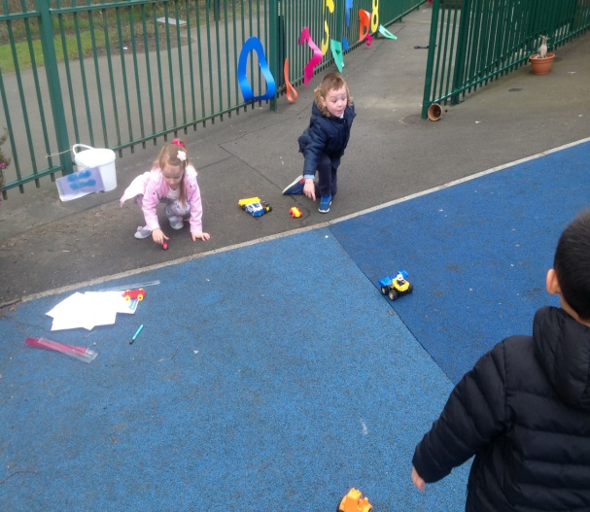
An erupting volcano Exploring moving toys

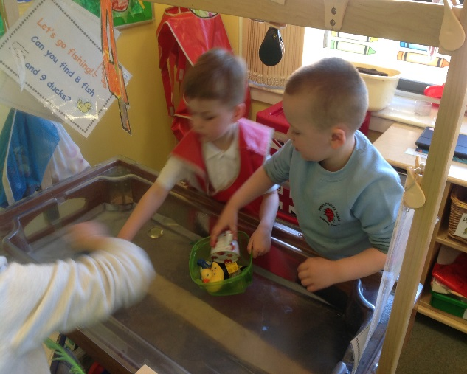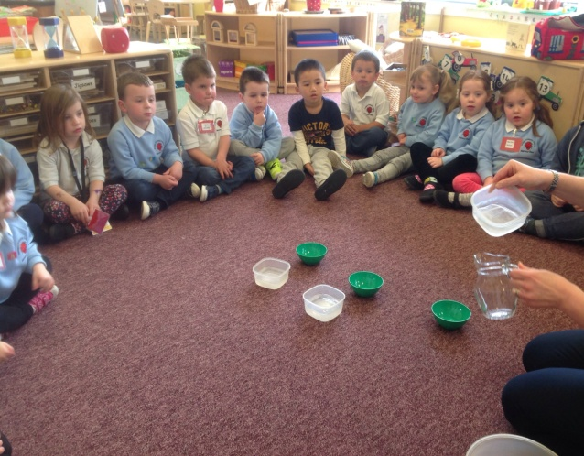
Floating and sinking Melting ice

Planner
Our April/May planner is already on display in the foyer and has been uploaded onto the Nursery blog. For those of you that have not had an opportunity to view it, here is a rundown of the areas the children will be covering:
We are learning about Jungle animals
Sounds of letters
Exploring size and patterns by matching and sorting
Moving our bodies and becoming aware of space
Creating pictures and objects using art resources

Induction days
As the end of the school term is fast approaching, the pre-school children will have several school visits and induction days, as well as visits from class teachers. Letters will be given out shortly detailing dates and times for inductions.

Graduation
Over the next two months the children will be working extremely hard preparing for their nursery graduation, which will be held on Tuesday 28th June at 9.30am. All children are invited to attend nursery in the morning, therefore there will be no afternoon session this day. Letters regarding the graduation will be distributed soon.

Reminders

Summer trip
The nursery trip is on Tuesday 31st May and will be a full day outing. Children should arrive at nursery at 9am and be collected at 3pm. We are looking for parent helpers to join us and help out on the day. If you are interested please notify a member of staff and we will try to accommodate as best we can.

Sun safety
Now that Spring is finally here and the weather is getting warmer it is important that the children are safe while playing outdoors. On warm and sunny days we ask parents/carers to apply sun cream to their child before arriving at nursery. Staff will provide sun cream for parents to apply to their child, in case of emergencies. Hats should also be worn while playing outdoors at nursery to protect the children from the sun.

Building the Ambition
As prime educators we value parents input and thoughts on their child’s nursery education and learning journey, therefore, it is important that we consider your views on how staff can continue to offer the best nursery experience for your child and family. Every few weeks we display a questions for parents to answer on the wall display which is located next to the learning wall. We welcome any input you may have.

Fair trade week

The children took part in Fairtrade Fortnight and had fun finding out about Fairtrade and looking for the logo on food and drinks. They watched video clips showing the benefits of Fairtrade to the farmers and their families.They then had a Fairtrade snack with banana and chocolate muffins baked by the children and hot chocolate .

Sports relief day
The children had lots of fun during sport relief day and had a very active session. The children participated in physical actitivies such as dancing to the theme song and completing an outdoor obstactle course. The morning children joined the school aerobics workout which was lots of fun. The children were learning about where the money raised will go and how it can help other children and families. The children raised £44, well done everone!.
Dates for the diary!
Nursery Trip – Tuesday 31st May
Graduation – Tuesday 28th June- 9.30am

School and Nursery will be closed on:
Monday 2nd May – May Day Holiday
Thursday 5th – Closed for children (Staff In-service Day).
Friday 27th May and Monday 30th – May Holiday.

Highlights from Term 3

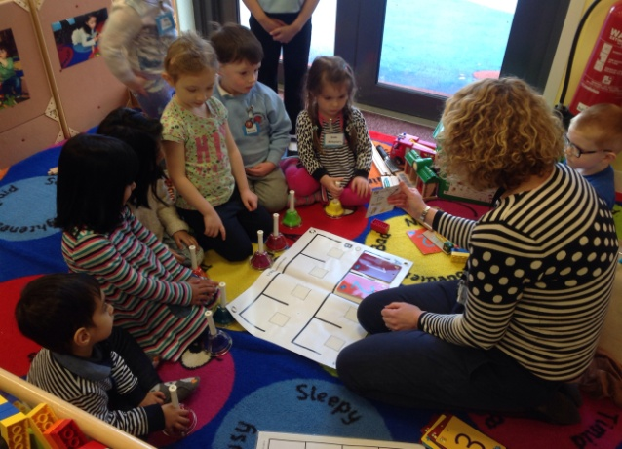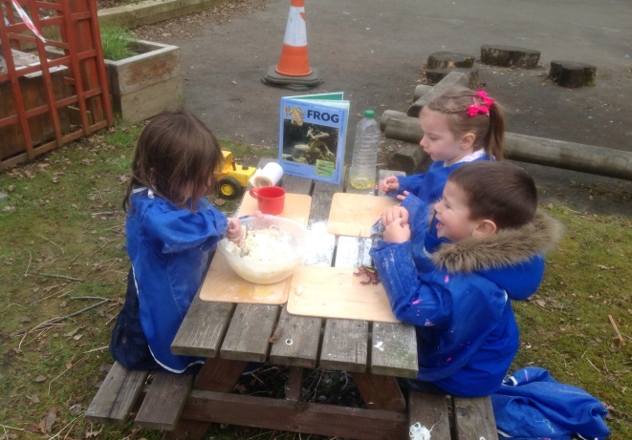
ABC music Making frogs
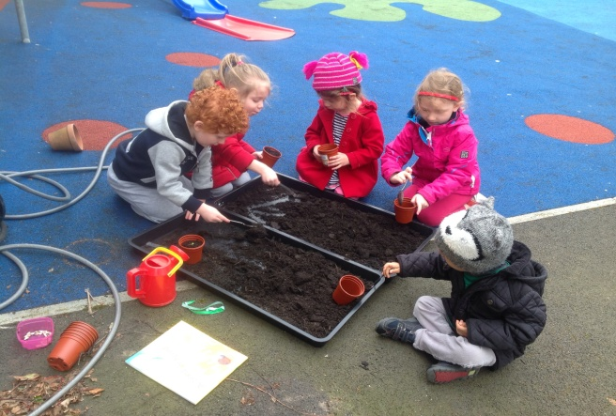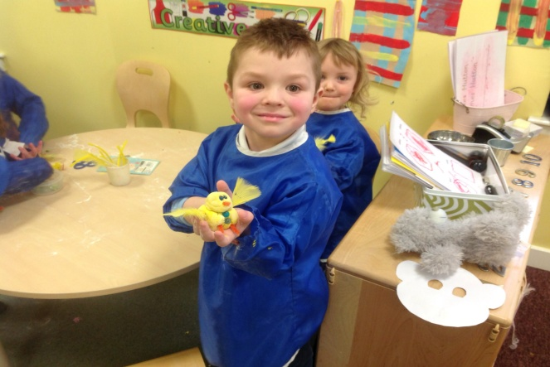
Planting sunflower seeds Easter fun
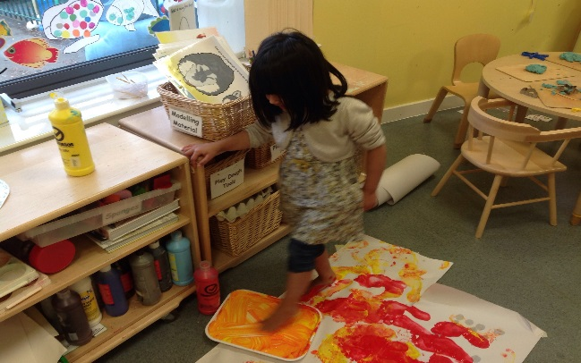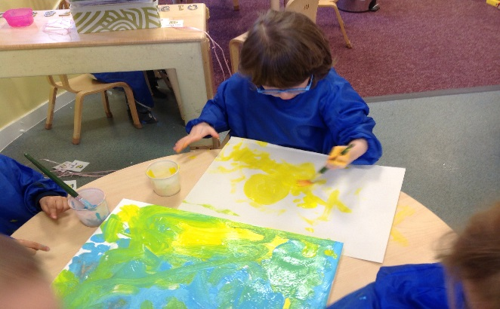
Foot prints Exploring paint

