St. Edward’s PSPSPS
Term 3
RRS Newsletter
Articles for this term
- Article 12 I have the right to be listened to and taken seriously
- Article 15 I have the right to meet with friends and join groups
- Article 17 I have the right to get information in lots of ways
- Article 19 I have the right to be protected from harm
- Article 31 I have the right to relax and play

Welcome Back
Hi everyone, we’re back for a new term! Welcome to our new committee members from Base 4. We are also excited to have more staff members on board too, Miss Garey, Mrs. Hamilton and Miss Clements. We look forward to working with you all.

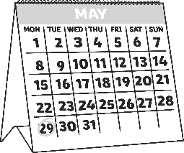
ate)

See our department noticeboards for more information as we continue with our Journey to the Rights Respecting Schools Silver Award, Kind Regards, Mrs Hughes

Calendar
- Mental Health Week 5th to 9th Feb
- Internet Safety Day-Tuesday 7th February
- Neurodiversity Celebration Week 13th to 19th March
- World Water Day-Wednesday 22nd March

Some useful links for pupils and parents;
(Insert Term)
Newsletter
https://www.unicef.org/child-rights-convention

https://www.gov.scot/policies/human-rights/childrens-rights/

https://www.unicef.org.uk/rights-respecting-schools/wp-content/uploads/sites/4/2019/09/Outrightpack2019_v9.pdf

https://www.cypcs.org.uk/rights/uncrc/articles/article-31/

