# 

Kirklands HQ

Fallside Road

Bothwell

G71 8BB

Telephone: 01698 858176

Tuesday 7th December 2021

Dear parent/carer,

NHS Lanarkshire’s test and protect team are carrying out contact tracing after COVID-19, which is likely to be the new omicron variant, was identified in the school community in St David’s Primary School.

NHS Lanarkshire is working closely with North Lanarkshire Council in relation to the case and is contacting those identified as close contacts. Public health advice is being given to these individuals and they are being told to self-isolate in line with Public Health Scotland guidance.

The aim of self-isolation is to reduce the transmission of coronavirus infection and reduce the number of people who become ill and save lives.

We are aware that there will be concern for children, their parents/carers and staff at this time. However, I want to reassure you that a full risk assessment has been carried out by NHS Lanarkshire public health and North Lanarkshire Council (NLC). NLC has put in place all the recommended infection prevention and control measures and has a thorough cleaning programme for the building.

However, please be vigilant for symptoms of COVID-19: if you, your child, or other members of your household, experience loss of taste or smell, new continuous cough or high temperature – or any other symptoms which you consider unusual – you or they should self-isolate immediately, book a PCR test, and inform Test and Protect. Information on how to access testing is available from NHS Inform at:

<https://www.nhsinform.scot/illnesses-and-conditions/infections-andpoisoning/coronavirus-covid-19/test-and-protect/coronavirus-covid-19-testing>.

With the emergence of this new COVID-19 variant, which is potentially more transmissible, we would like to remind you of the importance of taking regular lateral flow device (LFD) tests before you socialise and continuing to follow the current guidance.

Please be reassured that, for most people, COVID-19 is a mild illness. Children are at a low risk of serious illness from coronavirus infection. For those people who are eligible, vaccination is highly effective at preventing severe disease.

The measures in place are even more so important at this time. Remember to wear a face covering in line with guidance, keep your distance, keep rooms ventilated, and wash your hands with soap and water regularly. If you are eligible for your booster or you are still to receive a first or second dose of the Covid-19 vaccine, then please arrange to get vaccinated. Further information is available at www.nhsinform.scot/covid-19-vaccine.

To respect and maintain patient confidentiality no further details will be released at this time.

**Further Information**

For general Coronavirus Frequently Asked Questions and information: [https://www.parentclub.scot/topics/coronavirus/coronavirus-faq?age=0](https://www.parentclub.scot/topics/coronavirus/coronavirus-faq?age=0%20) and <https://www.nhsinform.scot/illnesses-and-conditions/infections-and-poisoning/coronavirus-covid-19>

[Translations (nhsinform.scot)](https://www.nhsinform.scot/translations) for accessible, easy read formats or other languages.

For local information and details of the services available in Lanarkshire:

<https://www.nhslanarkshire.scot.nhs.uk/novel-corona-virus-covid-19/>

Yours sincerely

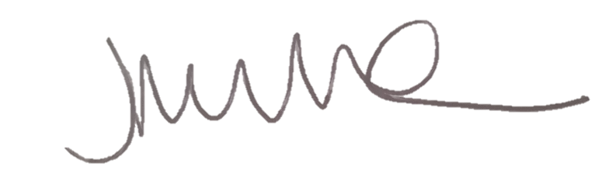

Joanna Miller

Test and Protect Specialist Nurse

NHS Lanarkshire