St. David’s Primary School
Newsletter May 2021
Dear Parents and Carers,
Thank you for all of your support over this school year, we are all very grateful to you for the way in which you have supported your children and the school in keeping everyone safe. As things begin to become more normal it is even more important that we make sure that our whole school community is safe. The last thing that anyone wants is for things to start going backwards again and for people to become unwell. There are some celebrations coming in the weeks ahead and with the virus still being in our surrounding area, we ask that you follow all Government Guidelines to reduce the risk of it coming into our school community and spreading between families.
Primary 1 Transition for August 2021
Most of our new Primary 1 children are coming from our own nursery here in St. David’s, and for all of them we have arranged for two play sessions with the Primary 1 teacher, in the Primary 1 classroom. The play sessions will take place on Wednesday 2nd June, Thursday 3rd June, Wednesday 9th June and Thursday 10th June in the afternoons and the children will come into the school in their small bubble of 6 children. This will give the children an opportunity to meet their new teacher and see their new learning environment. We will also send a video to all of our parents introducing the teacher and giving a tour of the school and classroom. At the moment we are not able to arrange a face to face meeting with parents, however this may change soon and we will offer this if we are able to do so. The Primary 1 teacher will also visit the nursery to work with the children and get to know them. Already Mrs Livingstone has been working with the pre-school children in their bubbles, in a weekly fun Spanish session. This has been really successful and the children and Mrs Livingstone really enjoy the sessions. Mrs Clezy is hoping to visit the children who are coming from other nurseries in the weeks ahead, and we may be able to offer them an after school visit to the school.
Sacrament of Reconciliation (Confession)
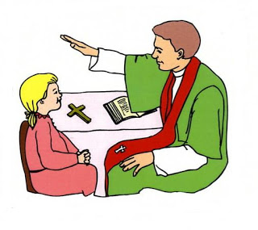
A very big congratulations to all of the boys and girls who received the Sacrament of Reconciliation for the first time on Tuesday 11th May. The service took place in the school hall and was led by Father Bergin. We are very proud of our Primary 3 children who were immaculately turned out on the day and who were so cheerful and enthusiastic. The children got to mark their special occasion with a small celebration in the class on the Wednesday morning when they enjoyed some cake and treats. Thank you to everyone who helped to make this a very special Sacrament, and especially the class teachers Mrs Smith and Mrs Kirk for preparing them so well.
Sacrament of Confirmation (Primary 7 only)
This year our Primary 7 pupils have been preparing for their Confirmation, and the first of the celebrations took place on Wednesday evening in St. David’s Church and the second on Thursday evening. We are so grateful to Father Bergin who has been visiting the school to help with the preparations for the Sacraments and we are delighted that this was able to be celebrated in St. David’s Church, all be it with limited numbers. We ask that you remember our Primary 7 children in your prayers. As part of their commitment to their faith and to this special Sacrament the children have also signed up to being Prayer Partners to people in the Parish community.
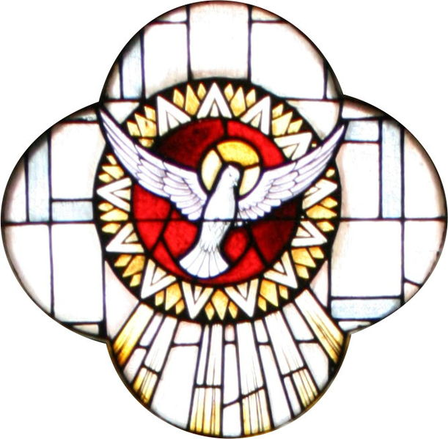
Primary 4 First Holy Communion
Our Primary 4 children will celebrate their First Holy Communion on Saturday 5th June. There will be two Masses on the day, one at 10am and the other at 12 noon. The children have been preparing for this next step in their journey of faith and we are all looking forward to a very special day. Father Bergin will celebrate both Masses with the children and the children will be allowed a limited number of guests in the church due to the current restrictions and for health and safety reasons. Please keep our First Holy Communicants and their families in your prayers.
Sports Hall Athletics North Lanarkshire Active Schools
On Monday and Tuesday of next week, the 24th and 25th May ALL of the classes will be taking part in North Lanarkshire’s Active Schools Sports Hall Athletics event. The children should come to school in their gym clothes on all four days next week, as we are going to tie this event in to a HEALTH WEEK for the whole school. All schools across North Lanarkshire are taking part virtually and our gym hall will be set up with appropriate measures in place with Mrs Steel organising and supervising the two days. We are so happy that we are able to take part in this virtual event and that we are finally able to use our gym hall for PE and other sports. The classes will have an allocated time slot and all of the equipment will be cleaned between classes. Our scores for this have to be submitted to the Active Schools Co-ordinator and there will be a virtual final involving those schools with the best scores. Go Team St. David’s!!
HEALTH WEEK 24TH MAY 2021
We do apologise for the very short notice, the week ahead will be our school’s Health Week when the children will take part in a variety of activities every day to promote good physical, mental and emotional health. The children should dress in their sports clothes every day (Mon-Thurs) and be encouraged to bring healthy snacks to school. House points will be awarded to those children who participate in promoting good health for all.
Sports Day
This year’s Sports Day will take place during the week beginning Monday 14th June. All classes will be competing separately and have their own events. The pupils will receive points for their House Team and these will go towards the end of year House point totals. Unfortunately we are not allowed to invite parents to the Sports Day but we will take lots of pictures of this event and keep you informed of the winners. We will make a decision on the final date closer to the time taking into consideration the weather.
Primary 7 Transition
Saint Margaret’s High School have been in touch with the cluster primary schools and have a tentative plan in place for the Primary 7 pupils to visit the school in June. At the moment we do not have final details about this, however it will hopefully take place the week beginning 14th June and the children will be visiting in small groups. I will let you know the final arrangements when we have more information.
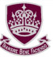
Shorts and Shades Day
As you know this year we have not had the opportunities that we would normally have to fundraise for our school funds and so at the moment we are in need of a boost to the school funds to help us to plan treats and events in the coming weeks. Our Parent Council have been immensely supportive in coming up with new ideas. On Friday 11th June we will have our first Summer themed event ‘SHORTS AND SHADES DAY’. The children will be asked to dress in Summer clothes for a donation of £1. There will be a Summer Tuck Shop with ice-poles, sweets, drinks and ice-cream cones for sale and a special Summer Raffle for which donations of prizes are welcome. The tickets for the raffle will be on sale from Monday 24th May and we will have the prize draw on Shorts and Shades Day. This date ties in with the Nursery Beach Party, so let’s pray that the weather improves and we can enjoy some much needed sunshine!
Reporting
End of year reports will be issued to all pupils at the end of May. The teachers have been working hard to assess children since they returned to school full-time. We ask you to continue to encourage your child to do their very best in school and to perform to their highest potential.
Parent Council
St. David’s Parent Council usually meets on the first Monday of every month in the school, however due to the current restrictions all of our meetings so far this year have been online and at different times of the month. If you would like to become more involved, please contact the school so that you can be invited to join our next meeting of the school year on Monday 7th June 2021 at 6pm on the virtual meeting platform Webex. At this meeting we will continue to focus on raising funds for our school, how we will use funds raised and also our new school website and Parent Council Newsletter. If you are not able to attend the meetings every month, we would still love to hear from you if you are able to support the Parent Council in any way at events throughout the year.
Parent Drop-in
I am very aware as a working parent that it can be difficult to come to the school during school hours to ask a question or voice a concern that you may have. Please email me at my school email address
ht@st-davids.n-lanark.sch.uk if you have any questions or concerns. I would be more than happy to set up a meeting either by telephone or on Webex to discuss anything with you privately. You can also phone the school on 01236 632142 to talk with either myself or Mrs Clezy our Principal Teacher. We are here to help you at all times.
Saint David’s School Website
Our new school website is now up and running with updates and information about our school. We are continuing to work on this with some help from our Primary 7 Digital Leaders. This will improve our methods of communication with you and will develop the digital skills of our young learners. We hope to develop our website further in the coming weeks and also use it to share new information with you.
Digital Learning
Every class has been asked to complete at least one of their homework activities online every week. This is to ensure that the hard work and progress made during our home learning this past year does not go to waste and that we continue to make use of the Teams platform to improve our learning and teaching opportunities. We still have a Virtual Assembly every week in school, and our Primary 7 pupils have also been leading a Virtual Rosary during the month of May on a Tuesday and Friday every week.
HOLIDAY WEEKEND REMINDER
The school and nursery will be closed on Friday 28th May and Monday 31st May for the May Bank Holiday Weekend. Pupils should return to school on Tuesday 1st June at their normal time.
Twitter
Please follow us on Twitter to keep up to date with all the latest activities and events especially during these times when children are not in school. The address is @StDavids4 and it is definitely the easiest way to see what your child is learning during the school day and during other school events.
As always please feel free to contact the school if you have any concerns or queries, we will try our best to help you.
With kind regards,
M. J. Livingstone
Head Teacher

