Second Level Speech and Language Home Activities
How well do you know your concepts such as big, small, long, short, curved, straight etc? Work with a partner to see if you can take turns to find bricks to match the descriptions – for example “find me the long, rectangular green brick”. | Read a story together with someone at home. Once you have read the story talk about who was in the story; what the characters were doing in the story and what they were doing it with (for example - playing on the swings); and where the story happened. This helps develop your sentence structure and vocabulary; as well as helping you to better understand WH- questions! | Quick name!  Name as many words as you can within a category in 60 seconds!  Ideas could include: different foods, different methods of transport, countries around the world etc. | Collect a mixture of random items from around the house and put them into a bag. Peek into the bag and describe one of the objects using as many adjectives as you can and see if your partner can guess what it is!  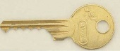
Pick a word – can you make up a visualiser word map about the word, for example:  What is the start sound of the word?  What is the end sound of the word?  How many syllables are in the word?  What is the meaning of the word?  Can you use the word in a sentence?  What type of word is it, e.g. verb/noun/adjective?  Can you draw a picture to match?  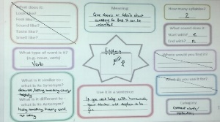 | Make a recipe together! Can you give your partner instructions about how to bake a cake? Can you listen to instructions from a partner and decorate a biscuit in a certain way? | Play “who am I?” or “where am I?” with a partner.  Example: “I work in a school and help children to learn – who am I?”; or “I am somewhere that is very quiet and I can see lots of people reading – where am I?”. | 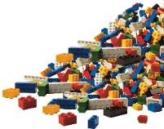  Work with a partner and sit across from each other. One person hold the instructions so that your partner can’t see them and explain (using only your describing words – no pointing!!) what bricks are needed and where to put them to build a model. Your partner has to listen carefully to the instructions to find the correct bricks and put them in the correct places!

