Second Level Maths & Numeracy Home Activities
Research a famous mathematician. How did they impact the world?  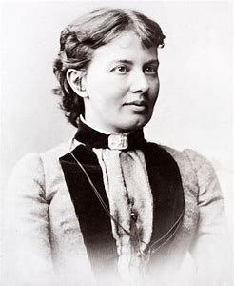 | Create a multiplication/division board game. Play it with your family.  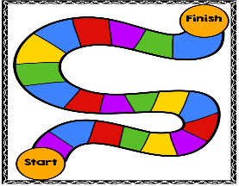 | Find as many different examples of numbers within the environment as you can.  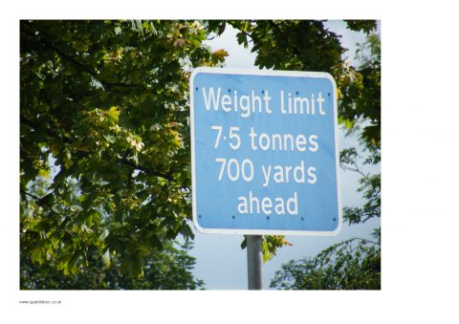 | Build something out of Lego bricks. Work out the fraction of each coloured brick.  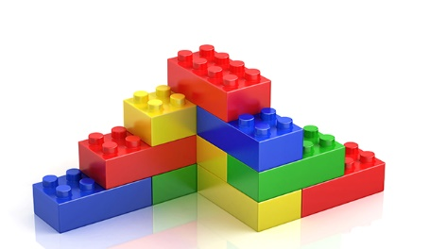
Estimate the perimeter and area of your garden or local park in metres. Convert it to cm and mm.  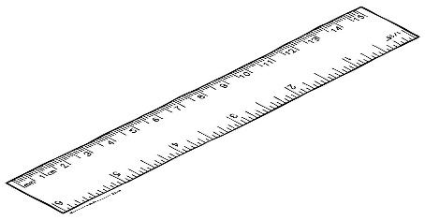 | Log on to Sumdog. How many questions can you answer correctly? | Look through a catalogue or a website and find as many special offers as you can. E.g. 25% off or Buy One Get One Free. Work out if the offer is a good deal. | Get someone to give you random numbers. Practise saying the number before and the number after the number.  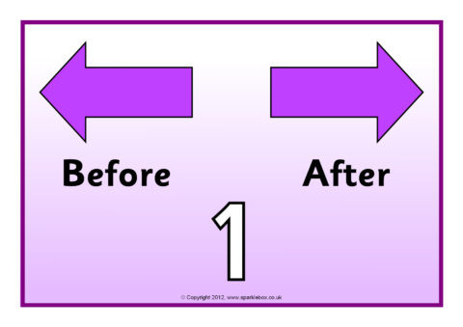  999
Use the internet to plan a weekend away for a family of 4. You must include transport and accommodation. You have a budget of £450.  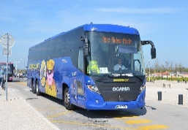 | Using a TV magazine or a TV Planner choose different TV programmes or films. Note the start time, the end time and the duration of each one. Which lasts the longest? | Practise time tables facts. Focus on the times tables that you find most challenging.  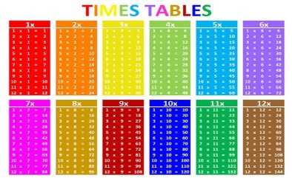 | Choose a famous landmark and draw it to scale.

