Accessing the Parent Portal
Please make sure that the web address typed is exact or type mygovscot into your search engine.

- Go to the Website
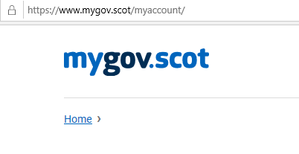

- Scroll down and click on the link
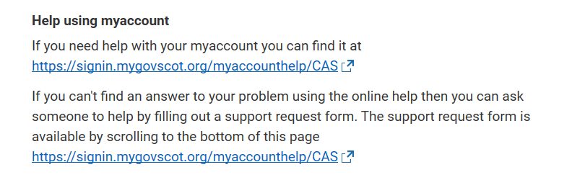

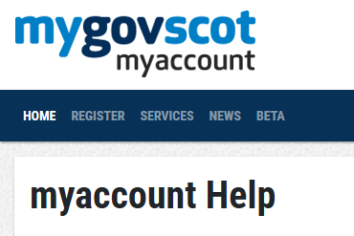
- Click on Register

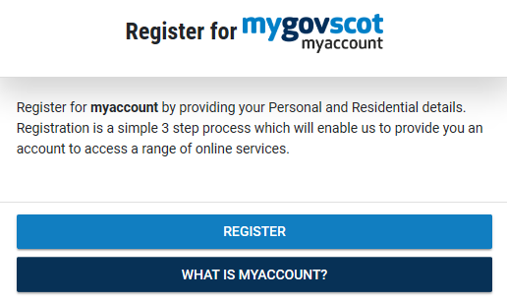
- Click on register and fill in the information

Once you have registered you will receive an e mail to VERIFY the account. You need to access your e mail and click verify. Your mygovscot account will then be active and you can go onto the PARENTS PORTAL

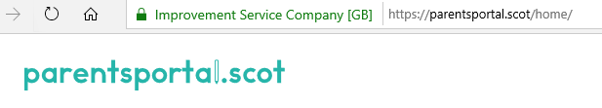
- Go to Website

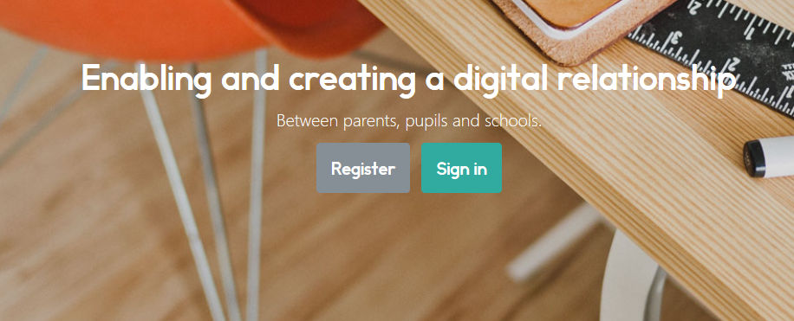
- Click on sign in

- Sign in using your MYGOVSCOT account which you created at Stage 1.
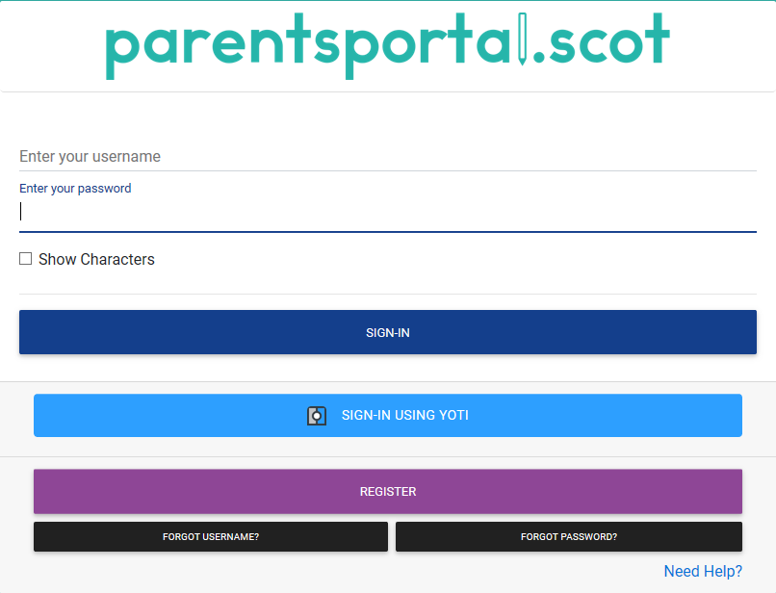

- Click on Link Child

- Click Start the process
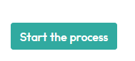

Using the Data Sheet issued by the school fill in the child’s information EXACTLY as it is on the Annual Data form.
Once linked a one time code will be sent to either your phone or e mail. ENTER THE CODE.

Your access to the PARENTS PORTAL will now be pending until the school APPROVES IT.
Once APPROVED you can access the PORTAL.

